Autumn Term 2020
Issue 2 23.10.2020
Good Luck Mrs Ferguson  Today is Mrs Ferguson’s last day at Belford Primary for a little while, as she leaves today to start her maternity leave. She is expecting a new baby daughter in November. We will really miss her, but can’t wait to hear news of the new addition! Good luck to her and her family. |  | Children in Need 13th November  We will be joining the UK in raising money for Children in Need on Friday 13th November. Please can the children come to school on this day in jogging bottoms, trainers and a top of their choice. We will be taking part in a Joe Wicks PE challenge. Please could the children bring a pound on this day (if possible) to donate to this very worthwhile cause. Many thanks
A Huge Thank you
Thank you very much to all our families who have donated food over the past week for our local Food Bank. I know that the Food Bank organisers will greatly appreciate your support, as will the people who access the Food Bank. This is a very challenging time for many people in our community and together we will hopefully make a positive difference.

Commando Joe’s  The children are really enjoying their weekly Commando Joe’s sessions. These sessions are proving valuable and are already developing positive character traits in the children such as resilience, confidence, empathy and independence.  Follow the link below for further details:  https://commandojoes.co.uk/about/ | Welcome back Class 3.  It was lovely to welcome class 3 back into school yesterday. They had a great day learning all about Mexico and enjoyed sampling some tasty Mexican snacks. |  | A Warm Welcome to Miss Foster  We welcomed Miss Foster into our school on Monday. Miss Foster will be teaching Class 3 for the remainder of the academic year. She has had the opportunity to get to know the children a little this week and is really looking forward to new half term.
Half Term
We hope that you all have a safe and happy half term holiday and look forward to seeing you all again on Monday 2nd November.
Social Distancing Reminder
We appreciate that it’s not always easy, but please can all adults dropping off and picking up children, ensure that they are observing social distancing. Thank you very much.
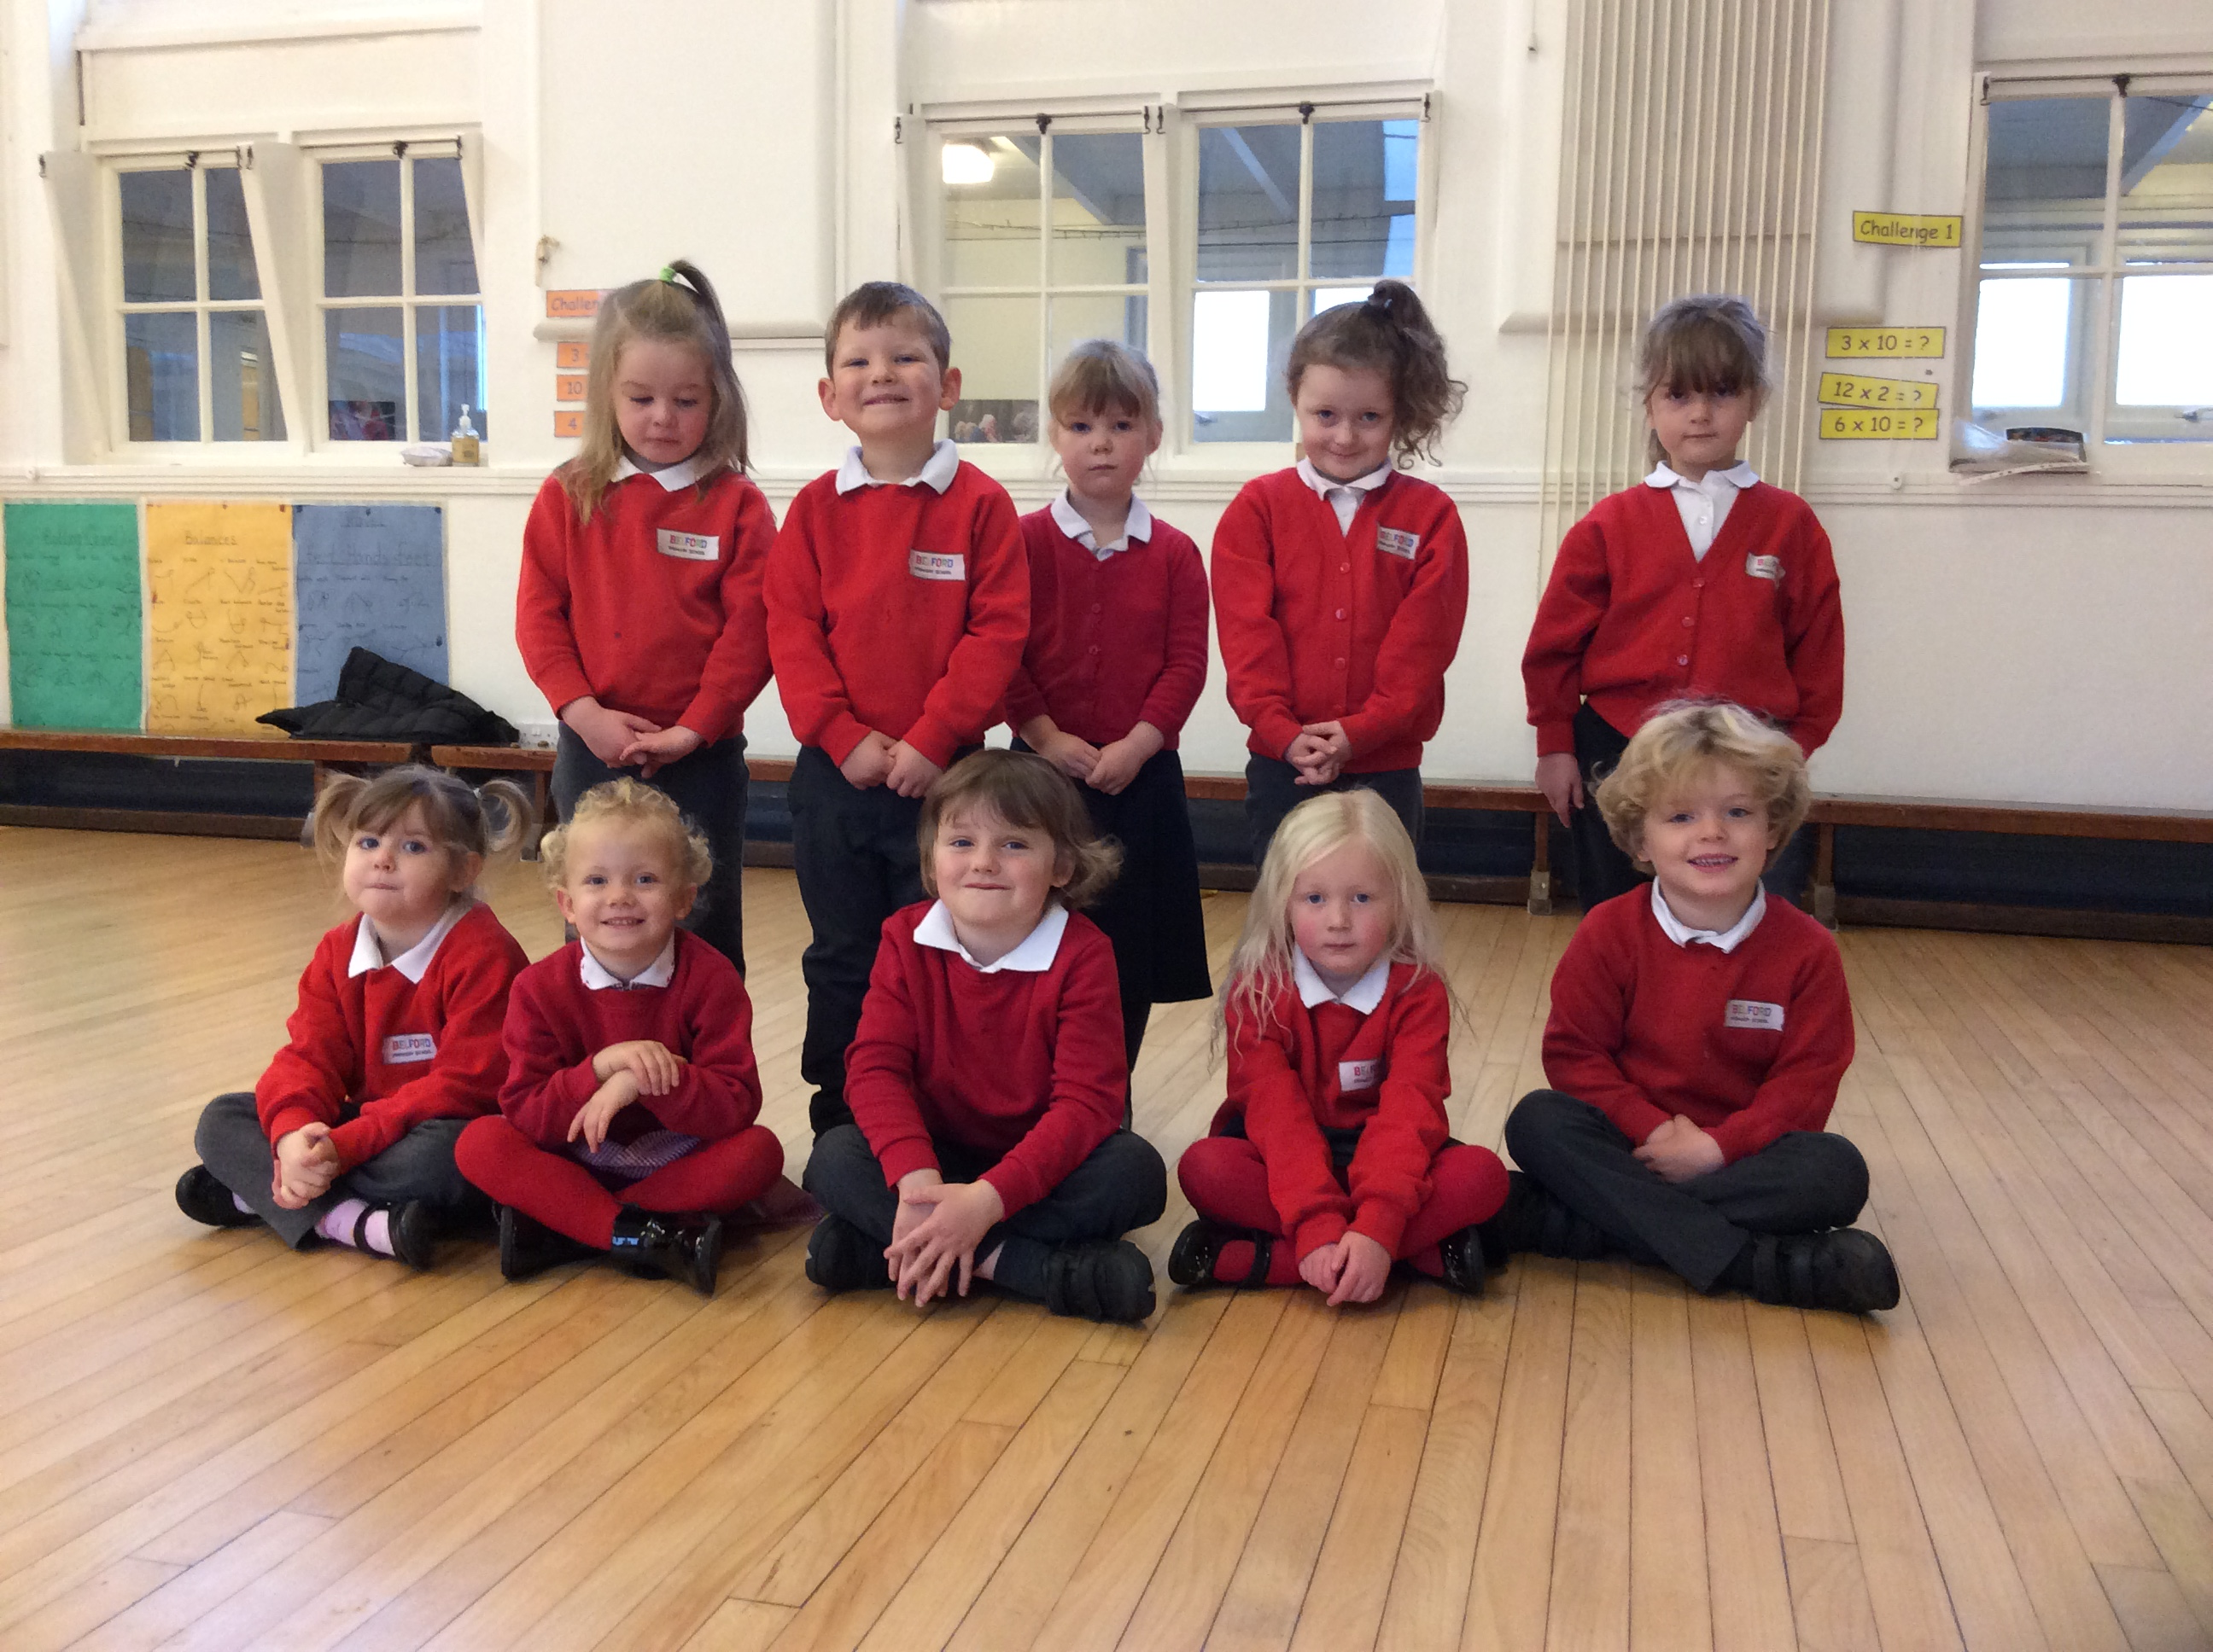
Well Done to Class 1
Class 1 have now completed their first half term in Reception and are doing brilliantly. I continue to be amazed at how quickly the children adapt and learn new skills. Thank you to all their families, who are supporting them at home wonderfully.
Breakfast Club
It has been lovely to see many of our families making use of our new Breakfast Club this half term. The children are enjoying a fun start to their day.
We still have spaces available. Please contact the school office if you would like to find out more or book a place.

