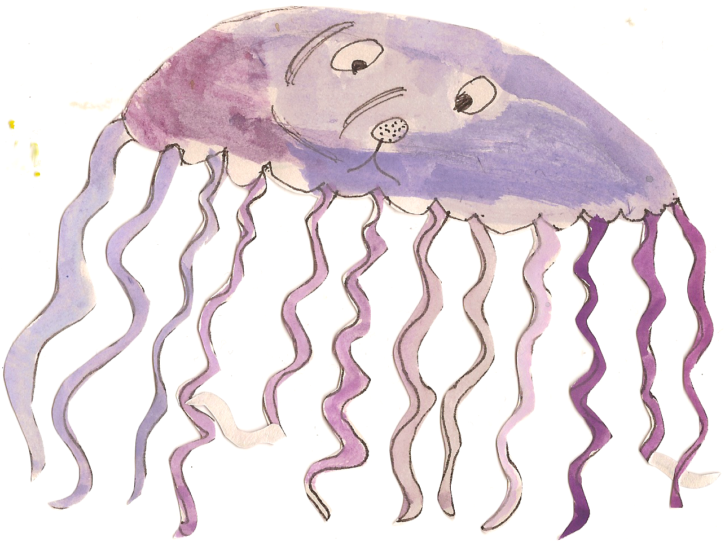

**Topic Work**

Class Three will be learning all about ‘The Tudors’. In our topic sessions the children will be learning about:

* The Battle of Bosworth
* The Tudor family
* Tudor Fashion
* Tudor food
* Crime and punishment
* Life of Tudor children
* King Henry VIII, his wives and children.

**Science Work**

Children will be learning to:

* identify common appliances that run on electricity
* construct a simple series electrical circuit, identifying and naming its basic parts, including cells, wires, bulbs, switches and buzzers
* identify whether or not a lamp will light in a simple series circuit, based on whether or not the lamp is part of a complete loop with a battery
* recognise that a switch opens and closes a circuit and associate this with whether or not a lamp lights in a simple series circuit
* recognise some common conductors and insulators, and associate metals with being good conductors

**Literacy**

This half term we are focussing on fiction books in Power of Reading. The children will be planning, drafting and writing extended pieces of writing in a variety of genres based around the book. We are mainly going to focus on descriptive writing. Producing character and setting descriptions for our short stories. We will also be practising our grammar and punctuation and including these in our independent writing.

Please continue to practise spellings each week at home. Children each have a spelling book to take home and will be tested every Friday.

**Numeracy**

At the beginning of the half term the children will be focussing on multiplication and division. We are covering both mental and written methods for both operations.

We will also be learning how to calculate the area of shapes.

Then we will be moving on to fractions and decimals and the relationship between the concepts.

**PE and Swimming**

Class Three will have PE twice a week.

**Thursday Outdoors-** Children to bring shorts, white t-shirt, jogging bottoms, a warm jumper and trainers. This half term a NUFC coach will be teaching the children team games.

**Friday at the Swan Centre**- children to come into school in jogging bottoms and trainers, and bring a swimming costume to change into.

**Homework**

Children will receive homework linked to work they have been doing in class that week.

Homework will go out on a Wednesday and should be returned by Tuesday the following week.