Theme: Fun on the Farm Term: Autumn 2 Year: 2022
Key Knowledge and Skills |  | Key Questions
To be able to talk about how a farm environment is different to school/home.  To be able to name some animals and their babies found on a farm.  To be able to know what can be grown on a farm and how we make food products that we can find in the shop. To know what foods are produced .  To be able to describe the features of highland cow.  To learn about harvesting and how we celebrate it in school.  To learn about the dangers on a farm.  To be aware of how to care for the farming environment.  To look at a map of the UK and point to Scotland and England. To know that countries are made up of smaller cities, towns and villages.  To be bale to retell The Little Red Hen using a story map. |  | How is a farm different to school/home. What animals can ne found on a farm but also at home?  What is a young horse, cow, sheep,pig,…called  What are cereals, biscuits, burgers, milk made from?  Can you remember the difference between a female/male highland cow?  Why do we harvest crops and vegetables. Can you tell me what we could make with them?  Why do you think farms can be dangerous?  Can you name some celebrations and festivals that we have celebrated? How are they the same/different?
Key Vocabulary |  | Key Content
Cow,calf,sheep,lamb,goat,kid,horse,foal  Seeds,grain,barley,maize,corn  Bread,oatcakes,cereals,dairy,milk,yogurt,cheese,meat,beef,pork,chicken,  vegetables  highland cow, male,female,horns,,grazing,grass, long hairy coats,shed  Positional language:over, ubder, through, past, across, around, beside, infront of, behind  Rooster,sheepdog,early, rise, chewing,faithful,loyal, plump, snuffle,gobble,peckfluffy fleece |  | The children will learn that a farm is a working environment which crops are grown and animals cared for. They will begin to understand where the food in the shops have come from and the process that has been taken to grow and harvest the food.  The children will experience farming machinery and observe the affects they have on our environment: ploughing, harvesting, seeding etc.  The children will learn about different festivals and celebrations and be able to link it to parties and celebrations that they have already experienced.
Links to Previous Learning:  Some Nursery can name a cow sheep and pig, but not the names for their young animals.  The children have never visited a working farm. They can talk about White House Farm and name the animals that they have observed in their pens: cows, sheep, pigs, chickens. |  | Cross Curricular Links: 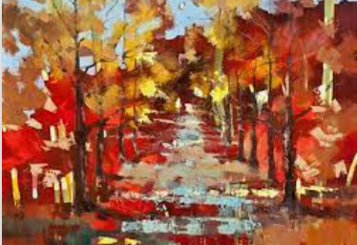Ewa Czarniecka – red autumn  Text 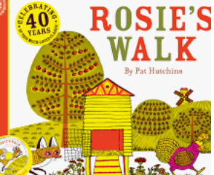 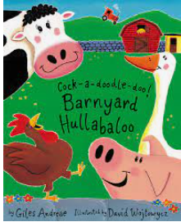 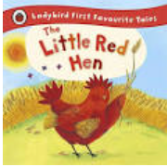 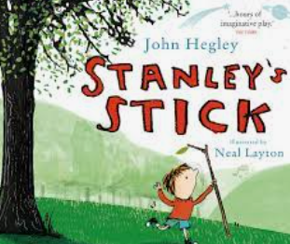 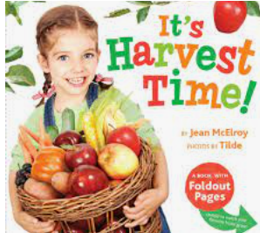
Children working towards expected | Children who have achieved expected |  | Children working at greater depth

Week 1  Autumn | Autumn PP discuss changes to environment and animals. Go on walk around school and collect autumn treasures. Discuss what we found.  Science/C&L | Mixing different shades of paint to represent autumn. Using fingers to paint leaves on trees.  Leaf hunt in forest school. How can we sort these leaves into groups? Following picture instructions.  EAD/Science/Maths | Hibernation: what is hibernation, why do animals hibernate?  Watch video about squirrels and discuss features, habitats, food eaten etc.  Make leaf squirrel-spreading glue and scissor skills. | Read Stanleys stick then head to Forest School. How can we make a den for squirrels? What does the den need to keep the squirrel warm and dry?  What can you make with a stick?  EAD/Literacy.
Week 2 | Positional language: Read Rosies walk and make a whole class story map. Retell story together with actions.  C&l, Geography, Literacy | Whole class retell Rosies walk then model how to make a story map. Chn to record in their topic books/scrap book. Who can use the positional language accurately?  What can we add to our map?  Geography/Maths | Floor book: what farm animals can we name?  Read farmyard hullabaloo. Discuss new vocab and new farm animals named. Add to scrap book.  Make sheep cupcakes (Hirsel recipie)  Geography/ C&L/ EAD/ PD | Sheep: cotton wool, soft, flffy,sqidgey etc  Make a plate sheep: spreading pva glue, covering all of the plate.  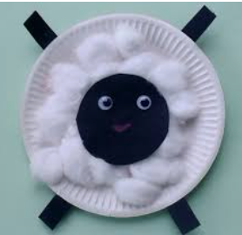  History/PD
Week 3 Visit to Hirsel Farm | Visit to farm: Risk assessment with chn.  Visit highland cows and calves, learn how to are for them, describe their features and know what food they produce.  Experience different grains/crops grown on the farm, how they are harvested and what foods are produced then sold in the shops.  Learn how to make Kale soup.  I spy farmimg : tramlines in fields, muck heap, fertiliser, shoots, tractor cultivating land, bird scareres.  PSED/C&L/PD/Geography?Science?History/EAD | Sight  Wheat, barley and oats: tasting foods and guessing which grain they are made from. Which is our favourite? Make bar chart and discuss most/least popular.  PD/Science/Maths | Naming parts of a tractor and farm machinery? How they work , dangers, tracks made, wheel sizes.  Trays of damp compost, chn make tracks with tractors and then plant seeds. Observe over time.  Painting with tractors and talking about different patterns/tracks/sizes of wheels. | Large map of uk. Discuss we live in England and travelled to Scotland to the farm. Sample Scottish foods and traditions.  Geography/EAD
Week 4 Harvest | PP: What is Harvest? Discuss and sort different vegetables into different categories.  Taste them then print patterns pictures with paint and vegetables.  Geography/History/EAD/PD | Learn Harvest songs for assemblies: thank you farmer, we are grateful, tasty food, harvest time.  Read the Little Red Hen  Literacy/EAD | Learn Harvest songs for assemblies: thank you farmer, we are grateful, tasty food, harvest time.  Create the Little Red Hen story map and let chn decide on actions. First half.  Literacy/EAD  Literacy/EAD | Learn Harvest songs for assemblies: thank you farmer, we are grateful, tasty food, harvest time.  Create the Little Red Hen story map and let chn decide on actions. Second half.  Literacy/EAD
Week 5 Bonfire  Remeberence Day | Guy Fawkes Story- pp  Set up tuff spot to recreate story together  History | Bonfire Safety Talk with Reg.  Creating a fire outside, toasting marshmallows, making sticky apples and hot dog role play. Safety officers to set off pretend fireworks  EAD | Using chalks and splatter paint from toothbrushes to create fireworks  EAD | Rememberence Day: Watch video on cbbc and discuss bravery and why these veterans are remembered. Make poppy activities and celebrate with familes.  History/EAD
Week 6 Diwali | Rama and Sita book and discuss feelings and actions.  Visior to discuss traditions?  HIstory | Light over darkness and hope that good luck will happen. Learn how Diwali is celebrated.  https://www.bbc.co.uk/programmes/p02n5hl0 Discuss similarities and differences between our celebrations: gifts, candles, new clothes, cleaning house  Geography | Festival of light: discuss candles and light.  https://www.youtube.com/watch?v=KZU6M4EisyA  Make a Diwali holder from clay  PD/EAD/History | Learn how to do a hindu dance  https://www.youtube.com/watch?v=DMRWmTnXBOU  EAD
Week 7  Xmas | The Xmas Story  History | How Christians celebrate Christmas at church/ visit to Paxton House to learn about Victorian Xmas. Songs, games and dancing  History / EAD | Symbolic tree and how decorated across the world. Show box of international decorations  History | Making xmas card with families  EAD
Comments

