Spring Term 2024
Issue 3 15.02.24
Positive Noticing, Dojo Points and Postcards Home  At Belford Primary, we have a strong focus on positive noticing.  Positive noticing is simple, practical and highly effective. It is catching children doing the right thing and marking it with positive acknowledgement.  We are delighted with the growing number of children earning Dojo points each day (for a wide variety of achievements). A number of children have also received cards through the post celebrating their kind behaviour and great attitude towards learning.  We know that you get more of the behaviours or attributes that you notice most and the impact of positive noticing is both immediate and long-lasting. It helps build self-esteem and confidence in the children. |  | 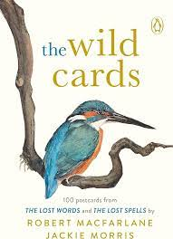  We are Kind, Friendly and Helpful
The Fire of London  Class 2 have really enjoyed their history learning this half term. They learnt about the main events of the Fire of London and even had an opportunity to build their own Tudor houses and recreate the fire.  Many thanks to Mrs Moscrop, Mrs Dunn and our friendly Belford Fire Crew, who made this possible. | Dates for the Diary  16.02.24  Break up for half term.  26.02.24  Back to school  06.03.24  National Measurement Programme  Reception and Year 6  07.03.24  World Book Day  08.03.24  Spring Disco 4-5pm  11.03.24  Whole School Science Week  Journeys!  21.03.24  Y5 and 6 Football Team  Tournament  27.03.24  Easter Family Bingo  3.30pm  28.03.24  Break up for Easter  15.04.24  Back to School | Mrs Bradbury  We are looking forward to welcoming  Mrs Bradbury back to Class 4 after half term.  She is returning following her maternity leave.
Robert Burns Celebration Lunch
The whole school and our Class 3 parents enjoyed a special Burns Lunch on the 24th January.
Mrs Dollin cooked a special meal of haggis, neeps and tatties. We even had a musical accompaniment of the Northumberland pipes!

Class 4 Visit to St Mary’s Church
On Tuesday 30th January, Class 4 enjoyed a guided tour of St Mary’s Church, led by Rev. Knox.
They learnt about the important features of the church and Christianity, and also studied the stained-glass windows.

Yoga
Class 1, 2 and 3 have enjoyed their Wednesday yoga sessions with Rhiannon from Yogi Bairns this half term.
Our whole school community has also supported Rhiannon’s February yoga challenge and we are doing our very best to incorporate yoga into our daily routines.
World Book Day
On Thursday 7th March, we will be celebrating World Book Day.
Please can the children come to school on this day dressed as a storybook character.
We will be studying the picture books of award-winning author, Anthony Browne.
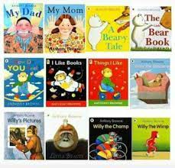
Healthy Choices
Please can we remind everyone, that we are a healthy school and promote healthy eating.
Please can the children NOT bring fizzy drinks, chocolate bars or products containing nuts to school in their packed lunches or after school snacks.
Thank you very much.

