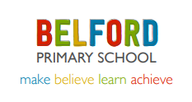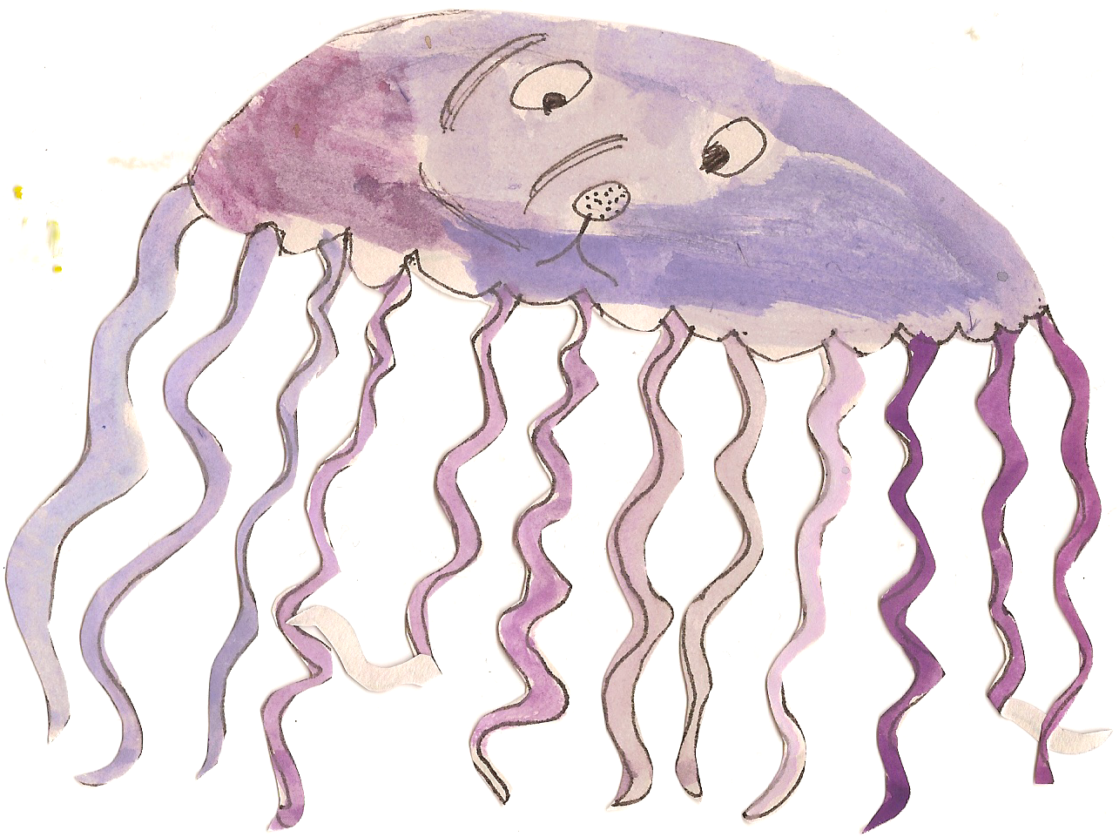

**Topic Work**

Class Three will be learning all about ‘Deserts’. In our topic sessions the children will be learning to:

* Identify out what deserts are and where in the world they are located.
* Investigate the weather and climate of deserts.
* Finding out about desert formations.
* Finding out how deserts are used by humans.
* Finding out about people who live in deserts.
* Identifying the causes and effects of desertification. To find out about the causes and effects of desertification.

**Science Work**

Children will be learning to:

* Recognise that living things can be grouped in a variety of ways.
* Explore and use classification keys to help group, identify and name a variety of living things in their local and wider environment.
* Recognise that environments can change and that this can sometimes pose dangers to living things.

**Homework**

Children will receive homework linked to work they have been doing in class that week.

Homework will go out on a Wednesday and should be returned no later than Tuesday the following week.

**PE and Swimming**

Class Three will have PE twice a week.

**Tuesday Outdoors-** Children to bring shorts, white t-shirt, jogging bottoms, a warm jumper and trainers. This half term a cricket coach will be teaching the children.

**Friday at the Swan Centre**- children to come into school in jogging bottoms and trainers, and bring a swimming costume to change into.

**Numeracy**

At the beginning of the half term the children will be focussing on their understanding of number through place value. We will be looking at place value in negative numbers, 2 digit, 3 digit and 4 digit numbers.

We will also be learning to read Roman numerals up to 100.

We will then be moving on to mental and written addition and subtraction and looking at the relationship between the two operations. The children will also be applying these skills by solving problems which involve money and measures.

**Literacy**

This half term we are focussing on fiction books in Power of Reading. The children will be planning, drafting and writing extended pieces of writing in a variety of genres based around the book. We are mainly going to focus on writing for a purpose, for example to write a persuasive letter. We will also be practising our grammar and punctuation and including these in our independent writing.

Please continue to practise spellings each week at home. Children each have a spelling book to take home and will be tested every Friday.