A picture a day!
Week 2

What sentences can you come up with about these pictures?
Write about 1 picture a day!


1.

Can your writing include:
- capital letter and full stop
- ambitious adjectives
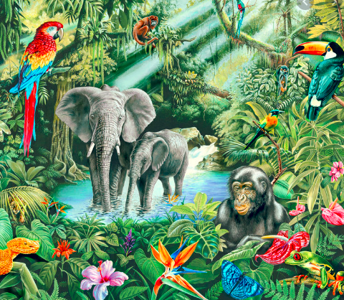

2.

Can your writing include:
- capital letter and full stop
- a conjunction to extend the sentence (and, because, so…)
- ambitious adjectives
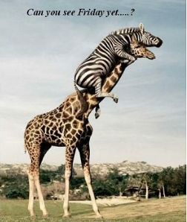
3.

Can your writing include:
- a question about the picture
- use the correct punctuation

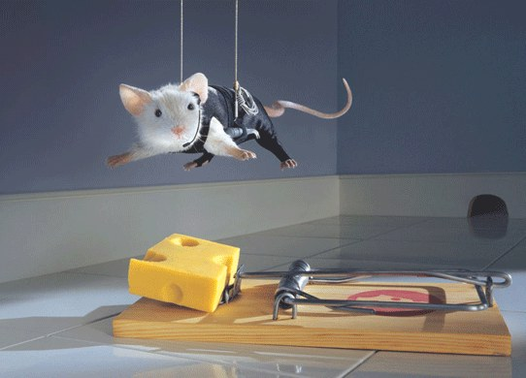
4.

Can your writing include:
- capital letter and full stop
- a conjunction to extend the sentence (and, because, so…)
- ambitious adjectives



5.

Can your writing include:
- capital letter and full stop
- a conjunction to extend the sentence (and, because, so…)
- ambitious adjectives
- an adverb to tell us more about the verb (e,g, hanging cautiously, nervously waiting, quietly hanging)

