A guide to using School 360 at home

Google search - School 360.com

Click on - EYFS Log in

Log in using your pin number, colour and object

Click on JIT
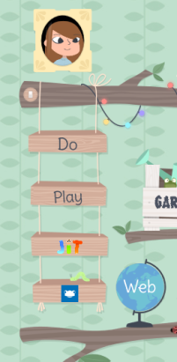

Once on you can choose the following apps
