Theme: Transport Term: Spring 1 Year: 2022
Key Knowledge and Skills |  | Key Questions
To be able to name different forms of transport and discuss their similarities and differences.  To be able to describe familiar forms of transport within their environment and talk about the how they can support them.  To be able to know what they can do to help reduce the air pollution in Belford.  To learn about road safety and the dangers around our village.  To be able to look at a map of the village and identify roads, rivers and fields.  To be able to add pictures to a map to show buildings of their interest in the village |  | How many different forms of transport can you now name? Can you tell me more about this form transport?  How is a police car similar to a fire engine? How is it different?  Where does air pollution come from? How can you help to reduce the air pollution in Belford.  Is it safe to cross a road between two cars? Why not? Can you show me how to cross the road safely?  Can you show me where the burn/golf club/main street is on the map?
Key Vocabulary |  | Key Content
Walking, heart pace, healthy mind, quality family discussions,  Police, car,van, ligts, sirings, speed, fast,slow, community, safety, protect, walkie talkies, hand cuffs, uniform, propellers, sea boat, speed boat. Hull,  Ambulance, illness, bed, medicines, healthy/unhealthy/poorly, equipment  Fire engines, tools, ladders, risk, fire hazards,  Life boat, sea, high/low tides, choppy, life jackets, charity  Air pollution, grey smog, cloudy, reduce, increase,damage lungs, prevention  Service, breathing, air way, mouth to mouth, plaster, broken, hurting, 999  Cardboard, wood, plastic, cotton wool, plasticine, float, sink |  | The children will learn about walking, police cars, ambulances, fire engines, life boats, buses and trains. They will have the opportunity to explore real vehicles that have a meaning around the Belford Community. They will learn new vocabulary linked to each vehicle and find out about the job role of each person who drives one of these vehicles.  The children will be introduced to air pollution and this will help to make the community more aware of the impact this has on our village and how we can reduce the sir pollution for everyone.  The children will learn the very early skills of first aid and how to get help when needed, in different situations.  The children will explore different materials and investigate floating and sinkng.
Links to Previous Learning:  One child has a paramedic as a father. There is a local fire station near to the local park so most children will be aware of it.  There are no pedestrian crossing, traffic lights or zebra crossings in the village. |  | Cross Curricular Links:  Text Cbeebies Graces Magnificant Machines: Vocab and vehicles  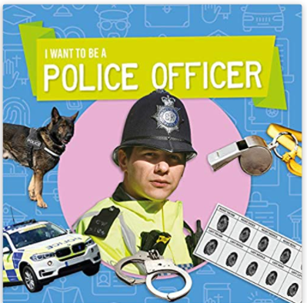 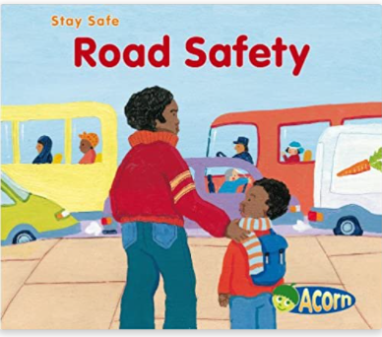 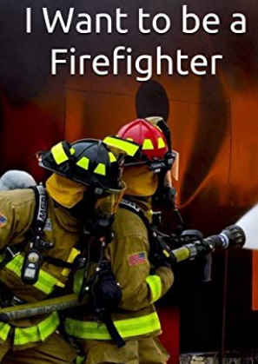 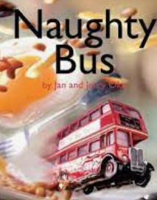 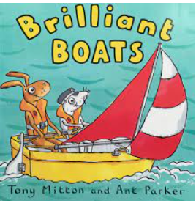 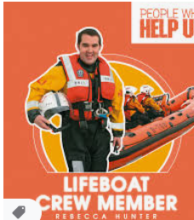 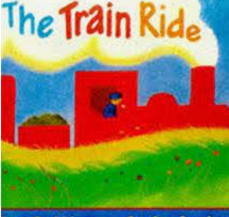 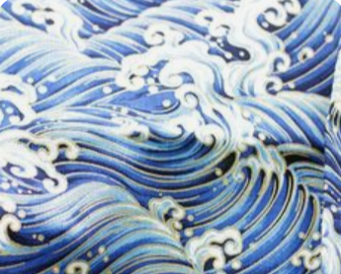 Japenese patterns seascape art
Children working towards expected | Children who have achieved expected |  | Children working at greater depth

Week 1  What is transport Walk to school week? | What forms of transport do you know? Chn mark make in scrap book.  Discuss transport pp and differences between vehicles.  Discuss what forms of transport they have used and was their favourite?  PSED/History | Air pollution  Talk about different ways that we could travel to school and impact that it has on the environment.  https://www.youtube.com/watch?v=fephtrPt6wk  Make grey clouds with paper plates and cotton wool. Discuss walking to school and introduce walking to school pictograph challenge. Display on Nursery window for parents. | Sorting different types of vehicles into hoops by different categories  C&L/Maths  Make a risk assessment for tomorrow with the chn. What will be dangerous?  Colour Traffic Survey from school gate | Traffic tally on Main St  Chn to find out most popular form of transport in Belford. Mark make on tally sheets.
Week 2  Police and road safety | Chat with Police Officer on road safety/ visit to station?  UTW | How to cross road safely.  Traffic lights red amber green  Zebra crossing  Pelican crossing  Sleeping Policeman  UTW/Safety | Signs in the environment: Twinkl  In hall on body boards: chn to listen to commands: fast, slow. Forwards, backwards, stop and go. Walking, like a plane then on body boards.  UTW | What have we learnt about a police officer? Read I want to be a police officer and chn mark make in scrap book.  Compare past and present uniforms and transport  UTW/History
Week 3 Visit to Fire Station | Visit to Belford Fire Station and explore fire engine. Naming different equipment on truck.  Safety round the home.  UTW | Recall visit and new vocabulary. Create a large fire engine together. What tools and equipment can we add? Chn to make ladders, hoses, batteries, crushers, cameras etc.  EAD  Learn Makaton song: https://www.youtube.com/watch?v=x_I2ysM0w0g  EAD | The walking water experiment: paper towels, cups of coloured water.  Science: absorption | Gymnastics equipment out: the day of a fireman; different ways to travel the equipment to get to the house and put out the fire.  Compare past and present uniforms and transport  History
Week 4 Ambulance | Visit from Paramedic with ambulance  UTW | What is inside an ambulance and watching a call out.  https://www.youtube.com/watch?v=UClBcKfQVIs Go outside and make an ambulance for role-play. Act out scenarios together. UTW | Visit from St Johns Ambulance: 01289 330688  Basic first aid/ Role within community  PSED/UTW
Week 5 Naughty bus | Naughty Bus Creative Literacy Week: See separate planning
Week 6  Boats | Visit from RNLI 01665 720370 TBC | Materials experiment: which would be the best materials to make a boat from? Make boats | Test boats-floating/sinking  Science | Compare different use of boats. PP on Twinkl.  UTW
Week 7  Trains | Creative Literacy Week: see separate planning for train journey book
Comments

