Theme: Storytime Term: Spring 2 Year: 2022
Key Knowledge and Skills |  | Key Questions
To be able to name different seasons.  To be able to talk about changes to trees, name some spring flowers and what animals are in the garden/fields.  To be able to name some popular characters from the fairytale books. To be able to describe the main character and discuss their emotions.  To have the confidence to taste new foods and textures.  To be able to name parts of a daffodil.  To experiment with water colours and different sized brushes.  To be able to describe how heat can affect changes to food. |  | Can you name some of the different seasons? What can you see in the spring? How is that different to the winter?  Can you remember the name of the blue/yellow/white flowers that we found in the garden?  Who was the main character? Was he a goody or baddy? Why do you think that?  How did we make porridge? What did we do to thicken the porridge ?  How did the jelly change?
Key Vocabulary |  | Key Content
Spring, seasons, months, bees, blossom,bluebells,snowdrops,buds,chicks,daffidol,nest, returning birds, lambs,tadpoles  Huff,puff,blow,push,house,hut,bricks,straw,sticks,little,big,hot,  Steaming.porridge,breakfast,lunch,dinner,rough,smooth,itchy,bumpy,  Small,medium,large,beanstalk,seed,soil,compost,roots,stalk,leaves,sun,  Watering can, harp,giant,golden,silver,coins,money,bean,market,stalls,  Mean,grumpy,brave,over,under,threw,beside,below,on top of, hill,meadow,river,absorb,sink, |  | The children will learn about the changes of the season and be able to talk about how our garden has changed. We will study the farm animals , trees and flowers that the children will see when they go on a walk.  The children will become familiar with repeated phrases from well known stories. They will add intonation and rhythm to their story telling. We will explore different emotions and characters.  The children will explore how combining different materials can change materials from one state to another. We will focus on adding heat.
Links to Previous Learning:  The children live in a small village and will have had the opportunity to walk around the rural environment during the Covid 19 lockdown. |  | Cross Curricular Links:  Text  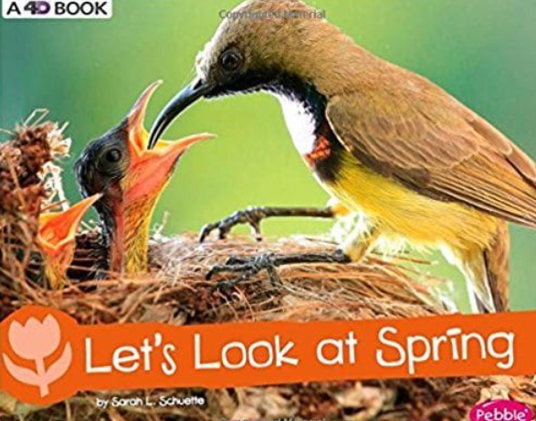 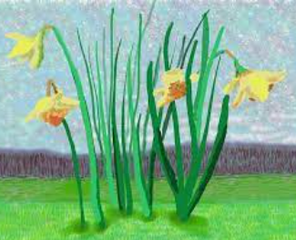 David Hockney artist from Normandy: Cant cancel spring  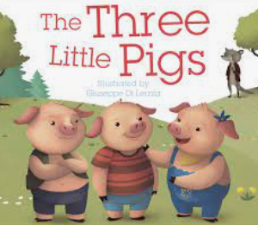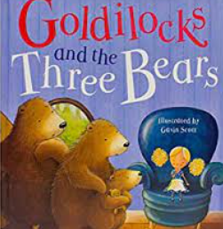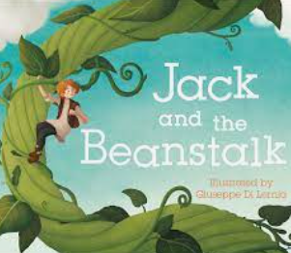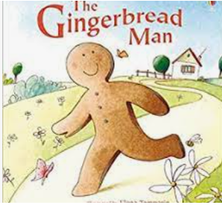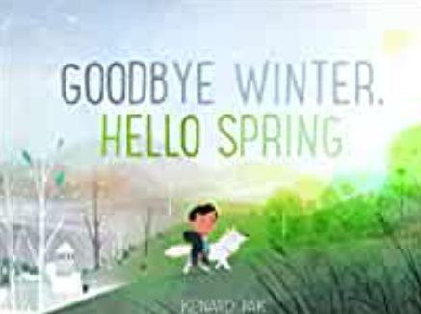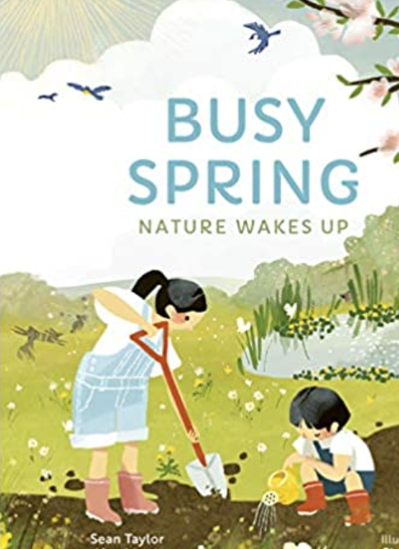
Children working towards expected | Children who have achieved expected |  | Children working at greater depth

Week 1  Spring | Spring PP and environment walk looking for signs of spring.  UTW | Lets look at spring book: Who can recall/ use new vocb?  Dissecting a daffodil: naming parts and functions. Using tools safely.  Science | Study David Harmony Artist and learning to paint background with watercolours.  EAD | Painting daffodils on to water colour background: sketching and different sized paint brushes  EAD
Week 2  Goldlilocks and 3 Bears | Read story then create tuff spot for chn to retell story in their play.  C&L | Making porridge together.  Which topping do they prefere? Jam, fruit, honey.  Make a pictograph and discuss least most/ popular  Discuss the changes that heat makes.  PD/PSED | Make jelly together and discuss the changes heat/cold makes.  Can they predict what will happen to the jelly placed in the cupboard, fridge and freezer.  UTW  Science | Goldilocks pushed the door open and pulled the bedcovers over her.  Discuss forces and find things that can be pushed outdoors/indoors. Mark with a sticky note and then discuss. Repeat with pulled.  Science
Week 3  Gingerbread man | Creative week: Pie Corbett Style |  | Making gingerbread men  EAD | Predict what will happen to gingerbread man in cold, warm and hot water.  Science
Week 4 Jack and the Beanstalk | Read story and plant magic beans in compost pots and also kitchen bags with wet paper towels. Can chn predict what will happen?  Science | Introduce instruments: triangle, tambourine, xylophone, drum  Can chn think of an instrument that represents a giant, jack climbing beanstalk, peaceful sleepy sounds. Read the story as chn perform with their instruments at the correct part of the story.  EAD | Look at castles: naming parts, materials, why built. Chn to paint castle using block prints.  EAD | Study leaves: make leaf rubbings  And discuss changes over seasons, patterns and sizings.  UTW
Week 5 3 Little Pigs | Read story and discuss characters. Put into hoops then show emotion cards and sort them into the character hoops. Discussing why they think that.  Set up tuff spot together to retell story. | Building houses from straws, lollipop sticks and blocks. Which house will survive your huff and puffs?  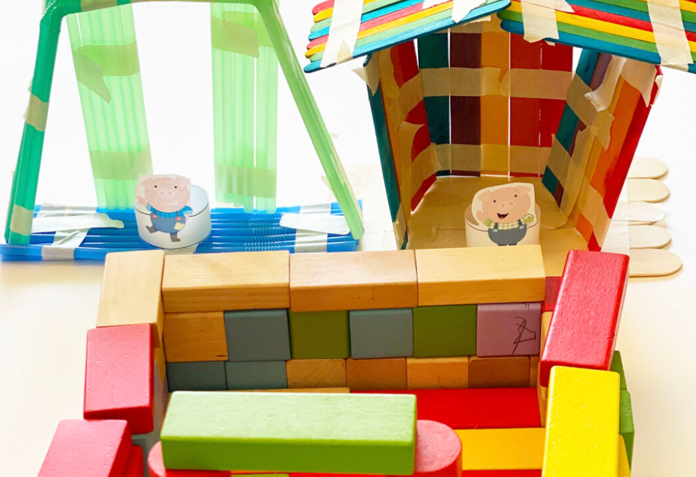 | What do we know about our lungs?  Who can fill their lungs with the most air and blow the feather the furthest?  Science | Make a story map together then chn to make up their own version.
Week 6  The jolly postman or Other Peoples Letters | Creative week The Jolly Postman or Other Peoples Letters: see separate planning
Comments

