Theme: Dinosaurs Term: Summer 1 Year: 2022
Key Knowledge and Skills |  | Key Questions
To be able to name different seasons.  To be able to talk about changes to trees, name some spring flowers and what animals are in the garden/fields.  To be able to name some popular characters from the fairytale books. To be able to describe the main character and discuss their emotions.  To have the confidence to taste new foods and textures.  To be able to name parts of a daffodil.  To experiment with water colours and different sized brushes.  To be able to describe how heat can affect changes to food. |  | Can you name some of the different seasons? What can you see in the spring? How is that different to the winter?  Can you remember the name of the blue/yellow/white flowers that we found in the garden?  Who was the main character? Was he a goody or baddy? Why do you think that?  How did we make porridge? What did we do to thicken the porridge ?  How did the jelly change?
Key Vocabulary |  | Key Content
Spring, seasons, months, bees, blossom,bluebells,snowdrops,buds,chicks,daffidol,nest, returning birds, lambs,tadpoles |  | The children will learn about the changes of the season and be able to talk about how our garden has changed. We will study the farm animals , trees and flowers that the children will see when they go on a walk.  The children will become familiar with repeated phrases from well known stories. They will add intonation and rhythm to their story telling. We will explore different emotions and characters.  The children will explore how combining different materials can change materials from one state to another. We will focus on adding heat.
Links to Previous Learning:  The children live in a small village and will have had the opportunity to walk around the rural environment during the Covid 19 lockdown. |  | Cross Curricular Links: https://www.bbc.co.uk/cbeebies/curations/dinosaur-facts This website cover fats for each type of dinosaur: use at snack times: info from computer/recall or share knowledge  Sea dinosaurs:anaomites: https://www.bbc.co.uk/iplayer/episode/b03wc6kd/andys-dinosaur-adventures-4-eustreptospondylus-and-ammonite  Text  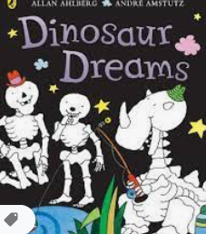
Children working towards expected | Children who have achieved expected |  | Children working at greater depth

Week 1  Fossils | Watch https://www.bbc.co.uk/bitesize/topics/zd8fv9q/articles/zf6vb82 and discuss fossils.  Make fossils using flour,coffee,salt,sand water and dinosaurs (Twinkl dinosaur fossil) To be cooked in oven.  History-Mary Anning | Examine fossils and decide if dead, alive or never lived.  Sort objects into hoops as above.Plants pets,dead flowers, leavespebble, seashell, pencil.  Science  (Make sets of dinosaur eggs for Friday) | Make dinosaur biscuits (Hamilton recipe)  She sells sea shells on the sea shore- tongue twister  EAD/PD | Problem Solving  Eggs in nest: Where came from, what are they, how can we open them? Etc  C&L/Teamwork/Sustained shared thinking  Match dino to description game- (Cards and real dinosaurs Game)
Week 2  Describe a dinosaur | Tryanasaurus Rex facts: https://www.bbc.co.uk/cbeebies/curations/dinosaur-facts What facts can chn recall?  Make paper plates T Rex  C&L/EAD | dinosaur life in the sea: https://www.bbc.co.uk/iplayer/episode/b03wc6kd/andys-dinosaur-adventures-4-eustreptospondylus-and-ammonite  Sealife Dinosaurs  History/science | Read Dinosaur dreams and discuss features: Each skeleton tells a story: sharp teeth and massive jaws tells us that that dinosaur ate meat; tough, toothless beak, a plant eater; powerful hind legs, it could probably run fast; features like horns show us how they defended themselves; small braincases tell us which dinosaurs had small brains.  Chn use A3/A4 to paint dinosaur outline. Add scrumpled paper for texture then, paint or college. | Show and tell our dinosaurs, using new vocab. BL scribe what chn say for display. Each chd to mark make or record sentence or lists to describe their dinosaur.  PSED/C&L
Week 3  Textures and EAD | 2 afternoons to learn how to mix glue using flour and water: then paper mache. Follow instructions to make egg with balloon, dinosaur and paper mache. |  | Paint eggs.  EAD | We are going on a dinosaur hunt, we are going to catch a big one…  Forest school: follow dinosaur footprints into forest school to find our hidden eggs. Work together to hatch them.  PD/C&L/Science
Week 4 | Read story and plant magic beans in compost pots and also kitchen bags with wet paper towels. Can chn predict what will happen?  Science | Introduce instruments: triangle, tambourine, xylophone, drum  Can chn think of an instrument that represents a giant, jack climbing beanstalk, peaceful sleepy sounds. Read the story as chn perform with their instruments at the correct part of the story.  EAD | Look at castles: naming parts, materials, why built. Chn to paint castle using block prints.  EAD | Study leaves: make leaf rubbings  And discuss changes over seasons, patterns and sizings.  UTW
Week 5 3 little pigs | Read story and discuss characters. Put into hoops then show emotion cards and sort them into the character hoops. Discussing why they think that.  Set up tuff spot together to retell story. | Building houses from straws, lollipop sticks and blocks. Which house will surivive your huff and puffs?  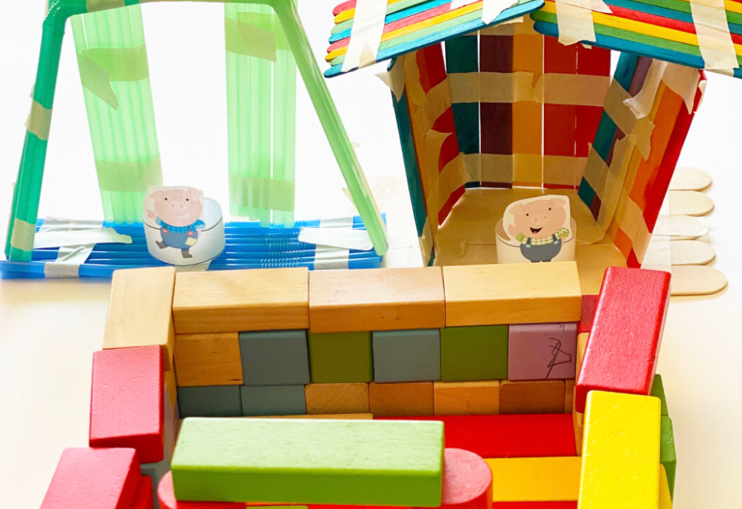 | What do we know about our lungs?  Who can fill their lungs with the most air and blow the feather the furthest?  Science | Make a story map together then chn to make up their own version.
Comments

Here are two ways to make dinosaur pasta skeletons with your preschool, pre-k, or kindergarten students.
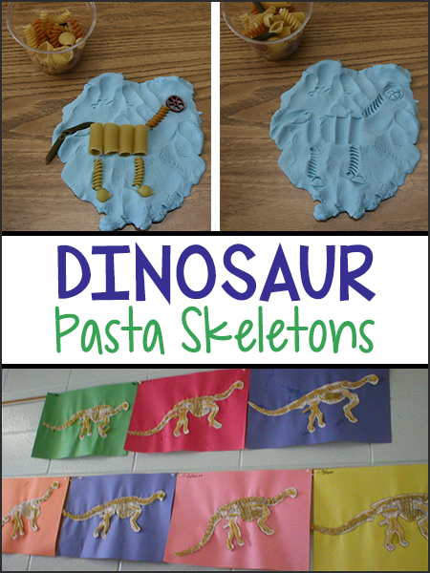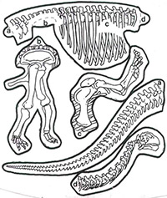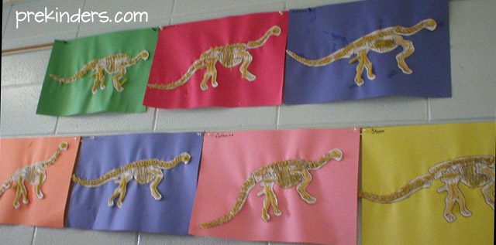

Dinosaur Pasta Skeleton #1
First, download the printable skeleton at the link below, and cut out the pieces. Children will assemble and glue the paper pieces of the dinosaur skeleton to a piece of construction paper (12×18 size), and glue dry pasta on the skeleton.

The pasta pieces you will need are:
- Shell: for the skull
- Rigatoni: for the legs
- Fettucini: for the ribs
- Elbow (Macaroni): for the neck, backbone, and tail

Dinosaur Pasta Play Dough Skeleton #2
Children pretend to be paleontologists who have discovered bones (the pasta) in the ground. We have to figure out how to put the bones together to make a dinosaur. Have children mash play dough flat on a plate. For younger children, its a good idea to use a dinosaur-shaped cookie cutter to make the outline of a dinosaur in the play dough. Then press pasta shapes (bones) into the play dough inside the outline to make a skeleton.
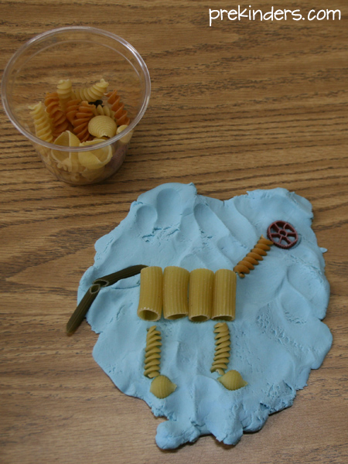
Model Magic or self-hardening clay would also work well. The pasta can be removed and the children will see the imprint left in the play dough, which is like a fossil.
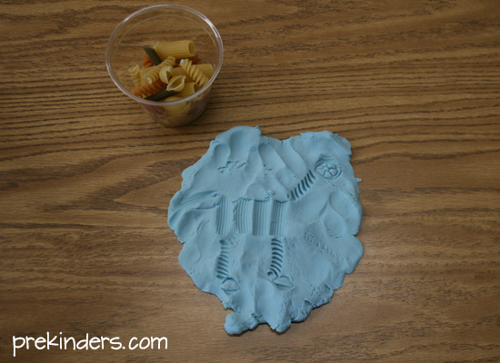

MAKE A HATCHABLE DINOSAUR EGG  More Kinder Crafts  This is a great way to make HUGE, hatchable, papier-mâché dinosaur eggs. If you make a bunch of these eggs a few days in advance, they can be decorated at a party. | 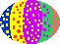
SUPPLIES NEEDED:
- One balloon for each dinosaur egg
- A lot of old newspaper and/or brown-bag paper
- Flour-water glue (instructions below)
- Paints (tempera works well) and markers

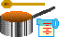 | Make a simple, thin glue from flour and water (boiling gives it a nice consistency). Mix 1 cup of flour into 1 cup of water until the mixture is thin and runny. Stir into 4 cups of boiling water. Simmer for about 3 minutes, then cool.  Have children tear a lot of strips of newspaper and/or brown bag paper. Strips should be about 1 inch wide; the length doesn't really matter.

- For an extra special dinosaur egg, put a small, plastic dinosaur inside the balloon before blowing it up.
- Blow up a balloon for each child.

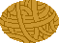 | Dip each strip of paper in the flour glue and wrap around the balloon. Have at least two layers surrounding the balloon. Let it dry (at least overnight) after each layer.  Let the dinosaur egg dry for a few days. When it is dry, you can pop and remove the balloon from inside the egg.

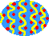 | After the dinosaur egg is completely dry, decorate with paint or markers. Let the children know that no one knows what color the dinosaurs' eggs were. Also, some dinosaurs dug nests out of sandy soil and some just laid their eggs on the ground. Maybe the eggs were camouflaged to blend in with twigs, sand, mud, or fallen leaves. For more information on dinosaurs, click here.  You can later "hatch" your egg and find a tiny dinosaur.

