Spring Term 2021
Issue 6 25.03.2021
Key Stage 2 PSHE sessions with NUFC
Over the past 3 weeks, the children in class 3 and 4 have enjoyed a series of PSHE lessons delivered by Lee and Adam from NUFC.
Class 3 have studied how to keep their bodies and minds healthy, through eating a balanced diet, drinking plenty of water, exercising regularly, getting 10-12 hours sleep each night and brushing their teeth twice a day.
Class 4 have studied diversity and equality. They have had opportunities to discuss a range of important subjects such as gender equality and racism.
Thank you  Our ‘Open the Book’ assembly team have donated lovely Easter books for the children, which they are bringing home today. George Morrison has also donated an Easter egg for every child in school.  Our sincere thanks go to George and the ‘Open the Book’ team.  Happy Easter  I’d like to take this opportunity to wish you all a very happy and peaceful Easter break.  We look forward to seeing you all again on Monday 12th April. | Easter Egg Decorating Competition.  We had lots of amazing entries to our ‘Decorate an Easter Egg’ competition.  Thank you to all the children who took part. You demonstrated many creative skills and your masterpieces have brightened up the school this week.  Congratulations to the following children who won prizes today: Noah, Hayden, Isla M, Jess, Ava, Robert, Megan, Charlotte, Eliza, Georgia, Corissa and Emelia.  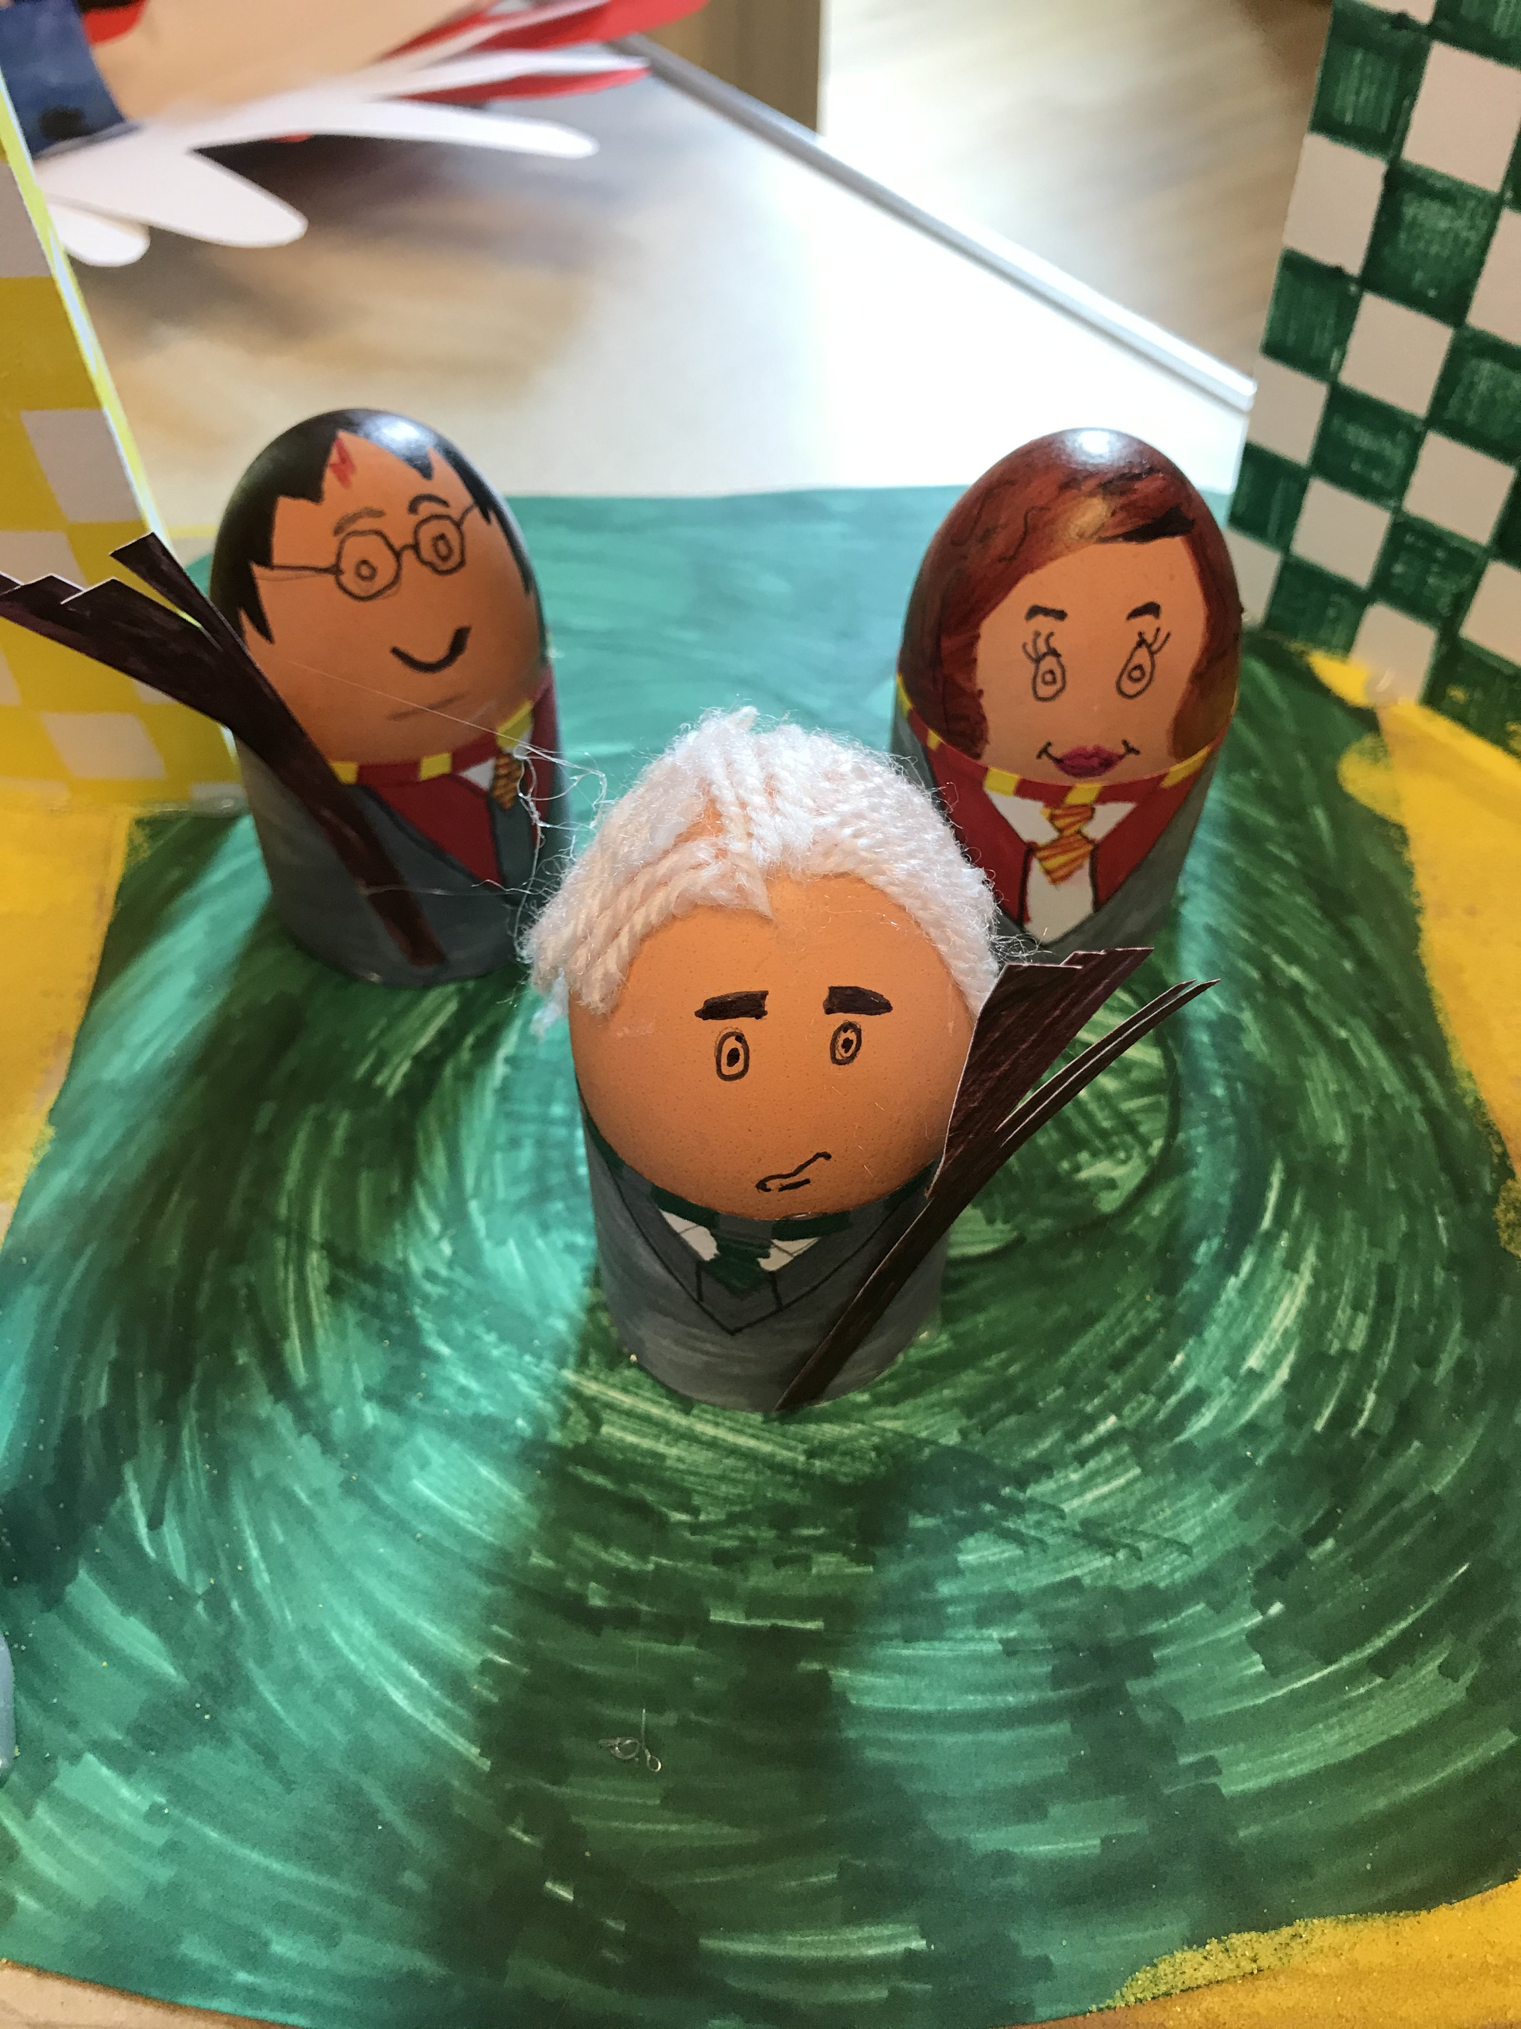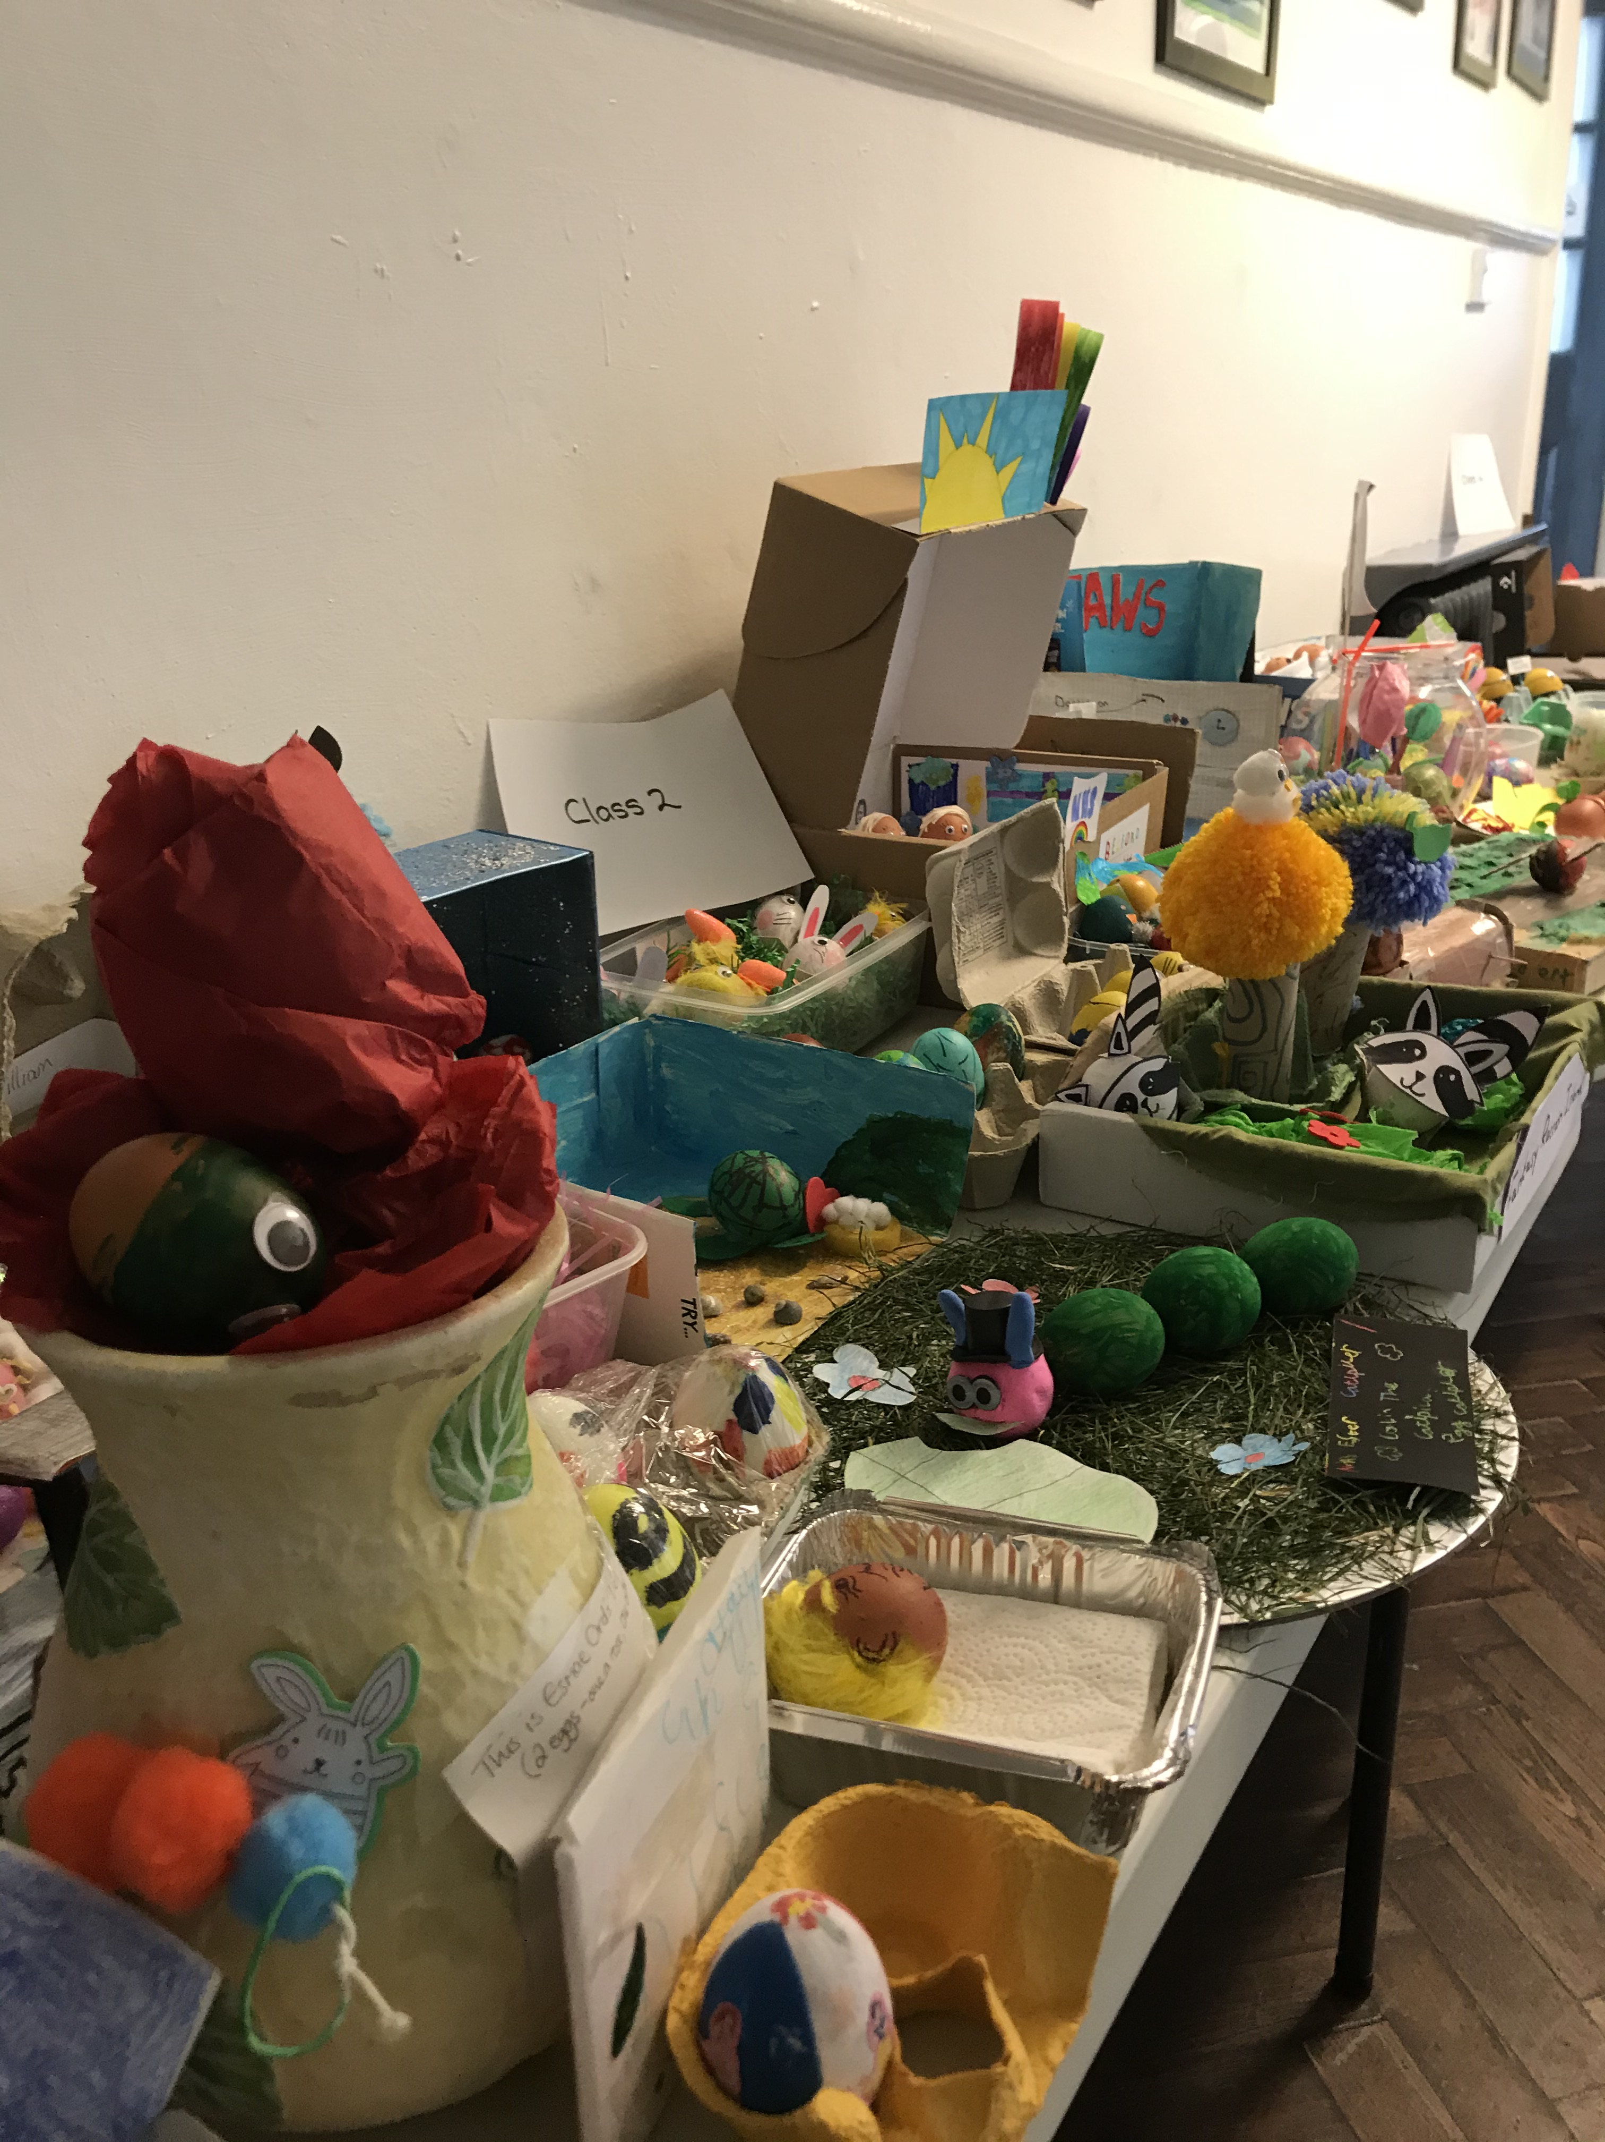 |  | Tree Maintenance  On Wednesday 31st March, a number of trees on the school site are being trimmed back and one large tree at the front of school is being felled.  If you would like any wood for use at home, please feel free to help yourself on the afternoon of the 31st after 3pm.
Dates for the Diary
Friday 26th March – break up for Easter.
Monday 12th April – back to school.
Friday 14th May – Pyjamarama Day
Friday 28th May – break up for half term.
Tuesday 8th June – back to school.
Friday 16th July – break up for summer.

Maths Club
Many thanks to all the parents who completed the questionnaire regarding school running a maths club after Easter.
We had a hugely positive response and we will be running a club every Thursday after school from 3.15-4pm for the children in class 1,2,3 and 4.
The club will run for the whole of next half term, starting on Thursday 15th April.
Please can you complete and return the permission slip that was sent home on Wednesday if your child/children would like to attend.
Many thanks

Easter Raffle
Thank you to everyone who has supported our raffle this week to raise funds for school. The lucky winner was Dexter in Nursery.
We have raised £127
Many thanks to the PTA for organising this for us.
Specialist Music Teaching
After Easter we welcome a new music teacher to Belford Primary School; Mrs Susie Cochrane.
Mrs Cochrane will be teaching music every Monday afternoon. She is a highly experienced music specialist and has spent a number of years as Head of Music at DCHS, Alnwick. We are looking forward to working with her and hope she enjoys her time at Belford.
Our thanks and best wishes go to Mrs Humphreys who has done a fabulous job developing music in our school to date.
World Autism Awareness Week
World Autism Awareness week is back from 29th March – 4Th April.
You can find out more about it here:
https://www.autism.org.uk/get-involved/raise-money/world-autism-awareness-week

