Theme: The Zoo Term: Summer 2 Year: 2024
Key Knowledge and Skills |  | Key Questions
To be able to name a few different animals from the zoo  To be able to use descriptive language to describe the features of an animal  To be able to comment on characters, settings and events in stories  To be able to talk about their knowledge of certain animals and how their habitat is different to others.  To be able to listen to each others responses and add their opinions  To mix various paints together to create different shades  To know the difference between a solid and a liquid  To be able to make predictions, talk about our findings and make a conclusion |  | Can you name some of the different animals that seen at the zoo? Tell me about your favourite animal and why you like it. Can you describe it?  Which is your favourite character? Tell why you like it? What was your favourite part of the story? Was there a part of the story that you did not like? Why?  What will happen when we add… is it lighter or darker. What will happen if we add more… How can we make it lighter? How can we make it darker?  How do you think the crystals will change when we add tap water? Will hot water be the same or different? How do you know? I wonder why they look and feel different.
Key Vocabulary |  | Key Content
Australia, Africa, Madagascar Island, Continent, Equator, Countries, Ocean, climate  Meerkats, burrows, fruit, insects, babysitters, pups, gang, mob  Lemurs, extinct, scent, patterned tail, communicate, female, leaders, pup, seed transfer  Wallaby, kangaroo, rock wallaby’s, cliffs, caves, marsupials, joeys, agile, rough padded feet, long tails, grass, leaves, bark  Tortoise, skeleton on outside of body, shell, endoskeleton inside, 100 years old, bask in sun, burrow in ground, body temperature,  Swing, slide, side to side, jump, bend, spread, flap, dance, attract mates, slowly, sweeping, squat, climb, tall, short, spring, balance, scales, armour, hatch, eggs, hunt, prey, wallets, belts, purse, extinct, underground, burrow, tunnel, protect, predators  Bark, fruit, Insects, berries, leaves, intelligent, babies  Sand timer, crystal formations, set, gelatine, hot/tap/refrigerated water  Bus canoe  Earth, world, over flow, water, oceans, electricity, litter, wrapper, compost, recycle |  | The children will revisit using a globe to find the different continents that the zoo animals live in. They will learn new facts about each animal and compare them to similar animals. We will learn about the animals that we will visit at Northumberland Zoo.  We will read The Tiger who came for Tea and discuss the different characters and events of the story.  We will learn how to retell Dear Zoo and then innovate our own class version, using new animals and describing words.  We will explore how a solid can change into a liquid by using different water temperatures  We will learn how to reduce, reuse and recycle so that we can help to save these environments that we have learnt about.
Links to Previous Learning:  The chn have read the zoo when they were in Nursery and can name common animals found there.  The chn can name mini beasts and describe their appearance and habitats  The chn can use a globe.They know they live in a village called Belford, in England. They can describe the different seasons and weather. |  | Cross Curricular Links:  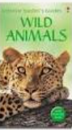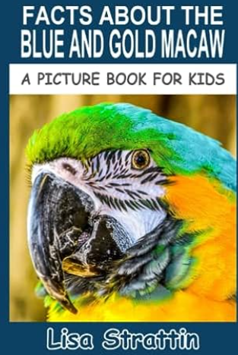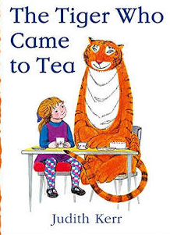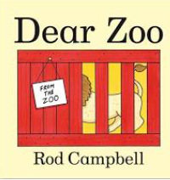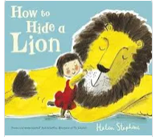
Children working towards expected | Children who have achieved expected |  | Children working at greater depth

Week 1  Tiger who came for tea | Have you ever been to a friends for tea?  https://youtu.be/xJbs_S0XC_g  Set up props to tell the story; The Tiger who came for tea.  Sequence story cards in floor book. Who can retell the story?  Literacy/C&L | Revisit story https://youtu.be/JNMkcCC873E  Have a large print out of the tiger. Work together to label the picture with descriptive words: stripy, big, furry etc  Can we describe the character? Is he mean and selfish or kind and caring?  Mark make in the floor book.  Study and compare photographs of tigers. Model how to draw a tiger then shade in with chalks.  Literacy/EAD |  | Revisit floor book and describe the tiger.  Model how to write descriptive sentences. Chn to write their own sentences for display.  EAD/C&L  What can we make for the tiger’s tea?  Write a shopping list for tomorrow. | ALL DAY Activities  10 Tiger facts  https://www.wwf.org.uk/learn/fascinating-facts/tigers  Floor book activities  Making sandwiches and buns for the tiger tea party.  Jelly experiment  https://gosciencegirls.com/solid-liquid-sensory-edible-science-play/  PD/PSED/Science/C&L/EAD
Week 2  Animal facts | Discuss visit to Northumberland Zoo. We will learn about the animals that are at this zoo.  Globe to show South Africa .Twinkl PP about Meerkats.  Working together to fend off predators  https://education.nationalgeographic.org/resource/strength-numbers/ Can you describe the environment where the meerkats live?  Recall facts for Floor book.  PD/EAD/C&L | Yellow footed Wallaby Facts  Show Australia on globe.  https://www.youtube.com/watch?v=FNrLuvUKKeE  Can you describe the environment that they live in? Mark make facts in floor book.  Model how to draw a meerkat using pencils. Create fur effects.  Geography/EAD |  | Lemur Catta Facts  Show Africa on the globe and the Island on the East is Madagascar.  https://www.youtube.com/watch?v=uNwJQYDYRGc  Mark make facts in Floor book. Compare differences to a meerkat.  Science/Geography | Tortoise facts  Who can find Africa on the globe?  Parent to bring in tortoise and discuss how to care for it.  https://www.youtube.com/watch?v=B9MvZI5eURg  Mark make facts in Floor book.  Science/Geography
Week 3 | Blue and Gold Macaw Parrots  Read the book and recall facts.  Make parrots: following instructions  Write facts on a parrot shaped template.  EAD/Science |  | Dear Zoo – Pie Corbett  Read story and create actions for the words.  Begin a class story map | Dear Zoo – Pie Corbett  Read story and create actions for the words.  Complete class story map and chn retell story using actions and intonation. | Dear Zoo – Pie Corbett  Revisit story map and discuss adjectives: big, tall, fierce, grumpy, scary, naughty, jumpy, perfect.  Chn to create their own story map.  Who can retell the story using their own map?
Week 4  Dear Zoo | Learning to spell words needed to write the story:  Wrote, zoo, send, they, back  Model writing beginning of the story. Chn to write their own version. |  | Learning to spell words needed to write the story:  So, tall, fierce,  Continue modelling and writing story.  Model writing beginning of the story. Chn to write their own version. | Continue modelling and writing story.  Grumpy, naughty, scary, jumpy | Continue modelling and writing the end of the story.  Thought, very, hard, perfect, kept
Week 5 Dear Zoo | Dear Zoo: Innovation Stage  Using the story and cut out pictures of different animals, change the animals.  Think about what other animals that are of similar size so that they would fit into the box, basket, crate, cage etc…  Retell the story. | Dear Zoo: Innovation Stage  Change the describing words and use yellow sticky notes to add in the children’s new words.  Who can retell the story? |  | Whole Class Innovation Writing.  Each child to choose 1 part of the story and to write the sentences independently.  Put all together for display. | Create back drop for Zoo display:  Study John Dyers Art:  Colour mixing, printing, shades, different tools and techniques  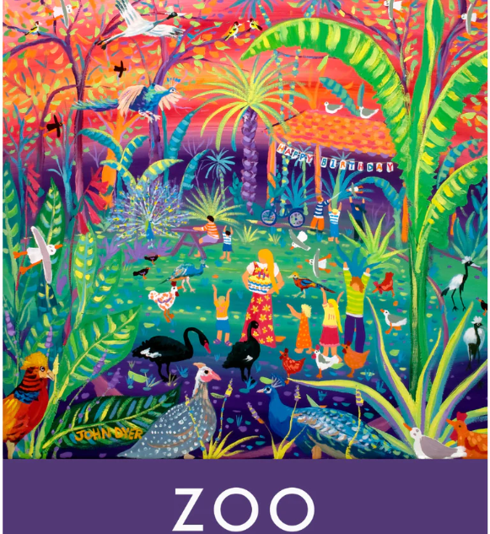
Week 6  Africa | Whole School Topic/ How to hide a lion with a visit from local author Helen Stephens
Week 7 | Summer activities based around children’s ideas  Art work for Belford Show
Comments

