At School | At Home
Hold a door open for someone | Help tidy up in your house
Give a friend a compliment | Help your family carry something
Volunteer to help in class | Give your family a hug and tell them you love them
Invite you friends to play with you | Read your sister or brother a story
Make someone laugh – tell them a joke | Leave a happy note for your mum or dad to find
Pick up litter if you see it | Make your sisters or brothers bed
Talk to someone new today | Leave a treat on your neighbours doorstep
Help someone in your class | Make a card for someone
Sharpen the pencils | Help make dinner
Smile at everyone you pass | Say good morning and goodnight to everyone in your home
Draw a picture for someone | Offer to help
Random Act of Kindness Day
Thursday 17th February

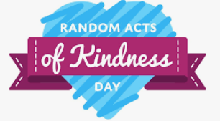Today is Random Act of Kindness day, here are just some of the ways you can ‘Be Kind’

