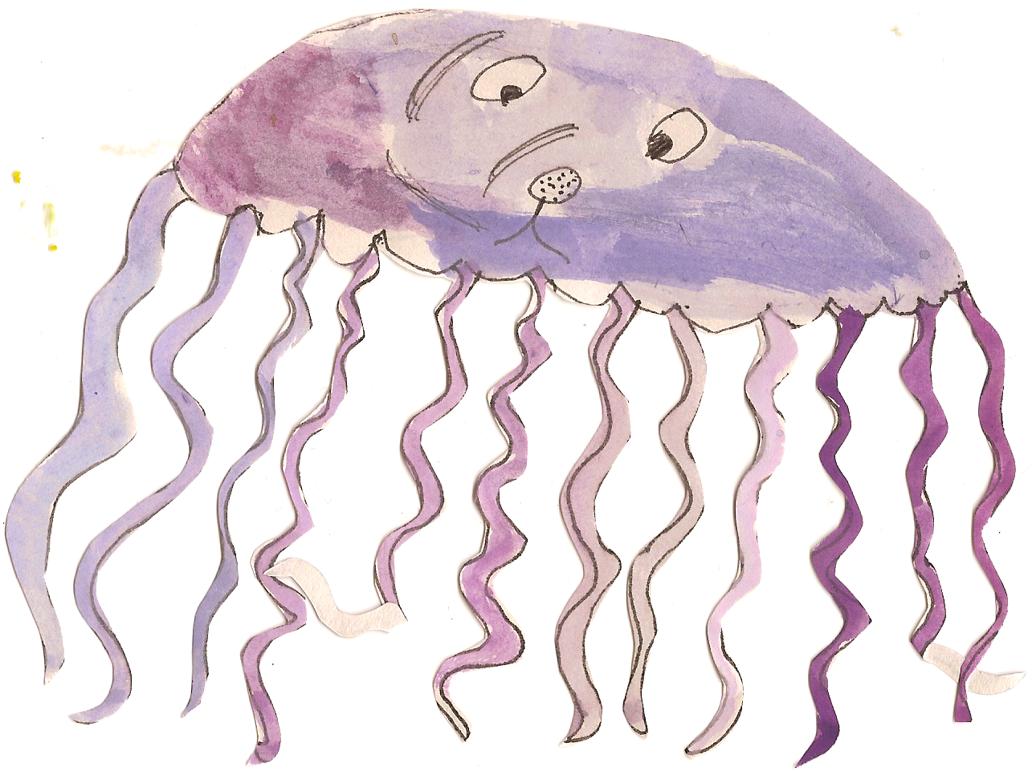

Topic Work
During the summer term, Class 4 will be studying the Victorians as their history topic. We will be looking at the life of Queen Victoria, the extent of the British Empire, what life was like in the Victorian era, as well as the medical and industrial developments which took place and the impact it had on life in Britain.
In Geography, Class 4 will be continuing the study of rivers which was started in the spring term. In addition to looking at how rivers are formed, the children will also look at the impact they have on the landscape and on towns and cities, and the impact humans have on rivers both positive and negative. This will involve some fieldwork where the children will get hands on experience of studying physical parts of the landscape.
We will also be completing a local study of Belford and this will be linked to the history topic, looking at what Belford was like in the Victorian times compared to now, the surrounding landscape and the structure of the village.
Science Work
The summer term will see the children using skills linked to planning investigations, making fair tests, making and recording observations and analysing their findings in order to make conclusions, more independently.
Linked to the history topic, we will be looking at Darwin and his ideas of inheritance and adaptation, and how this impacted on science and the people of his time. We will also look at how to classify plants and animals using scientific ideas and thinking. The children will be collecting their own examples of flora and fauna and they will be creating their own classification criteria to help them sort their samples.
The final topic will be revisiting electricity, reminding the children about circuits and how they work, drawing circuits and altering them to change the output/effect.


Literacy
During the summer term we will be finishing Stormbreaker by Anthony Horowitz, and using it to write a range of types of writing. In addition to this, we will be looking at Dickens’ story of Oliver Twist which will again be used to stimulate writing activities. The children will continue to plan, write and redraft extended pieces of work in a variety of genres, both fiction and non-fiction, and they will be expected to up level their writing by using the different types of punctuation, grammar and sentence structure which they will learn in class. Handwriting and spellings will continue to be a focus to help the children present work to a high standard. Please continue to practise spellings each week at home. Details about High Frequency Words and Belford’s spelling policy can be found on the school website. Children each have a spelling book to take home and will be tested every Friday. It is also important to hear your child read at least 3 times a week and to ensure they have their reading books in school every day.
PE and Swimming
Class 4 will have PE and swimming on a Friday. In addition they will also have PE every Tuesday for the first half of the term, which will involve rugby. They will need to bring their P.E. kit including jogging bottoms and a warm top. Friday at the Swan Centre- children to come into school in jogging bottoms and trainers, and are to bring a swimming costume to change into.

Homework
Children will receive homework linked to work they have been doing in class that week. Homework will go out on a Wednesday and should be returned no later than Tuesday the following week. Belford’s calculation policy can be found on the school website.
Numeracy
The children continue to do well in maths. In the summer term, we will be focusing on geometry – looking at shapes and their properties, co-ordinates, translating shapes and reflecting them. In addition to this, the children will be learning about finding area, perimeter and volume of shapes and will be converting between measures. Reasoning and problem solving will be used to extend and challenge the children by encouraging them to use and apply the skills and knowledge they have gained in each topic.
Focus in maths for year 6 will also be on revisiting and consolidating all areas of maths in preparation for the SATS.

