Autumn Term 2022
Issue 1 21.10.22
Congratulations and Thank You!  Congratulations to Beatrice who won the Halloween raffle today.  Thank you to all the children who bought a ticket. The raffle and halloween party tickets have raised £315 for our school fund. |  |  | Yoga  The children in class 1 and 2 have really enjoyed their weekly yoga sessions with Rhiannon from Yogibairns.
Safeguarding Updates:
All staff attended safeguarding training on Monday 5th September. Every member of staff now has a clear understanding of their safeguarding responsibilities and is aware of the updated DfE document: Keeping Children Safe in Education 2022 (statutory guidance produced for schools and colleges).

KS2 Play Leaders:  This half term, a group of class 4 children have volunteered to be play leaders. They are beginning to teach our younger children new games and activities at playtime. |  | Harvest Food Donations  Thank you very much to everyone who donated tinned and dry food today. We will be taking the food to our local food bank which supports local residents.
Harvest Assembly and Dates for Christmas Productions
It was lovely to have our first whole school family assembly this morning and great that so many family members could attend.
We were very proud of the children and are now looking forward to our Christmas productions.
Please save the following dates in your diary:
Wednesday 14th December at 9.30am: Class 2 Christmas Play
Wednesday 14th December at 2.00pm and 6pm: Class 3 and 4 Christmas Play
Thursday 15th December at 9.15am: Reception and Nursery Nativity
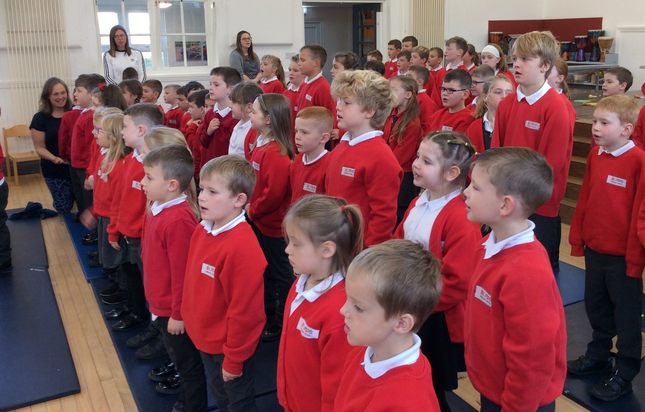
Bell View Food Recycling
Bell View are continuing to offer local families the opportunity to receive free frozen homemade meals. The meals are cooked on site and use fresh produce. The offer is for everyone and I know that they would be delighted if more people were benefiting from their service. For further details please contact Bell View using the following email address:

bellviewservices@hotmail.com

Class 4 STEM Workshop
On Tuesday 11th October, class 4 took part in a Sea Cadets Marine Engineering STEM Workshop. The aim of the session was to inspire the children to engage with STEM subjects and also highlight career opportunities in Marine Engineering.
Similar workshops have been delivered to 60,000 students Nationwide.
The workshop provided a great learning experience. The children discovered the science of buoyancy, explaining why some objects float in a fluid while others sink.
STEM = Science, Technology, Engineering and Mathematics

Dates for the Diary
Monday 31st November: Back to School
Tuesday 1st November 9.30am: Class 1 Halloween Stay and Play
Tuesday 1st November 5 -6.30pm: Halloween Party
Wednesday 2nd November: Class 2 Multi-Skills Festival
Monday 7th November 1-6pm : Class 2 Parent Consultation Meetings
Tuesday 8th November 1-6pm : Class 3 Parent Consultation Meetings
Wednesday 9th November: Whole School Cinema Visit
Thursday 10th November 1-6pm: Class 4 Parent Consultation Meetings
Monday 14th November 1-4pm: Class 1 Parent Consultation Meetings
Wednesday 16th November 6pm : Year 5 and 6 Parents SATs Meeting
Wednesday 30th November: Class 3 Road Safety Workshop
Friday 2nd December 3.30 – 5pm : PTA Movie Night for Reception to Year 6
Wednesday 7th December 4pm : PTA Family Bingo
Tuesday 13th December: Whole School Pantomime Visit

