Theme: All about me Term: Autumn 1 Year: 2021
Key Knowledge and Skills |  | Key Questions
To be able to know their family name and to give each family member a name.  To be able to describe their appearance and talk about how they are the same or different to their friends’ appearances.  To be able to know what part of their body they use to hear, touch, smell and look with.  To attempt to begin to take care of their own personal hygiene: blowing nose, wiping bottom and washing hands thoroughly.  To be able to name four emotions and begin to understand that we can all feel these emotions at some time. To learn how to self regulate with support from an adult. |  | Why do you think our names are different?  What colour is…Who has…How are you the same as…How are you different to…  Can you show me what you hear/taste/smell/touch/see with. How can we sort these sounds/objects/materials?  Why should we not pick our noses? What do you think will happen next…? Have you any worries about wiping your bottom?  How are you feeling today? Can you tell me more about how that feels? What ccan we do to self regulate/make you feel better?
Key Vocabulary |  | Key Content
First name  Surname  Family name  Mum, Dad, sister, brother, grandma, grandpa, aunty, uncle  Achievements  Effort  Try  Succeed , difficult, perseverence  Tall, taller than, short, shorter than  Colours  Name different body parts:eyes, ears, nose, mouth, head, shoulders,arms etc  Sound, noise, loud, quiet, long, short  Tongue, taste buds, sweet, salty, sour, unami  Hot,cold, freezing |  | Names are very important:  https://www.bbc.co.uk/bitesize/topics/zh3nmfr/articles/zmw6qp3  Achievements: Knowing that we work hard to achieve something can make ourselves and others happy  https://www.bbc.co.uk/bitesize/topics/zh3nmfr/articles/zvngf4j  Changing from toddlers into young children: nappies and accidents  https://www.youtube.com/watch?v=m6DkUw4JL54  Wiping bottoms: practise with balloons  https://www.youtube.com/watch?v=Dvcru3o-JqY
Links to Previous Learning:  Nursery know they have names and most can recognise them. They can say they have a mum and dad.  Some chn can touch named body parts but not all. Well Comm has highlighted that some of these chn do not know what they see/hear with.  Chn are aware that they have to wash hands often but they cannot care for their personal hygiene independently.  The children know happy, sad and angry emotions. |  | Cross Curricular Links: 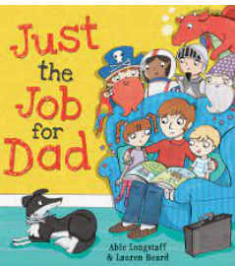 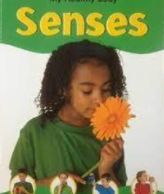 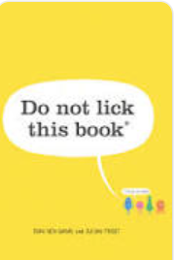 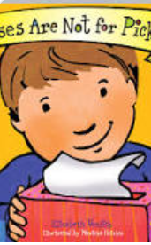 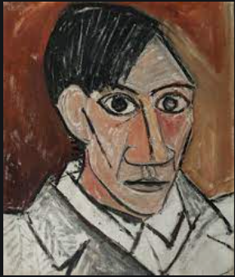  Quality Texts Linked to Theme 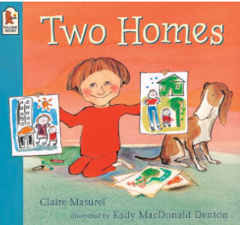 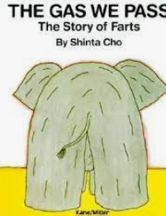 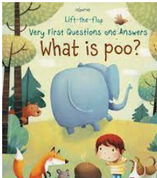
Children working towards expected | Children who have achieved expected |  | Children working at greater depth

Week 1  All about me balloon | Study Pablo Picaso and discuss a self portrait., using a dark line to sketch first.Ask chn questions so that they can describe the teacher. Then use mirrors and describe their hair, eyes, nose etc. Model how to draw a self-portrait, hold pencil and colour in.  Names are important: watch and discuss surnames. Clap out syllabelles singing song.  EAD/Science | Play a game of guess who-hair colour, eyes etc. Can children take lead and ask own questions?  Read Two Homes: discuss  Alex has two homes, two bedrooms, and two toothbrushes – one each with Daddy, and one each with Mummy. children to understand what happens when parents live separately. Can chn name other family members: aunt/granma etc  Complete my family balloon.  History | Reading Castle: Discuss favourite books , genres , characters etc. Can chn name their favourite book and talk about why they like that book?  Model how to draw a picture of book on my favourite book balloon.  Science/ C&L | Read just the job for Dad. Discuss the different jobs and what aspirations the chn have.  Model drawing when I grow up balloon.  History
Week 2 Body parts and senses | Sing Heads shoulders knees and toes. Together model drawing around our bodies with own finger. Head to toe. Have a large body drawn and cut out. Can the chn work together to build the body correctly? Model how to draw a body.Chn to draw themselves in floorbook: titled our school family? Science | Sight  Read senses pg 6-9 and discuss which part of their body they use to see with. Have a basket of objects and randomly pick some out eyes open, eyes closed etc.  Model using eyes to look at a toy and then paint it. Using eyes to pick correct colours.  EAD/Science | Hearing  Read senses pg 10-13 discuss. Model playing instruments with hands covering ears, uncovered, eyes opened , eyes closed etc.  Play guess what instrument is making the sound behind a curtain. Can the chn then take it in turns to be the teacher? Discuss loud, quiet, long and short sounds  Music/ Science | Taste  Read sense pg14-15  https://www.youtube.com/watch?v=C4rdqXXzPGU  Learning how the tongue works and different flavours.  Class investigation: have a variety of different flavoured crisps in bowls. Each chd to taste each one, can they guess the flavour? What does it smell like, feel like, crunch it etc. Which is your favourite. Make a bar graph and discuss most/least popular.
Week 3 Senses, balancing and sleep | Smell  Senses Pg16-17  Model how to close mouth, breathe through nose. This is how we smell. Discuss nice/horrible smells. Investigate using flowers, orange, toothpaste and tuna hidden in bags. Can chn make a reasonable guess of what the smell is and reminds them of? Science | Touch  Senses/pain pg 18-21  Have a basket of objects to pass around and use words to describe how they feel not look! Apple, pine cone, glue stick, brick, teddy  PD/Science | Touch  What do you now that is hot, cold or frozen? Chn to wash hands in cold, warm then water with ice cubes in. can they name the temperatures correctly.  Science | Balancing-how different parts of the body work together.  In hall with balls. Model tapping around room. Chn to do. What parts of your body did you use? Repeat this time with eyes closed. Why was this tricky?  Lie on balance boards, hands on board, how can you push or pull. What parts of your body are you using? Can you find a different way to travel using different body parts?  PD
Week 4 Washing hands and blowing noses. | What do you know about germs? Chn mark make in scrap book. Read Do not lick this book and discuss what a micro is and how /where it travels/ what damage can it do and how to get rid of them. Mark make what they have learnt in scrap book. Science | Washing hands- Bread experiment.  Control/dirty hands/clean hands in clear bags. What do you think is going to happen.  Science/history | Visit from nurse with glow machine to experiment how to wash hands properly.  Science/PD | Noses are not for picking book. Read book and model how to blow and wipe nose, toss in bin and wash hands.  Chn then mark make in scrap book to show learning and photos.  Science/PD
Week 5 Wiping bottoms | Read what is poo and discuss. Go into hall and use OT body awareness for preparing to wipe bottoms. | Read the gas we pass and discuss. Go into hall and use OT bodyawareness for preparing to wipe bottoms. | Watch and discuss how we have grown up and don’t need to wear nappies anymore.  https://www.youtube.com/watch?v=m6DkUw4JL54  Discuss other skills that chn have learnt since being a baby: walking, jumping, drinking from a cup etc. | Go into hall and use OT body awareness for preparing to wipe bottoms.
Week 6 Feelings | Read colour monster and name different emotions: discuss | Watch link and guess what emotion she is feeling. Link to book.  https://www.youtube.com/watch?v=dOkyKyVFnSs | Cutting out monsters- scissor skills and tool safety | Making monster college using different materials-using spatula and learning to soread pva glue.
Week 7  Self regulation | Read yellow monster and discuss happiness, smiling, laughter- fill a jar with yellow objects. | Read blue monster and discuss sadness and what tears are, feelong alone. Fill a jar wih bue objects. How can we make ourselves feel better?  Make someone laugh, listen to music, play a game, drink water, hug | Read red monster anger-makes you stomp, shout and hit out, grumpy.  Self regulate: walk away, cry, have quiet time with a book, lie on your bed, play with a friend or a football, breathe slowly | Read fear-alone, small, scared  Self regulate-tell a friend, talk it out.Hug helps too.  Discuss green as calm : breathing , ready to learn , focused
Comments

