Autumn Term 2020
Issue 1 16.09.2020
Welcome back to school EVERYONE!  The children have now been back in school for 7 days and we are delighted with their positive attitudes and approaches to our new routines and procedures. They are washing their hands regularly throughout the day and remaining in their class bubbles for lessons, play and lunchtime. The children are showing great determination with their learning and have already produced some lovely pieces of work. Well done to the children, parents and staff! |  | Staff Training  September 1st : Safeguarding Training  September 2nd : First Aid Training  September 14th (twilight) : Commando Joe’s Training
Safeguarding Updates:
The school safeguarding policy has been updated in response to Keeping Children Safe in Education 2020 (statutory guidance produced for schools and colleges).
The policy and government guidance can be found on the school website:
http://www.belfordprimary.northumberland.sch.uk/website/safeguarding_children/100026

Commando Joe’s  New to school this year is an exciting character building programme called Commando Joe’s. This is a whole school approach aimed at developing positive character traits such as resilience, confidence, empathy and independence. It will also teach the children how to keep themselves physically and mentally healthy.  Each session is presented as a ‘mission’ created by one of many inspirational people from the past and present.  Follow the link below for further details:  https://commandojoes.co.uk/about/ | 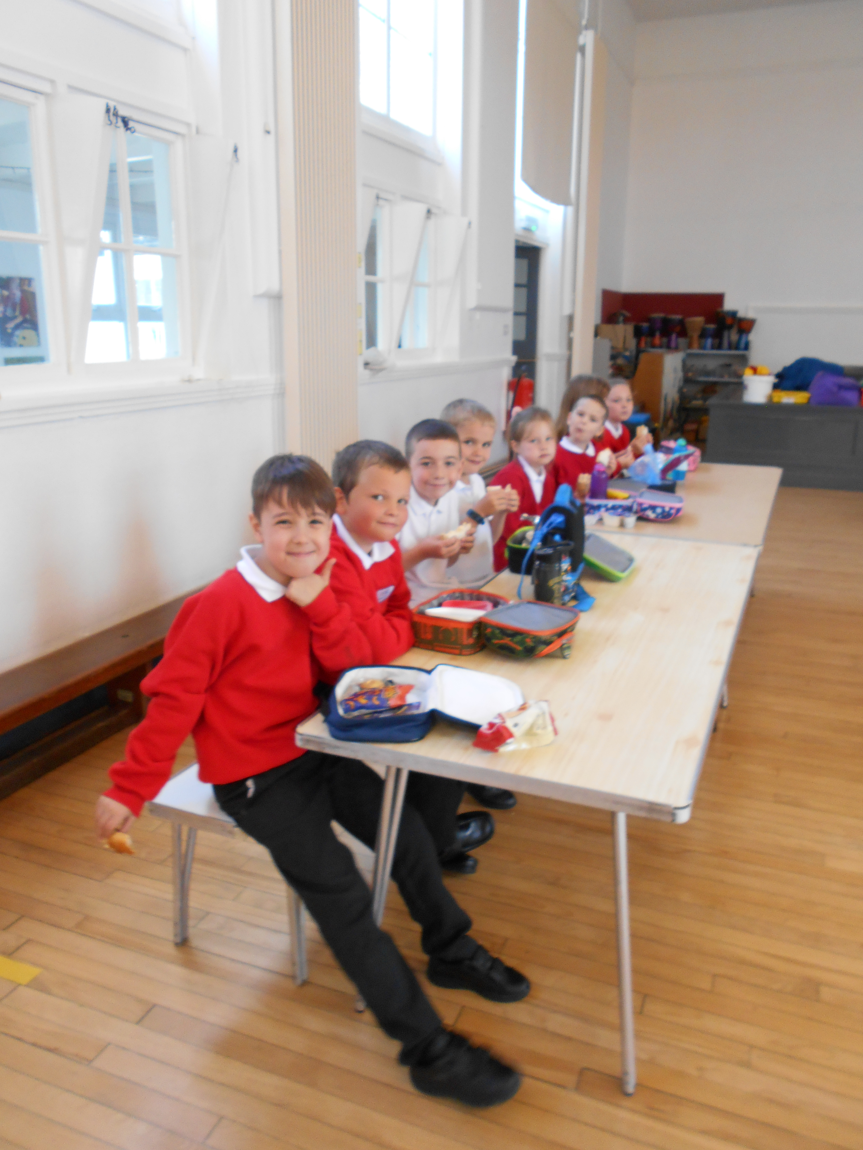  Class 3 enjoying lunchtime. |  | Lunchtime  Our staggered lunchtimes are going well and the children are now familiar with the routines involved.  Many thanks to our super staff team who are working additional time over lunch to ensure that our class bubbles are kept separate, reducing any risk of infection.  Our school garden has provided us with an abundance of apples, raspberries and salad vegetables this year, all of which Mrs Vallance has incorporated into our school lunches. The raspberry muffins were particularly delicious!
Bonjour!
The children across school will be learning French at different points throughout the year as part of our Modern Foreign Languages curriculum.
We believe that learning an additional language provides a valuable educational, social and cultural experience for our pupils.
Details of the topics we will be covering can be found on the school website, under the Curriculum tab:
http://www.belfordprimary.northumberland.sch.uk
Breakfast Club
It has been lovely to see many of our families making use of our new Breakfast Club. The children are enjoying a fun start to their day and seem to be really enjoying their breakfasts!
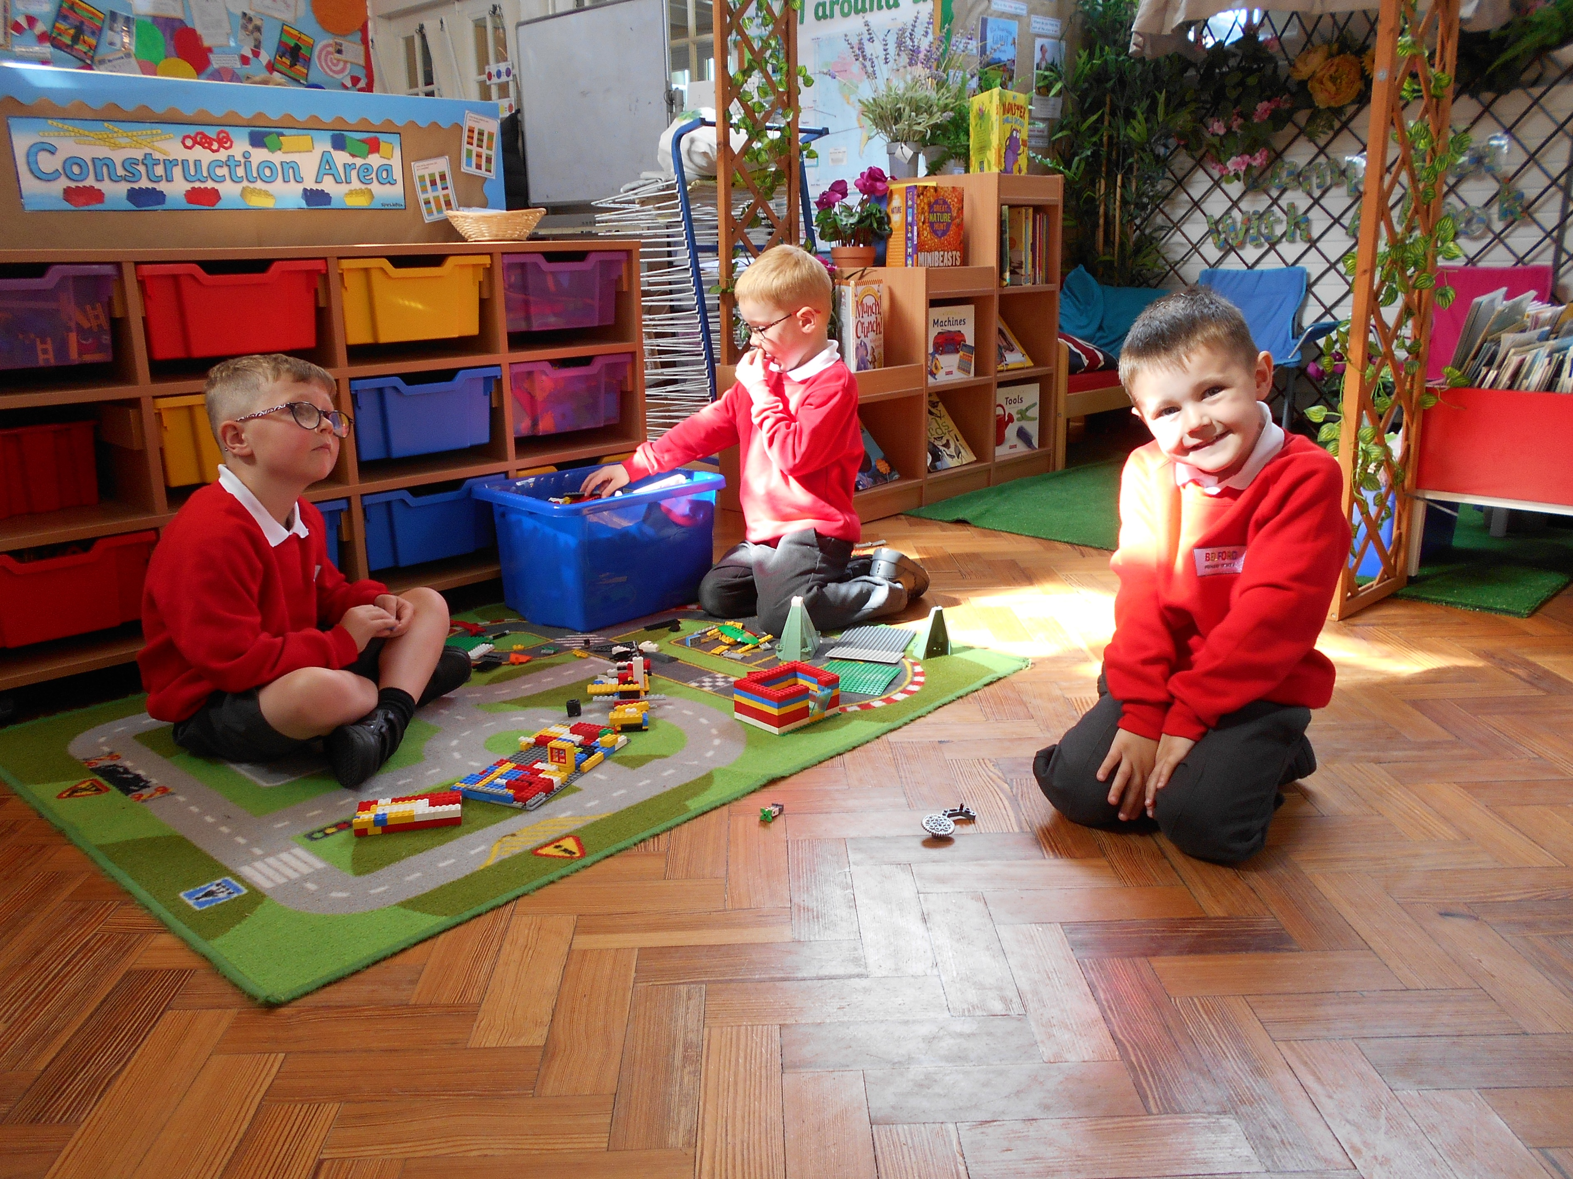  Fun in Class 2 | Dates for the Diary:  October Half Term: Week beginning 26th October  Christmas Holiday: Break up Friday 18thDecember and back to school Monday 4th January.
 | Social Distancing  We appreciate that it’s not always easy, but  please can all adults dropping off and picking up children, ensure that they are observing social distancing. Thank you |  | School Lunch Money and Office Correspondence Please could school lunch money be put in a sealed envelope with your child’s name and class written on the front. There will be a labelled box outside the front door for parents to put this in from tomorrow. Any letters or information for the office should be put in this box too please. Many thanks.

