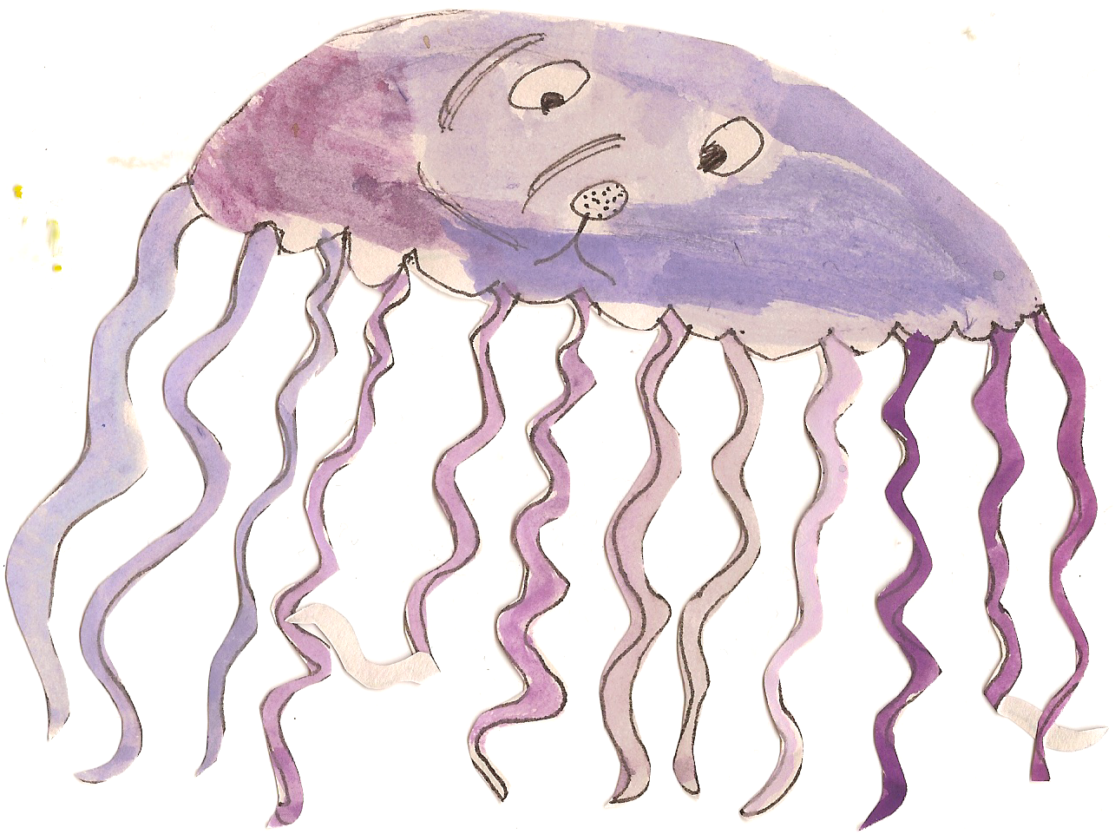

**Science Work**

Children will be learning to:

* identify how sounds are made, associating some of them with something vibrating
* recognise that vibrations from sounds travel through a medium to the ear
* find patterns between the pitch of a sound and features of the object that produced it
* find patterns between the volume of a sound and the strength of the vibrations that produced it
* recognise that sounds get fainter as the distance from the sound source increases.

**Topic Work**

Class Three will be learning all about ‘World War 2’. In our topic sessions the children will be learning about:

* Why World War 2 began.
* The countries and leaders involved in World War 2
* The Blitz
* Rationing
* Evacuation
* The Holocaust
* The end of World War 2

**Maths**

This term we will be covering:

* Money
* Time
* Statistics
* Properties of shape
* Position and direction

We will also continue practising written and mental methods for the four operations.

**English**

This half term we are focussing on the story of Rose Blanche in Power of Reading. The story is about a young girl who is a prisoner at a concentration camp. The children will be planning, drafting and writing extended pieces of writing in a variety of genres based around the book. We are mainly going to focus on emotive writing. Producing letters, diary entries and a balanced argument. We will also be practising our grammar and punctuation and including these in our independent writing.

Please continue to practise spellings each week at home. Children each have a spelling book to take home and will be tested every Friday.

**PE and Swimming**

Class Three will have PE twice a week.

**Thursday Outdoors-** Children to bring shorts, white t-shirt, jogging bottoms, a warm jumper and trainers. This half term a NUFC coach will be teaching the children team games.

**Friday at the Swan Centre**- children to come into school in jogging bottoms and trainers, and bring a swimming costume to change into.

**Homework**

Children will receive homework linked to work they have been doing in class that week.

Homework will go out on a Wednesday and should be returned by Tuesday the following week.