,

Dear Children,
I hope this letter finds you safe and well.
You have done some amazing home learning with your families this week and your windows are cheering up the village. I’ve spotted some beautiful sunshine pictures and rainbows as I’ve been driving home each day. Thank you and well done!

Today is the last day of the Spring term, with the Easter holiday starting tomorrow for two weeks. We won't be uploading any new learning resources on Facebook or the school website over the holiday. It’s time to relax and have fun with your families.

There are Easter activities on the school website though if you fancy doing some craft and art activities.
Also, if you’d like to decorate a boiled egg over Easter, we’d love to see your creations. Just ask an adult to put a photo on the school Facebook page. I will look at these on Easter Monday and send a message to everyone who has taken part.

Do you enjoy photography? If so, take part in our competition. All you need to do is take a photograph and post it on Facebook. I've got one to share today that I took earlier in the week, whilst on a walk with my family.
Could it be the Loch Ness monster? Class 3 know all about this!
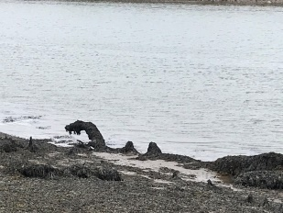

A final activity that you may like to do, is to draw or paint a Spring picture and post it through the school letter box over Easter. We will laminate these when we are back in school and then deliver them to people in the village to cheer them up.

Take care everyone, we miss you all, but are so happy that you are keeping safe.

Mrs Rainey and all the staff at Belford Primary School

