Autumn Term 2019
Issue 3 25.10.19
Hedgehog Excitement in Class 1
Class 1 children welcomed a very spiky visitor into their classroom on Monday; a small and very friendly hedgehog! Kay, a volunteer from the Swan Trust, came to talk to the children about how to have a hedgehog friendly garden. The children listened beautifully and have created their very own hedgehog friendly space and nest in their outdoor area.
Class 3 Visit to The Sill, Hexham
On Thursday 17th October, class 3 children enjoyed a day at The Sill in Hexham. They learnt how to be an archaeologist and met a Stone Age man! The children were able to handle Stone Age artefacts, create their very own cave art, grind flour with stones and learnt about important archaeological sites in the North East.

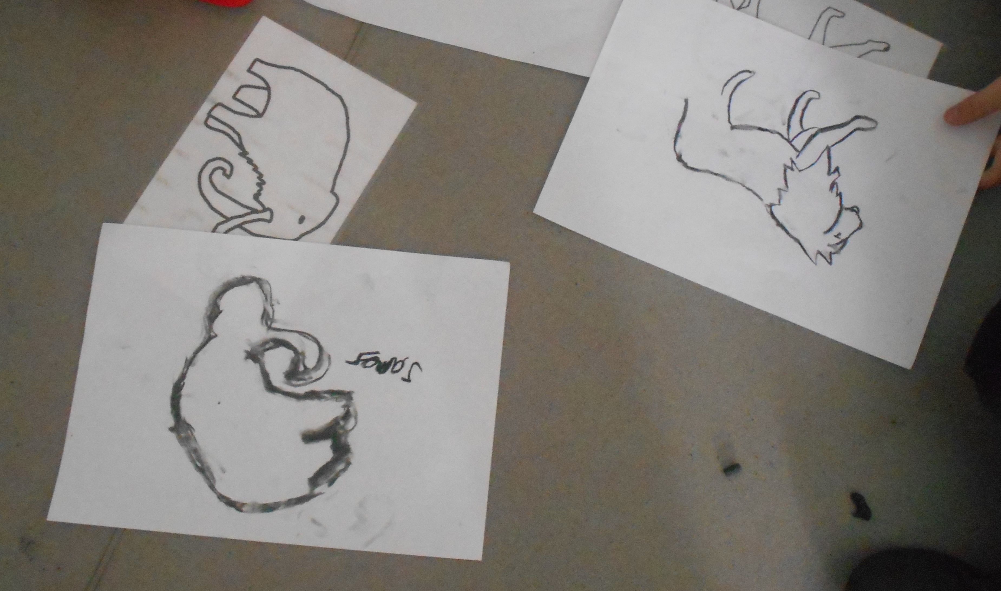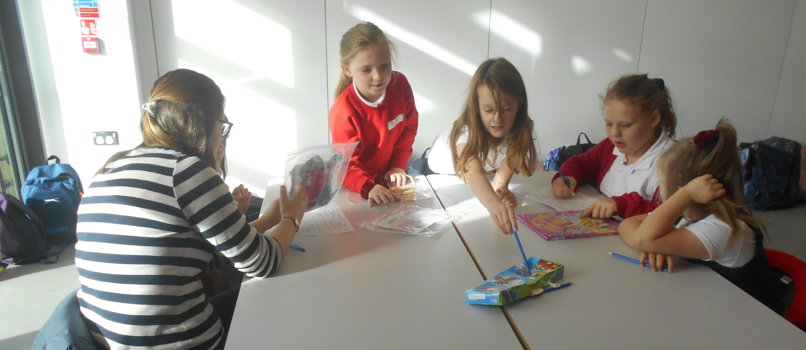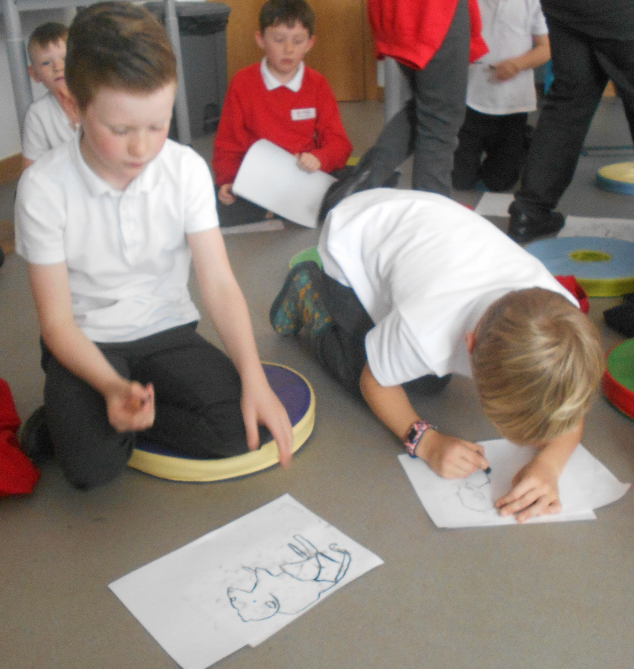

Class 1 Stay and Play  Thank you to all the parents and family members who came to stay and play with the children in class 1 this morning. Great fun was had by all! | Parent Consultation Evening  Thank you to all the parents and carers that came along to our parent consulation evening on Wednesday this week. It was lovely to see so many of you in school. We hope you found the evening informative and useful.
Class 3 Family Assembly  Our thanks to Class 3 and Mrs Ferguson for their wonderful assembly this morning. They have certainly learnt an awful lot about the Stone Age. The children shared their knowledge with confidence and did some fantastic singing. Well done! | Dates for the diary:  Monday 4th November  Training Day for Staff  Tuesday 5th November  Return to school for children  Wednesday 6th -8th November  Year 6 residential to Kielder  Monday 11th November  Whole School and Family Remembrance Service. St Mary’s Church, Belford.  10.30-11.10am.  Parents, carers and grandparents are very welcome to join us in the church at 10.30am.  Wednesday 20th November  Drop-in session for Operation Encompass.  3-4pm  Wednesday 11th December  Class 3 and 4 Christmas Production.  2pm in the school hall.  All are welcome to come and watch. |  | Dates continued:  Friday 13th December  Class 1 and 2 Nativity.  9.30am  All are welcome to come and watch.  Tuesday 17th December  Pantomime day  Wednesday 18th December  Class 4 visit to  Thursday 19th December  Christmas Dinner and Christmas Jumper Day (this has moved from the 18th).  Friday 20th December  Christmas Carol Service  St Mary’s Church 9.30-10.30am
Class 4 Recorders
Class 4 continue to enjoy their recorder lessons each Tuesday afternoon.
They will be performing Christmas songs at the Bell View Day Care Centre on Monday 16th December.
A Thank You from Bell View
We received a letter this week from the Bell View Day Care Centre, thanking us for the Harvest Festival food that was very kindly donated by our families and staff.
The clients at the centre were delighted that we had thought of them and took the produce home with them.
The Food Bank were also grateful for our contributions. Food was taken to the collection point at the Co-op in Belford and to Sainsburys in Alnwick.

