Theme: Jungle Adventure Term: Summer 2 Year: 2022
Key Knowledge and Skills |  | Key Questions
To be able to name a few different animals from the jungle  To be able to use descriptive language to describe the features of an animal  To know about different habitats of animals  To be able to comment on images from the Africa/United Kingdom and compare the differences  To be able to follow instructions about how o make a fruit salad  To make predictions about what will change/happen to jelly  To be able to listen to each others responses and add their opinions  To know that facts can be found in non fiction books and on the internet  To compare differences between pictures in books  To combine various materials together to create a planned effect  To know that a recipe has to be followed accurately |  | Can you name some of the different animals found in Africa? Tell me one that begins with t /s  How can you describe their skin, colours  How are these two pictures the same/different  What can you tell me about this image? How do you know that?  What would happen if I put this in the cupboard/fridge/freezer…How could I change it back too…  Will I find a character in this information book? What will I be learning about?
Key Vocabulary |  | Key Content
Africa, Continent, Equator, Countries, Ocean, climate  African wildlife, jungle, habitat, rainforest, hot, cool, water, rivers, wet lands thick dense trees, green firests, eco-system, vehicles, homes, shops  Spider monkey, long tailed manecan, orangutan, Sloth, armadillo, anteater, crocodile, snakes,  Swing, slide, side to side, jump,bend,spread,flap,dance,attract mates, slowly, sweeping,squat,climb,tall,short,spring, balance, scales,armour, hatch,eggs,hunt,prey,wallets,belts,purse,extinct,underground, burrow,tunnel,protect,predators  Bark,fruit,insects,berries,leaves,intelligent,babies  Bus canoe  Earth, world,over flow, water, oceans,electricity, litter,wrapper, compost, recycle |  | The children will learn what a jungle is and where they are found on earth. They will use a globe to recognise continents, oceans and the equator line. We will use the equator line to identify where jungles can be found.  We will learn what features make up a jungle, what animals live there and be able to describe them.  We will study Kenya, homes, dance,food and traditions. We will compare an African village to Belford village.  We will learn how to reduce, reuse and recycle so that we can help to save these environments that we have learnt about.
Links to Previous Learning:  The children have read the zoo and can name common animals found there. |  | Cross Curricular Links: https://www.bbc.co.uk/iplayer/episode/p06tmrxr/andys-wild-workouts-series-1-6-rainforests  https://www.youtube.com/watch?v=ZKUUKOdIpOA Crocodile facts  https://www.youtube.com/watch?v=OPt0nFem5SY Armidelo facts  https://www.youtube.com/watch?v=IkOlwbjUofI Alternative African instruments  Text  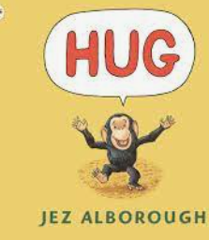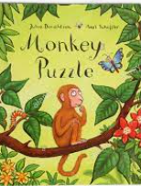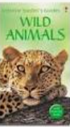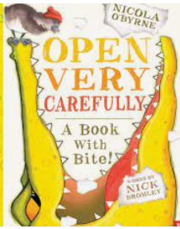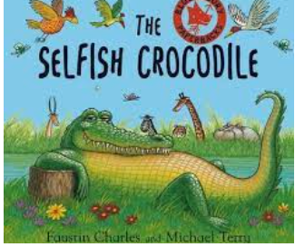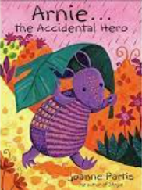  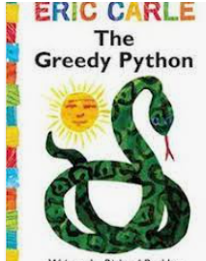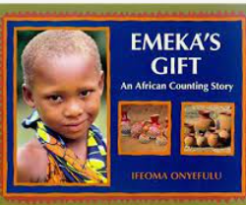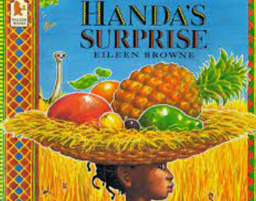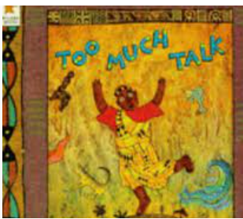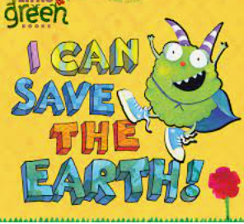
Children working towards expected | Children who have achieved expected |  | Children working at greater depth

Week 1  Environment | Set up carpet area with camouflague nets, jungle seats, globe, monkey puzzle book. New passenger on our jungle bus: monkey. Read Monkey puzzle, discuss animal noises.  Read letter from monkey | Where is the jungle on a globe? Equator , Continents, Oceans  Make paper plates as globe to show continenets and oceans. Red equator line to show hottest continents.  Discuss pp |  | Learn new song: intonation, rhythm and pitch  https://www.youtube.com/watch?v=plvY0quSyJg ‘Walking Through the Jungle’ Barfoot Books  EAD/C&L | Environment and sounds:  https://www.youtube.com/watch?v=GvxJWsr7uao Sounds  Environment: Compare to Forest School  https://wwf.panda.org/discover/our_focus/forests_practice/importance_forests/tropical_rainforest/  Did you see shops, vehicles, homes?
Week 2  Orangantan manecan parrot | In hall: movement and dance like animals  https://www.bbc.co.uk/iplayer/episode/p06tmrxr/andys-wild-workouts-series-1-6-rainforests  Recall facts of orangutan and Manecan parrots  PD/EAD/C&L | Read hug: picture book with no words: chn to develop meaning and understanding from pictures. Discuss how emotions and feelings differ from each page.  Who can/not we hug. Why hug. Who do you feel safe with. Stranger danger.  PSED/Literacy/C&L |  | Spider Monkey facts  https://kidsanimalsfacts.com/spider-monkey-facts-for-kids/  Watch video, discuss features, model how to draw around template and cut out. Paint with water colours . When dry add lines with pencil to show textures.  EAD/C&L/PD | Read sections from Wild Animals information book:  Discuss features of writing a description.  Recall Spider Monkey facts and write a description of them for display  LA Draw and label  MA Simple sentence  HA Openers and conjunctions
Week 3  Nile Crocodiles | Read open very carefully book/a book with a bite. (Letters, words,print)  What do we know about crocodiles? Chn mark make in scrap book together.  UTW/L/C&L/EAD |  | Crocodile facts  https://www.youtube.com/watch?v=ZKUUKOdIpOA  Recall facts. Model how to paint crocodile usng water colours different shades of green. Then ripping college paper and sticking on. Discuss camouflage.  UTW/EAD/C&L | Model writing description of a crocodile.  LA Label  MA Simple sentences  HA List of facts | Read the selfish crocodile: what does selfish mean: label a picture with new vocabulary.  Why did the crocodile make the right choices?  Discuss tooth hygiene  PD/PSED/C&L
Week 4  Armadillo | Read Arnie the accidental hero: discuss timid and fear. Why did he want to protect his friends?  How to solve problems, who to ask for support .  PSED/PD/C&L |  | Armadillo facts:  https://www.youtube.com/watch?v=OPt0nFem5SY  Discuss and model how to write a description/fact sheet. | Armadillo art: using different shades and dots.  Similar to this  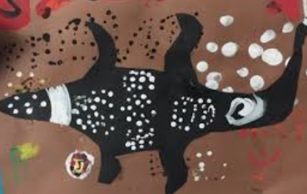 | Transient art making small landscapes with atelia. Using a photgraphs of jungle animals.  EAD/C&L
Week 5 Snakes | Read the greedy pythan:  Science activity | Snake facts:  https://study.com/academy/lesson/rainforest-snakes-facts-lesson-for-kids.html  Recall and discuss shedding , cold blooded and poisonous. HA to create fact sheet. |  | Snake printing.  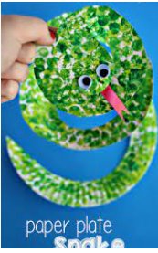 | Create back drop for Jungle display:  Study leaves, tree prints, nile etc together. What habitats do we need to create?
Week 6  Africa | Where is Africa. Locate Nigeria. Read Emekas gift and discuss similarities /differences to to his/our lives. Toys, clothes, skin,markets/shops/brushes/jewlerrymusical instruments/water pots/water. Paint flag of Nigeria.  Geography/EAD | African music.  Discover African misoc powerpoint. Listen to styles of music and learn how to play a drum and do an African dance.  https://www.youtube.com/watch?v=IkOlwbjUofI Discuss alternative instruments  Geography/EAD |  | African necklaces: Emekas gift book  Discuss bright colours and patterns. Model making one from pasta, paint and string.  Geography/EAD | Compare African mud huts to houses in Belford-use images. Both are villages.  Geography.
Week 7 | Read Handas Surprise and sample African fruits:mango,pineapple,passion fruit,avocado,orange, guava,banana. Likes/dislikes.  PD/PSED | Read African Folk Tale and discuss what folktales are.  Look at illustrations in details, colours and shades. Chn to represent their own ideas from print.  Geography/Kiteracy/EAD |  | I can save the earth creative days : linked to topic  Chn to be aware of the small changes that we can make to help to protect the world we live in.  Science/UTW
Comments

