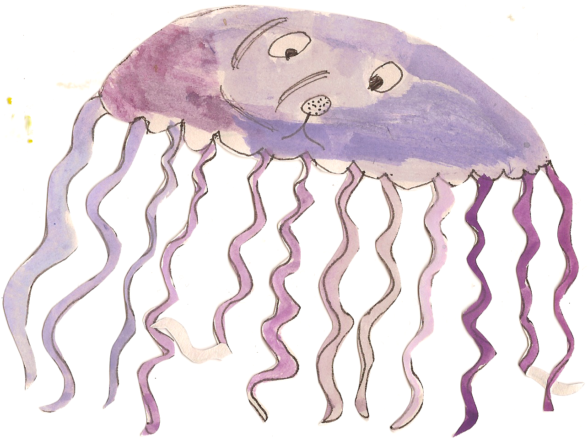

**Our topic this Term will be: Why do ladybirds have spots?**

**Personal Social and Emotional Development**

Watch video footage of ants- discuss working together as a team to create obstacle course-keep play going, resolve conflicts.

Philosophy for Children-A group of bees have seen a child squash another bee? What should they do?

**Communication and Language**

Learn action poems-There’s a worm at the bottom of my garden, how does a butterfly go and ladybird ladybird-Two channelled attention.

Why do ladybirds have spots? - making mind maps and asking ‘how’ and ‘why’ questions.

Making spider webs and following instructions to peg spiders on- understanding of prepositions and following a two part instruction.



**Numeracy**

Mini beast safari- finding beasts and counting them all-using language of addition.

Making large butterflies, using 2d shapes to create symmetrical patterns-interest in shapes, naming properties, halving and doubling quantities

**Physical Development and Health Care**

Trip to fire station-understanding how to stay safe without support of an adult.

Digging up worms and making wormery- gross motor skills.

Weekly football sessions.

Weekly swimming sessions.

Taking care of our teeth- show an understanding of healthy practises.

**Understanding the World**

Mini beast visit- comparing different habitats-talking about observations, similarities/differences.

Using simple software to design minibeasts- using appropriate ICT software.

Making a womery- talking about chanhes over time.

Butterfly observatory- observing changes from caterpillar to a butterfly.

Collecting leaves and sticks and wrapping in wire to make a bug home. Leave in garden then investigate what happens over time.

**Literacy**

What the lady bird heard’-Julia Donaldson- Recognising rhyming words and repeated refrains, anticipate and recall story.

Creating a story map- ‘The bad tempered ladybird’ by Eric Carle-aware of way stories structures, using vocabulary influenced by books.

‘Diary of a spider’ by Doreen Cronin- writing diary entries-mark making, attempts to write meaningful sentences.

Read Six dinner Sid- Pie Corbett Read and Respond.

Pie Corbett Extended Writing- The hungry caterpillar.

**Expressive Arts and Design**

Making mini beasts using sugar paper, wires and pva glue- joining materials.

Inventing our own mini-beats-using white pebbles and tiles- exploring colour changes.

Creating large 3d spider using tubes and boxes, covering with paper mache and painting- constructs with a purpose in mind, using a variety of materials.

Learn bumble bee song-actions and repetitive phrases.

Painting tree shadows.

Designing a super car- planning, problem solving and joining materials, choosing colours for

a purpose.

Making a dragon puppet- Using a variety of materials.

Make a shield and decorate it with different materials- Using tools safely.

Dragon dust leads trail into the Forest School- Being imaginative.

Find a nest of dragon’s eggs? What shall we do? - Sustained shared thinking.