Theme: Mini-beasts Term: Summer 1 Year: 2024
Key Knowledge and Skills |  | Key Questions
To be able to name a few different mini beasts and be able to identify them.  To be able to use descriptive language to describe the features of a mini beast that they have found.  To know about the life cycle of mini beasts and compare them to others.  To be able to comment on images from the Titanic.  To be able to tell the story of how the Titanic sank.  To make predictions about what materials will float and sink.  To be able to listen to each others responses and add their opinions  To know that facts can be found in non fiction books and on the internet  To compare differences between pictures in books  To combine various materials together to create a planned effect |  | Can you name some of the different mini beasts found in our garden? Tell me one fact about it. How can you describe their skin, colours?  How are these two pictures the same/different  What can you tell me about this image? How do you know that?  What would happen if I put this in the water? Will it float or sink?  Will I find a character in this information book? What will I be learning about?  Why is Florence Nightingale remembered?  What did St George do that was brave?
Key Vocabulary |  | Key Content
Egg, larva,caterpillar, pupa, cocoon, butterfly, metamorphasis  Grow, hatches, sheds skin, moulting, cocoon, chrysalis,  Predators, wings, flight  Queen, Worker, Drones, hive  Wax, jelly, bee bread  Legs, head, thorax, abdomen  Pollen, necter,  Smooth skin, segments, bristles, hairs, muscles, vibrations, burrows, soil, decay, breathe  Slimy, mucas, hard shell  Doubles, two of the same, aphid, insect, feelers, claws, spots, wing cases  Titanic, iceberg, propeller, life boat, life jacket, first,2nd, third class, sink, unsinkable, collision, passengers, survivors  Florence Nightingale, sick, soldiers, dirty, unhygienic, hospital, care, war, red cross, Lady with the Lamp, paramedic  St George, dragon, knight, shield, sword, Patrion St of England |  | The children will learn to name and describe a variety of mini beasts. |They will learn about the different habitats and how to create new living habitats to attract more mini beasts into our garden.  We will learn about the sinking of the Titanic and compare different classes of people. We will investigate materials that sink or float.  We will study Florence Nightingale and compare to how nurses work today.  We will learn about St Georges Day and celebrate with our families.
Links to Previous Learning:  The children have learnt about Space and that environment where no plants grow and no mini beasts live.  We have learnt about homes and what we need to survive: shelter, food and water. |  | Cross Curricular Links:  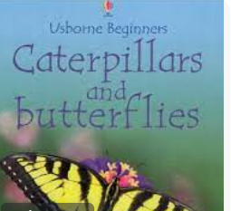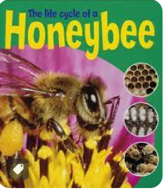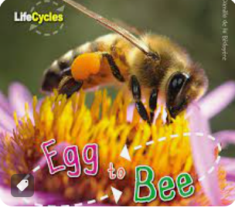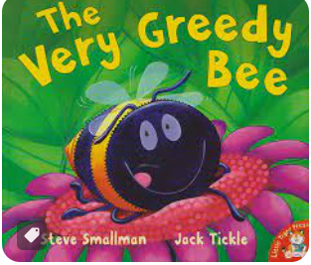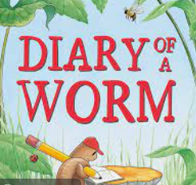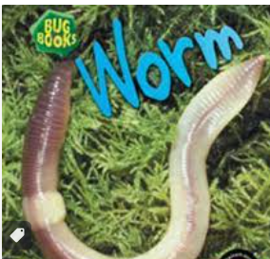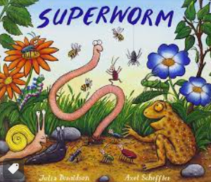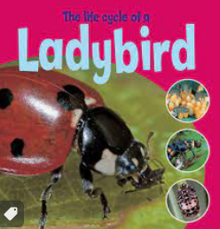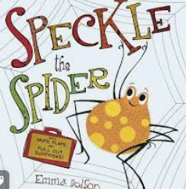
Children working towards expected | Children who have achieved expected |  | Children working at greater depth

Week 1  Caterpillars | Floorbook- What mini-beasts can we name? Do we know any facts about them?  Introduce new topic.  Create an investigation to find out what mini beasts live in our garden.  Chn to gather leaves,grass,twigs, flowers etc. Spread out onto a white shower curtain and roll into a ball. Tie with string. Leave for a few weeks in the garden.  PM-Pie Corbett Hungry Caterpillar planning | Learning about metamorphosis  What does this word mean?  Show the tub of caterpillars. What can you see? How do you think they will change?  Watch https://www.youtube.com/watch?v=3kZD6rlSLUw  Order the life cycle of a caterpillar.  PM-Pie Corbett Hungry Caterpillar planning |  | Caterpillar facts.  Read Caterpillars and Butterlies pg8-15.Mark make facts in floor book.  Make paperchain caterpillars: learning how to use stapler safely.  What can we use to create 16 legs?  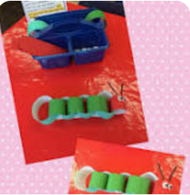  Science/EAD  PM-Pie Corbett Hungry Caterpillar planning | Butterfly facts.  Read Caterpillars and Butterflies pg16-end. Mark make facts in floor book.  Look at photographs of butterflies and discuss symmetry.  Model designing own butterfly. Use paints and small tools to create effect. Chn to create own butterflies, learning how to fold paper in half first.  Maths/EAD  PM-Pie Corbett Hungry Caterpillar planning
Week 2  Bees | What do we know about bees?  Discuss Twinl PP facts and record in floor book.  How can we help bees in our habitat garden?  Plant flowers-box of sprinkle seeds in habitat garden.  Create bee pond  Make a bee hotel with bricks and drill holes into wood-using tools safely.  EAD/Science/PSED | What is pollination?  Watch https://www.youtube.com/watch?v=YFsEOe2rYgY  Science experiment-bees and pollination. |  | Visit from Chain Bridge Honey Farm  Chn will learn facts about bees and the produce that can be made from honey and wax. Discuss life cycle of a bee and link to metamorphosis of a caterpillar.  PSED/Science | Red the very greedy bee book- discuss working as a team and helping others. We need to work together to cut wool for the next task!  Making a bee puppet : layering technique  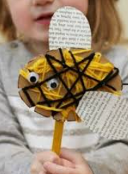  EAD/PD
Week 3  Worms and snails | What is a diary? Discuss  Red the diary of a worm and spend time discussing each event, humor, dangers and feelings. Do worms have feelings? |  | What do we know about earth worms?  Watch https://www.youtube.com/watch?v=l-zc_1vjLnI  Mark make in floor book | What do worms eat?  Read Worm book and discuss.  Make a wormery each to observe changes over time.  Plastic bottles/jars with lids newspaper, soil, sand, black paper, leaes plants,veg peelings, water  Science | Comparing the differences between slugs and snails  www.youtube.com/watch?v=c8ma6vDvXAM  Mark make facts in floorbook  Make snail soup and spread on a clear plastic tub.Add some snails and observe what they do. Can you see their teeth? https://www.youtube.com/watch?v=a0Q-zFLAvPE  Science
Week 4  Ladybug | Watch https://www.youtube.com/watch?v=nl7KqpqoN9o  What facts do you know about a ladybug? How do they stay safe?  Discuss Twinkl PP All about Ladybugs and record facts in floorbook. |  | Read The life cycle of a ladybug: pg6-7 and discuss different body parts of a ladybug.  Model how to make a ladybug from a toilet roll tube. Chn to create their own versions.  EAD/Science | Model drawing a ladybug and writing descriptive sentences.  Science/Literacy | Teach doubles using ladybug spots. Chn to design their own ladybug.  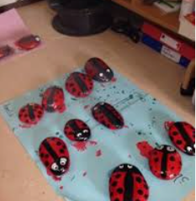  When dry can we sort them by doubles and recall facts?  EAD/Maths
Week 5 spiders | Read the Speckle the Spider and discuss alliteration.  Can we find and name the insects in the book? Can we change the alliteration names. Can we make up any other names for the insects that we have been learning about?  Mr Flip Flap Flea, Big Banana Boat, … Cat, Stunner Suzy.  Literacy/C&L | Watch https://www.youtube.com/watch?v=CTCJwemsQEA to take a closer look at webs.  Make our own webs by wrapping white wool around brown card. Keep for tomorrow.  EAD/Science |  | Watch https://www.youtube.com/watch?v=fSC0jWlSsL4 and discuss facts.  Mark make facts in book.  Make spider to add to web. Revisiting skills from yesterday.  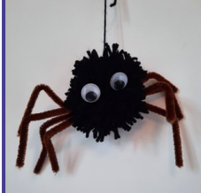  EAD/C&L | Mini-beast Investigation.  Unravel shower curtain and use identifying sheets to name the creatures.  What is the most popular? Which one do you like and why? How are they the same/different?  Using magnifying glasses, tubs and brushes.  Photographs for display.  Science/C&L
Week 6  History to be taught over the weeks. Slot in for relevent dates | Sinking of the Titantic Day- 110 years ago  Discuss Twinkl All About the Titanic PP and relate to their experiences. 3 x size of a football pitch, iceberg the size of a house. Different types of cabins,  Watch https://laughingsquid.com/4k-virtual-tour-of-the-titanic/ and compare different class’ sleeping quarters.  Can we make the titanic using blocks?  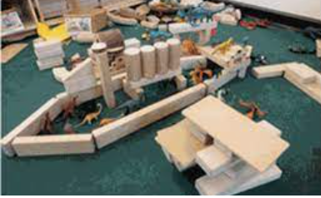  Investigate: which materials would be the best to use for a luxury ship? Test which floats: metals, woods, plastic, rubber etc | Florence Nightingale-210 years ago  Discuss Twinkl PP Florence Nightingale  Discuss facts from Twinkl PP then Watch Florence Nightingale - BBC Teach  Mark make facts in floor book.  Visit from Paramedic to discuss how they help others.  Make a lantern with a candle, glass jar, tissue paper and pva glue.  History/EAD |  | St Georges Day: Stay and Play Day with families and friends.  Twinkl PP to tell the story.  Preparing for St Georges Day  https://www.youtube.com/watch?v=A9QsPnTevO0  Make cardboard shields-white paint, red cross, glitter name.  Make knights capes: rectangle sheets of material and cut head holes, tied with a tie.  Make dragon puppets: cut out pictures and stick onto lollipop sticks.  https://www.youtube.com/watch?v=nr8b6jvC5l8 How its celebrated.  Games In garden-throw a wet sponge, cricket, Morris dancing with bells and scarves, knights and dragon races.
Comments

