

NORTHUMBERLAND COUNTY COUNCIL

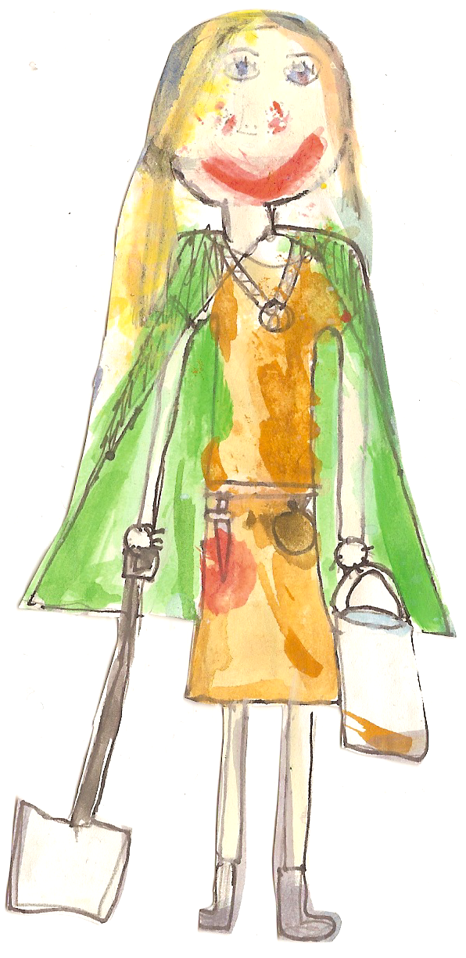

JOB DESCRIPTION

POST: CLASS TEACHER

GRADE: MAIN PAY SCALE (M1-M4)

SCHOOL: BELFORD PRIMARY SCHOOL

RESPONSIBLE TO: HEADTEACHER AND GOVERNING BODY

RESPONSIBLE FOR: YEAR 3 AND YEAR 4 CLASS TEACHING

PURPOSE OF THE JOB:

To meet the requirements of:

A teacher as set out in the School Teachers’ Pay and Conditions Document.

The Professional Standards for Teachers
- Promote and safeguard the welfare of all pupils.

GENERAL TEACHING DUTIES
- Plan and deliver a broad curriculum to the assigned class, which engage pupils’ interest and take into account their individual needs. Identifying those with Special Educational Needs, implementing IEP’s and seeking the appropriate support from other professionals.
- Provide a challenging, yet supportive learning environment, which simulates, maintains and develops lively enquiring minds.
- Direct the use of any support staff or classroom assistance.
- Have high expectations of the pupil’s behaviour, academic and social abilities, and set clear targets that are both realistic, measurable and which build upon prior knowledge or attainment.
- Establish and maintain a high standard of discipline by the use of praise, rewards and sanctions and thereby create an environment in which pupils feel safe, secure and confident; following school policies.
- Set homework to consolidate and extend learning.
- Use a variety of differentiated teaching methods, which incorporate effective questioning and response, whole class, small group and individual teaching.
- Keep up to date planning.
- Encourage pupils to be part of the school community.
- Develop in pupils a positive attitude towards themselves and others with a strong sense of self-respect. Also to develop a sense of respect for other people’s property, ideas and beliefs irrespective of gender, race, disability or academic achievement, etc.

Use Planning, Preparation and Assessment (PPA) time effectively

MONITORING, ASSESSMENT, RECORDING, REPORTING
- Be familiar with statutory and school assessment and reporting procedures and to prepare and present informative, helpful and accurate reports to parents.
- Write/collate high quality and informative individual, positive, honest annual reports to parents/carers and discuss pupil’s progress and welfare at parents’ meetings and other occasions developing positive relationships.
- Assess pupils’ work systematically and use the results for future planning, teaching and curricular development.
- Prepare pupils for National Curriculum Assessments.

CURRICULAR KNOWLEDGE AND UNDERSTANDING
- Have a thorough and up-to-date knowledge and understanding of the National Curriculum.
- Use detailed subject knowledge to deal effectively with subject-related questions raised by pupils and the common misconceptions that they hold – thereby deepening the pupils’ knowledge and understanding.

PROFESSIONAL STANDARDS AND DEVELOPMENT
- Understand the professional responsibilities in relation to school policies and practices and in so doing actively support and reinforce those policies. E.g. anti-bullying, homework, behaviour
- Be aware of the role of the Governing Body.
- Set a good example around the whole school, in appearance and personal conduct.
- Establish effective working relationships with other professional colleagues, not only those within school, but those from outside agencies.
- Attend meetings within the constraints of directed time and contribute to the development of programmes of study and staff share.
- Assist in the development of the School Curriculum in line with the School’s Improvement Plan.
- Assist in the maintenance of good discipline in and around school.

HEALTH AND SAFETY
- Undergo basic First Aid training as required.
- Be aware of the responsibility for personal Health, Safety and Welfare and that of others who may be affected by your actions or inactions.
- Co-operate with the employer on all issues to do with Health, Safety and Welfare.
- Be aware of Child Protection Policy and reporting adult.

CONTINUING PROFESSIONAL DEVELOPMENT – Personal
- In conjunction with the line manager, take responsibility for personal professional development, keeping up to date with research and developments in teaching pedagogy and changes in the School Curriculum, which may lead to improvements in teaching and learning.
- Undertake any necessary professional development as identified in the School Improvement Plan taking full advantage of any relevant training and development available.
- Maintain a reflective approach to evaluating and improving own practice.

SPECIFIC PASTORAL DUTIES
Support, Guidance, Monitoring and Reporting
- Consider promoting and safeguarding pupils’ welfare as paramount, and take action in accordance with the responsibility ‘in loco parentis’
- Monitor the social progress of pupils, including the progress in PSHE lessons.
- Use a counselling approach to help pupils explore thoughts, feeling and solutions to problems.
- Have a detailed knowledge of the pupils in the class and play a central role in the negotiations involved in forming a ‘behaviour contract’.

Liaising with Others
- Consider carefully who is the most appropriate person to help in a specific situation and determining who should make contact, when and how, etc.
- Consider carefully issues of confidentiality when dealing with pupils, teachers, parents and outside agencies.
- Inform appropriate member of staff about social or behavioural issues related to pupils.
- Contact parents, if appropriate, after proper consultation with the Headteacher.
- Be able to liaise with agencies responsible for pupils’ welfare providing the appropriate accurate information.
- Keep up-to-date with Child Protection Procedures and notify the ‘named person’ of any concerns about a child.

Teaching
- Plan and deliver quality PSHE lessons in accordance with the PSHE programme. This process should enable pupils to gain confidence, social and personal skills, understanding of self, and pertinent knowledge.
- Contribute to the development of the PSHE scheme of work through scheduled Pastoral/Team meetings.

General Tasks
- Set a prompt and structured start to the morning and afternoon sessions.
- Ensure that the classroom is left tidy at the end of each lesson.
- Participate in and deliver class assemblies, where required.
- Attend the relevant assemblies as requested by the Headteacher – unless withdrawing on the grounds of conscience or religion. Some assembly times may be used to free certain staff to develop the Curriculum or for CPD.
- Participate in the formulation and execution of Pastoral policies.
- Organise class participation in school events.

Administration: (Registration, Absences, Lateness)
- Mark the register fully and accurately. Unexplained absences or patterns of absence should be reported immediately in accordance with the school policy of attendance.
- Collect absence letters and to pass these on to the appropriate teaching assistant for recording and filing.

General
The work of schools changes and develops continuously which in turn requires staff to adapt and adjust. The duties and responsibilities above should not therefore be regarded as immutable but may change in line with national prescription on teachers terms and conditions of employment and / or relevant school improvement priorities set from time to time. Any major changes will involve discussion and consultation with staff.

Whilst the main duties and responsibilities of the post are set out above, each individual task to be undertaken has not been identified. Teachers will be expected to comply with any reasonable request from their line manager to undertake work related to teaching and learning and tasks which are commensurate with the level of the post.

Agreed that the job description/outline is a fair and accurate statement of the requirements of the job.

Job Holder………………………………………………Date……………………

Headteacher……………………………………………..Date……………………

BELFORD PRIMARY SCHOOL
PERSON SPECIFICATION
CLASS TEACHER

Area of Selection | Evidence of Meeting Criteria
Qualifications | App | Ref | Int | Essential/  Desirable
Degree Status | X | X | X | E
Evidence of further professional development | X |  | X | D
High Standard of Written/Oral Communication | X | X | X | E
Experience
High Quality Teaching and Learning | X | X | X | E
Experience across age range. | X | X | X | D
Ability to coordinate curriculum (in designated subject) | X |  | X | D
Experienced of work with multi agency teams | X | X | X | D
Experience of administering statutory tests and assessment | X | X | X | D
Knowledge
Knowledge and Understanding of the teaching and learning process and its application | X | X | X | E
Use of formative and summative assessment to develop pupil learning | X | X | X | E
Use of pupil tracking and target setting to raise attainment (including pupil groups) | X | X | X | D
Ability to construct and develop short, medium and long term planning for pupils | X |  | X | E
Knowledge and use of range of pupil learning styles | X |  | X | E
Developing positive rapport with pupils and adults through an understanding of their needs |  | X | X | E
Knowledge and Application of national strategies |  | X |  | E
Employment History
Excellent timekeeper | X | X |  | E
Personal Skills
Ability to contribute to and work as a positive team player | X | X | X | E
Ability to communicate clearly with pupils, parents, staff and outside agencies |  | X | X | E
Ability to reflect on own practice | X |  | X | E
Ability to use and act on initiative |  | X |  | E
Able to take responsibility for own self development | X | X | X | E
Well organised and employ orderly approaches/systems | X | X |  | E
Hard working, enthusiastic and resilient |  | X | X | E
Have a ‘can do’ approach that supports high expectations of self and others | X | X | X | E
Sense of humour and fun |  | X | X | D

