Spring Term 2022
Issue 3 27.01.2022
Chinese New Year  Our whole school enjoyed a special assembly this week about the Chinese New Year. The assembly was delivered by Ying Holwell (Mrs Holwell’s daughter-in-law), who very kindly travelled from Scotland to visit us.  We learnt many things including that the Chinese zodiac gives each year an animal sign. 2022 is a Year of the Tiger. This year the celebrations will begin on Tuesday 2nd February and will go on for up to two weeks!  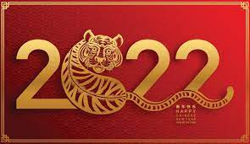 |  | Reading – turn on the subtitles!  Thank you to all our carers, parents and grandparents for continuing to support the children at home with reading.  Reading at home is just as important as reading at school, and research has shown that turning on television subtitles can really help to develop a child or young person’s reading skills. This BBC article (https://www.bbc.co.uk/newsround/56211735) explains more about the positive impact of using subtitles. The ‘Turn on the Subtitles’ campaign encourages parents to do this as often as possible when their children are watching TV. The campaign found that over an average week, a child could read as many words through subtitles as there are in all seven Harry Potter books, and much, much more! Research has also shown that we absorb subtitles when watching television even if we are not really aware that we are doing so. We would like to encourage parents and carers to make use of this powerful tool for improving reading at home, and we would love to hear about your experience if you choose to do this.
Friday 4th February NSPCC Number Day  We will be joining schools across the UK on Friday 4th February in a NSPCC mega maths fundraising day. The children can come to school in non-uniform or dress-up in a number inspired way! We will be collecting for this very worthwhile cause and would appreciated a donation of £1 per child if you are able. |  |  |  | 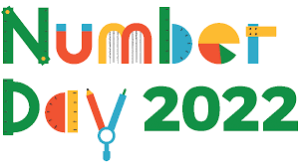
Eco Council  Last Friday, the children in our Eco Council gave a short informative presentation to the rest of school in assembly. They shared the results of an environmental review that they had carried out in the autumn term.  They have identified three key areas for us to develop and they are working hard to make our school and community more eco-friendly. | 8th February Safer Internet Day  We will be promoting the safe use of the internet over the next few weeks.  Here is a useful link for carers and parents:  https://saferinternet.org.uk/safer-internet-day/safer-internet-day-2022/advice-for-parents-and-carers |  | School Parliament  The school parliament have been exploring the ‘five ways to well-being’ and discovering ways they can support other children by encouraging them to ‘connect’ with each other. In the next few weeks the school parliament will be discussing how they can promote ‘random acts of kindness’ throughout school and at home.
Class 4 visit to The Granary Gallery
Our class 4 children enjoyed a visit to The Granary Gallery in Berwick on Tuesday 11th January.
They learnt about the craft of quilting and had the opportunity to observe a large number of beautiful traditional and contemporay quilts.
They will be creating their own quilted masterpieces over the next few weeks.
https://www.maltingsberwick.co.uk/whats-on/quilts-resurgence/

 |  |  | On Wednesday 9th February an astronomer from Kielder Observatory is visiting every class.
Dates for the Diary:
Monday 14th February - Class 3 Roman site visit.
Thursday 17th February – Break up for half term.
Monday 28th February – Back to school.
Thursday 3rd March – World Book Day (dress-up as book character)

