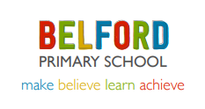
Nursery Weekly Learning 20.04.20 – Tasks Related to all areas of the EY Curriculum
This week we are learning about the queen
These activities should help to give your child a broad experience. Please do not feel that this is a must do list!

Personal, Social, Emotional Development (PSED)  Play card game at home where you have take turns and recognise the different numerlas. An you name the suits? Queen of hearts etc. | Communication and language  Can you watch Peppa and the Queen? https://www.youtube.com/watch?v=WhOfm3NZbEo  What did you enjoy about the story? Was there a part that you did not like? Can you sing the song we are off to see the queen? | Physical Development  Can you draw hopscotch on the ground and then add a chalk course?  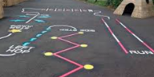  Joe wicks is also offering daily PE lessons on his you tube channel https://www.youtube.com/channel/UCAxW1XT0iEJo0TYlRfn6rYQ | Literacy  Reading  Can you watch the Grand Old Duke of York rhyme on Utube? Can you sing it and ask a parent to video it?  Writing  Practise writing your name.
Maths  Can you make jam tarts? You could learn the rhyme The Queen of Hearts.  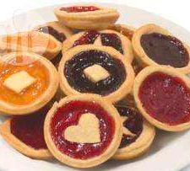  http://allrecipes.co.uk/recipe/492/jam-tarts.aspx | Understanding the World  Can you find out about castles? Maybes you could make one from lego or recyclable materials?  Can you design a new stamp?  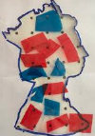 | Creative Arts and Design  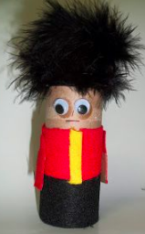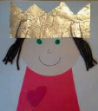  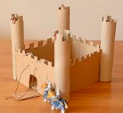 | Jobs to help our families  - Brush the path.  - Dig the weeds.  - Put your toys away.  - Give your family a hug and let them know you love them very much!

We would love to see any photographs and videos of your children completing the other tasks on tapestry or Class 1 facebook page too.

