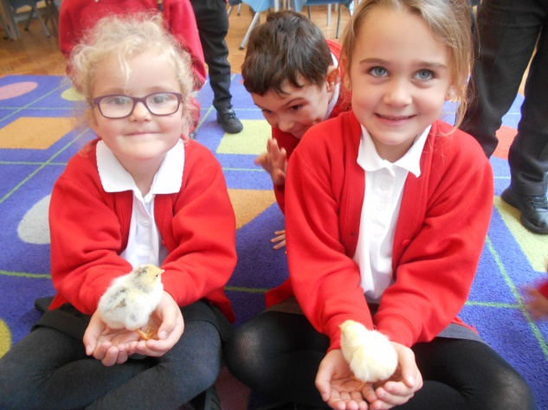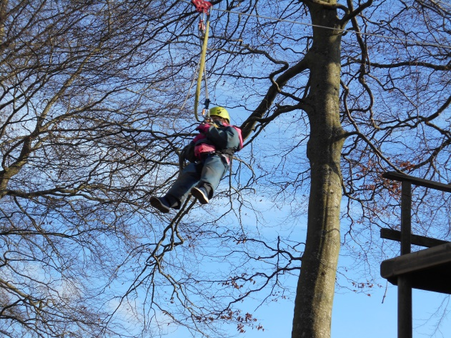
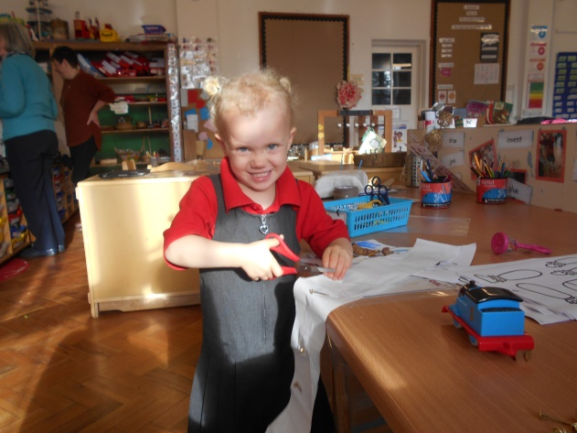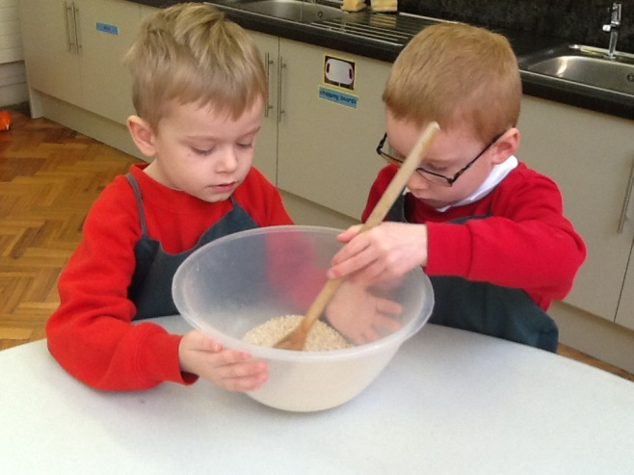

PROSPECTUS
2021 -2022

Our Vision

Make
Make a mess,
make mistakes,
make friends,
make an impression,
make progress.

We teach children to make with their hands,
their hearts and their minds.

Believe
Believe in yourself, believe anything is possible,
believe in others.

Belief is central to development, positive attitudes and self-esteem.
Our belief is simple, childhood is special and children learn most when they are happy.

Learn
Learn from others, learn about the world.
Learn what is appropriate, and what is not.

Children absorb information at a very fast pace. It is our role to keep the momentum going, find the challenges and create their success. Interaction with people of all ages and backgrounds is vital. We introduce the children to inspiring people with incredible talents, stories and knowledge of the arts, history, geography, global issues, sport and technology, to feed their hungry minds.

Achieve
When children are interested in and have ownership of what
they are learning they will achieve more.

Through targets, project work and homework we encourage children to take responsibility for their own progress, achieving more, and more.

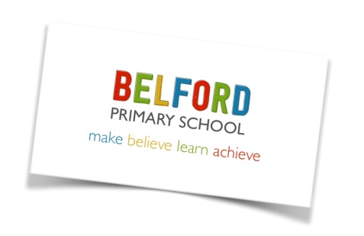

Dear Parents and Carers,

I was delighted to be appointed as headteacher of Belford Primary School in September 2019, having taught in a variety of schools in the North of England over the past 26 years.

Belford Primary School is small school with a big heart. As a staff team we share a common belief that children learn best when they feel safe, valued and have fun.

We provide an environment that fosters a love of learning, develops self-confidence and promotes high self-esteem. Attitudes, values and feelings have as much place in a classroom as factual knowledge and skill. We nurture positive relationships and promote care, concern and empathy for others.

Our curriculum is designed to extend the children’s knowledge of the wider world and develop their appreciation of global values, enabling them to ultimately grow into well rounded adults.

We speak a positive language here and we care for each other. We take time, we do not rush, we nurture. We create great opportunities for children and teach them to be spontaneous and adventurous.

We have created a safe, caring and stimulating learning environment where children can grow and develop. Our children have a lot of space, a lot of freedom and a lot of fun, but always at the heart of everything is learning. We aim to provide a sound foundation in the core skills of reading, writing, maths and computing, but also develop the skills and passion for lifelong learning.

We value our pupils as individuals and take account of their individual needs and interests and encourage them to contribute to the school community.
We also realise how important it is for parents to be fully aware of what we do and how we teach. We welcome parents and the wider community as partners, and their involvement contributes to our success and the success of the children.

My door is always open to you, why not come in and see what we do?

Mrs Lorna Rainey
Headteacher

EARLY YEARS FOUNDATION STAGE
The Early Years Foundation Stage (EYFS) sets standards for the learning, development and care of children from birth to 5 years. At Belford Primary School, we welcome children into our EYFS setting from the age of 2 onwards.
The seven areas of learning covered in EYFS are:
1. Personal, Social and Emotional Development
2. Physical Development
3. Communication and Language.
4. Literacy
5. Mathematics
6. Understanding the World
7. Expressive Arts and Design.

INTRODUCTION TO RECEPTION
In Reception we keep detailed records of children’s achievement and progress through an online learning journal. We use frequent, systematic observations to ensure children are happy, secure and progressing at the expected rate.

Children start in Reception in the September of the school year in which they reach the age of five. We want children to feel confident, enthusiastic and look forward to the new an exciting challenge of starting school.

Outdoor learning is an integral part of our school ethos. We believe that when children are immersed in nature they begin to develop respectful relationships with one another and learn to value the natural world. Our children spend much of their time in our outdoor classroom and in our Forest School. We strive to provide real experiences and multi-sensory opportunities which extend children’s thinking and creativity.

Our Reception and Nursery children join the whole school for weekly assemblies and for lunch each day. We encourage healthy routines and promote positive eating habits. The children sit down at a table to eat with their friends and use real cutlery, plates and cups.

THE CURRICULUM
Childhood is special. At Belford Primary School we recognise that every child is unique. Children take in and retain information in different ways.
Our curriculum prioritises basic skills in literacy and maths, practical hands on work,
investigation and enquiry. We want to excite and challenge our children then allow them to take risks. Children must learn to adapt and embrace change, to prepare them for a
wonderful, but unpredictable world.
Each week children in EYFS, Key Stage 1 and Key Stage 2 receive sports coaching. Children in KS1 and KS2 have a term of swimming lessons (each year) at the Swan Centre in Berwick.

Where appropriate, the curriculum extends beyond the classroom by making use of the
extensive school grounds, the local area within Belford and the wealth of resources which exist within easy reach of the school.
Our school garden plays a central part in the school curriculum. Throughout the year the children contribute to the growing and tending of the plants. When harvested we make soup, cakes and crumbles in our classroom kitchen. This gives children the opportunity to try seasonal foods.

We truly believe cooking can benefit the children in many ways and support their learning in the classroom. Together we can learn about the origins of food, develop mathematical concepts, fine tune children’s motor skills and coordination, build self-esteem, promote literacy and language development and generally have fun.

THE CORE SUBJECTS
ENGLISH
Each day, every child in our school takes part in an English lesson that allows them to learn new skills in an exciting and meaningful way. In EYFS and KS1, we use stimulating and purposeful texts linked to a structured intervention known as Read Write Inc. to encourage children to develop skills in reading, spelling and writing. Handwriting is taught daily and children are encouraged to join letters together as soon as they have mastered correct individual letter formation.
The teaching of reading is given a high priority at Belford Primary School. We use a variety of methods to teach children to read. We teach phonics so that children can tackle new words by blending sounds. We provide attractive and interesting books that the children will enjoy reading at home The key reading schemes used in school are Read, Write, Inc, Oxford Reading Tree and Project X. Children take these books home each night but should bring them to school each day so the class teacher can also hear them read. All children in school are also encouraged to borrow books from our attractive school library and class libraries. In Key Stage 2, children share good quality whole class novels and enjoy discussing story characters, plots and adventurous vocabulary.

MATHEMATICS
We believe each child should develop confidence, competence and enjoyment in
mathematics. Children take part in daily lessons. Practical investigations play a large part in allowing children to apply the concepts they have been taught. Children are taught to understand the relationship between numbers and to develop a range
of strategies to work out calculations. Mental arithmetic is used to ensure that basic
knowledge of number is learnt and can be applied at speed. Number bonds and timetables are considered essential basic skills and are taught across the school. As part of the mathematics curriculum we also teach shape, space and measure and data handling.

COMPUTING / INFORMATION TECHNOLOGY
To develop IT skills, all children have regular access to iPads, laptops and other equipment such as cameras and robots. Interactive whiteboards are in every classroom and are used for teaching across all areas of the curriculum. In addition we use portable technology as part of everyday lessons to support research, small group work and independent learning. As part of the computing curriculum children are taught how to stay safe when using a computer.

FOUNDATION SUBJECTS
SCIENCE
Science involves children in practical first hand experiences and activities to help them find out about the world in which they live and how it works. We believe that all children deserve a high-quality science education that is inspiring, memorable, and prepares them for high school, a future career, and life.

HUMANITIES
Humanities include History and Geography. They are taught across the school through cross curricular topic work making them as interesting as possible for the children. Visits to local places of historical and geographical interests give the children first hand experiences. The children are also given the opportunity to use artefacts, photographs and other resources to develop their skills and knowledge.

PHYSICAL EDUCATION
In PE children are taught to be active and improve their fitness. The emphasis is on improving and developing abilities. Aspects of gymnastics, games, dance, athletics and outdoor adventurous activities are taught. Children have at least two hours PE every week. All children in KS1 and KS2 have access to swimming lessons at specific points in the academic year. We run a variety of after school sporting clubs that children can attend. All children have an opportunity in KS2 to take part in a residential visit. This year we are visiting Robinwood - an outdoor adventurous activity centre. At the end of the Summer term parents and children take part in sports day on the school field.

MUSIC
It is our aim that children develop musical skills, knowledge and a genuine understanding of music that will provide a lifetime of enjoyment. In addition to music lessons in the curriculum, children have the opportunity to learn to play the recorder or clarinet. We also have a specialist music teacher, Mrs Cochrane, who delivers high quality music sessions to all classes every Monday afternoon.

ART
During their time at Belford Primary School children will have the opportunity to experience a wide range of techniques and media through painting, printing, modelling, drawing, textiles and collage work. Visiting artists and sculptors work alongside the children on whole school projects. Children are given opportunities to visit art galleries in the local area and wider afield.

RELIGIOUS EDUCATION
We observe Northumberland’s syllabus for the teaching of Religious Education. We take great care to promote the spiritual, moral, cultural and social development of children and prepare them for the opportunities, responsibilities and experiences of life.
ASSEMBLY
Children take part in whole school assemblies each week. Assembly time builds on the work being done in the classroom in Personal, Social and Health Education classes.
We encourage children to see themselves as part of the family of school and as part of a larger community, where they have rights and responsibilities.
Parents may withdraw their children from assembly time and to do this they must inform the school formally in writing of their wishes.

PSHE
It is through our Personal, Social, Health and Economic (PSHE) education that children develop the knowledge, skills and attributes they need to manage their lives, now and in the future. It helps the children to stay healthy and safe, while preparing them to make the most of life and work.

THE SCHOOL DAY
Nursery
8.50-11.50am or 12.50pm (if staying for lunch).
Afternoon session: 12.50-2.50pm

Reception
Morning Session 8.45am-11.55am
Lunch: 11.55-12.50pm
Afternoon Session 12.50pm-3.10pm

Key Stage 1
Morning Session 8.45am-12 noon
Morning Break 10.15-10.30am
Lunch 12.55-12.50pm
Afternoon Session 12.50-3.15pm

Key Stage 2
Morning Session 8.45am-12.00pm
Morning Break 10.15 – 10.30am
Lunch: 12.00-12.50pm
Afternoon Session 12.50-3.15pm

HOMEWORK
Each child has a reading book and reading diary. Parents are encouraged to read with
their child/ children every night and write comments in the diary. From year one onwards children are given homework each week relating to the work they’re doing in the classroom. Each half term children will receive a spelling book where they can practise their spelling each week.
EQUALITIES
We are an inclusive school, where every pupil has an entitlement to all areas of the curriculum and educational experiences, which will enable them to achieve. No one is discriminated against because of race, gender or disability. All staff and governors are aware of the educational access rights of disabled children. We make reasonable adjustments to promote the fullest possible participation by all children to access all school activities and facilities.

All children are positively encouraged to respect each other’s differences and treat others as they expect to be treated themselves.

LOOKED AFTER CHILDREN
Children and young people become “Looked After” either if they have been taken into care by the local authority, or have been accommodated by the local authority. Our school is committed to providing quality education for all its pupils, based on equality of access, opportunity and outcomes.

SPECIAL EDUCATIONAL NEEDS AND DIABILITY (SEND)
A child is defined as having Special Educational Needs if he or she has a learning difficulty which requires special educational provision or individual provision to be made for him or her. All pupils at Belford Primary School have their needs addressed though a broad and balanced curriculum. We ensure that children with SEND engage in all the regular activities of our school, as far as is reasonably possible.
In meeting our responsibility we have regard to the SEND Code of Practice and the SEND Strategy of the Local Authority. We aim for the early identification of needs through continuous assessments of basic skills, particularly in the area of English and Maths and Personal, Social, Physical and Emotional Development so that children can be supported appropriately as soon as possible. Parents must advise school if they have any concerns about their child’s development.
Individual education plans (IEPs) are prepared and reviewed in line with our SEND policy. Parents are kept informed and all information is regarded highly confidential. Once a child is identified as having a special need an IEP is prepared by a member of staff in liaison with parents. The programme contains set targets for the child and is reviewed on a regular basis.
Where an Education Health Care Plan (EHCP) is in place, we ensure that the child receives the provision that has been identified. Our SENDCo (Mrs Lorna Rainey) supports class teachers and children working within structured Individual Education Plans. She co-ordinates the work of other professionals, who may be involved in supporting a particular child. All adults responsible for the child are given copies of individual programmes or work, so the best support and expertise can be utilized for the benefit of the child. Some children receive individual support and / or may be included in a regular small group intervention.

RELATIONSHIPS AND SEX EDUCATION
The Governing Body of the school has approved a sex and relationships education programme that is an integral part of our overall health education curriculum. This includes learning about positive relationships through the SMSC (Spiritual, Moral, Social and Cultural Values programme). In addition to this, school staff teach the children in Year 5/6 about body changes and puberty. Parents have an opportunity to meet with the staff prior to this. Parents do have the right to withdraw their children from this session; in the spirit of partnership, this would be after discussion with the Headteacher or class teacher.

PARTNERSHIPS
We recognise that parents know more about their child than we will ever do. We welcome the opportunity to share that knowledge and learn from you. It is our policy to involve parents in the life of the school and to promote positive relationships with the aim of together providing the highest quality education for our children. There are a variety of opportunities to encourage you to support your children’s education at home.
• Reading diaries
• Stay and Play sessions
• Supporting “The Friends of Belford School’, our PTA.
• Assemblies and performances
• Sporting events
• Parent governors

CHILD PROTECTION
Belford Primary School believes that pupils have a fundamental right to be protected from harm. We work in partnership with a variety of agencies to provide the best possible care and support to children. We have a designated Child Protection Officer, a Governor with responsibility for Child Protection and staff receive regular training to ensure they are familiar with and skilled in implementing child protection procedures. We have a duty of care to report to the appropriate authorities any concerns regarding the well-being or welfare of children in school.

COMPLAINTS PROCEDURE
There may be times when you are unhappy or unsure about an aspect of the school. Please come and speak to a member of the staff as early as possible. In most cases worries or complaints can be sorted out quickly and easily in discussion with the class teacher or headteacher. Following consultation and if you are still dissatisfied you may wish to make a formal complaint via the Chair of Governors. Copies of the Complaints Policy are available from the school office and are on the school website.

REPORTING TO PARENTS
We want to keep parents informed about their child’s progress and development in school. Alongside the many informal opportunities each day and the times when you might make an appointment to discuss something with teachers, we organise the following to help keep you in touch with what your child is learning and the progress they are making:

- A written mid-year and end of year report.
- Parent consultation meeting are held in the Autumn and Spring term. This gives parents the opportunity to speak to their child’s class teacher and look at the children’s work books.
• Curriculum plans are sent out to parents at the beginning of every term and can
also be found on the school website.
• Workshops where parents can stay and learn with their children.
• Class assemblies where the children share their learning
• Parents are notified in writing of end of Key Stage results and Year 1 Phonic
screening results.

GENERAL ORGANISIATION

ABSENCE FROM SCHOOL
Good attendance is essential for all children and therefore attendance data is carefully
monitored. If your child is ill please call the school office before 9.00am on the first day of illness. If you know in advance that your child is going to be absent due to a medical appointment please let the school office have a note in order that absences may be correctly coded.
If your child becomes ill during the school day we will contact you. Please ensure the school has up-to-date contact details.

LATE ARRIVAL AT SCHOOL
Children who arrive in school after the bell has rung should be brought to the school office where your child can be marked present in school – but will receive a late mark. A member of staff will take the child to class. If you have to arrange emergency medical appointments, please telephone school to let us know you will be late and when you expect to arrive.

MEDICINE
We do not store or administer medicine to children unless they are prescribed four times a day by a doctor. Most can be administered before and after school and at bedtime. However, in the case of children who suffer from hay fever, epilepsy, asthma or other conditions which require medication to be stored and administered on school premises, we are able to do so. Please inform us by completing a medicine form available from the school office.

ADMISSIONS
Children are eligible to start Reception in the September in the year they will have their fifth birthday. Parents can apply on line for places at www.northumberland.gov.uk/families following the link to school admissions.

BEHAVIOUR
We aim to maintain a happy, safe and secure school where adults and children feel safe,
involved and valued. We base this on a positive approach to behaviour management. We
encourage and recognise good behaviour. We believe in listening to children and making expectations clear. We aim to be consistent in our approach. All children follow our six golden rules:
• We are gentle
• We are kind and helpful
• We listen
• We are honest
• We work hard
• We look after property
All parents, children and staff are asked to sign a Home-School contract when children start school. On the rare occasions that persistent difficulties arise the class teacher will contact parents to discuss the issue.

CHARGING POLICY
At Belford Primary School we have two sources of income – one from Northumberland County Council and the other is money raised ourselves. The Friends of Belford First School are very active in raising funds for specific projects and organise many fundraising events. Funds are used to enhance the provision for our children. However there are many activities which enrich the curriculum such as visits to museums and places of interest which incur an entrance fee or transport costs. In such cases voluntary contributions from parents are essential and greatly appreciated. No child will be excluded from participating in an activity during the school day because of a lack of parental contribution however; the activity may not take place if there is a continued shortfall of contributions. We make a charge for children receiving specialist music tuition, for swimming and after school clubs. Monies raised from after school clubs are spent directly on experiences or equipment for the children e.g. puppet shows, musical instruments and climbing equipment.

DINNER MONEY
Children in Reception and KS1 are eligible for a free school meal each day. There is a cost of £2.10 per day for school lunches, once the children move into KS2 dinner money must be paid in advance on the first day of the school week or the beginning of a school term. We have an online payment system in place. Some children are eligible for free school lunches in KS2. The following website should be used to check eligibility: https://www.gov.uk/apply-free-school-meals

HOME TIME ARRANGEMENTS
All children will be dismissed by the class teacher at the end of the day to an authorised adult. If you wish for your child to walk home alone it is essential that you complete the relevant forms in the school office. If you wish your child to be collected by another adult please ensure their details are on your child’s home time arrangements’ form.

HEALTH AND SAFETY
The safety of children in our care is always our first concern. We ask you to read the
following information and support the school by noting and following the policies we set:
• Vehicles are not to enter or leave the school site between 8.30am – 9.20am then
3.00pm – 3.30pm. Vehicles should not park or drop off at the school gates or in the
bus drop off area.
• Smoking is not permitted in any area of the school grounds or perimeter.
• Dogs, other than guide dogs for the blind, are not allowed on the premises
• We are a healthy school. We ask that children do not bring chocolate bars or fizzy
drinks into school as part of their packed lunch. No nuts to be brought in either please.
• Positive behaviour is expected from all parents and carers on site. They are expected
to behave appropriately and set a good example to the children.
• We do not allow the wearing of any jewellery other than watches, small stud
earrings or an item that has religious significance. All earnings must be removed
before swimming or PE.
• Coughs, sneezes, sickness and diarrhoea. It is important that children do not return to school too soon after illness. This helps to prevent the spread of infection to others.
We recommend that children are kept away from school for 48 hours after sickness
and/or diarrhoea.

MOBILE PHONES
Parents are asked not to use mobile phones on the school site.

SOCIAL MEDIA
Belford Primary School takes its responsibility to keep staff and children safe from any form of violence or harassment, physical, written or verbal. Positive behaviour is expected from all parents and carers. They are expected to behave appropriately in their use of social media and set a good example. Sanctions can be implemented by the school against any parent or carer who has published comments relating to any child, another parent, member of staff or the school that would bring them into disrepute. Complaints should be brought to the attention of the school in an appropriate manner and will be followed up in line with our complaints policy.

UNIFORM
Through our uniform we emphasise being part of a whole school team. It comprises of the following
• Grey skirt or trousers
• White polo shirt
• Red sweatshirt or cardigan
• Red/white gingham dress (summer)
• Black shoes (no high heels or trainers)
• PE Kit black shorts /white t-shirt /sandshoes
Sweatshirts and t shirts can be purchased from the school office.

PE kits should be kept in a named drawstring bags and left on the child’s coat peg. Jewellery must not be worn in school with the exception of studs in ears. It is essential that children are able to remove their own studs before PE, Games and Swimming lessons. For reasons of health and safety, these activities cannot be undertaken with studs in place.
Please ensure all clothing is labelled with your child’s name.
We recommend that your child wears a coat in ‘most weathers’. As our climate is quite
changeable they often need a coat at break times when they are outside.

AFTER SCHOOL FUN
Every term we organise after school clubs to extend the children’s curriculum. Clubs change each half term and letters are sent home to inform you of the changes. In the past children have enjoyed; Gardening Club, Dance, Sewing, Football, Tennis, Cricket and Drama. We welcome a variety of visitors into the school to support our curriculum.
Children also enjoy fundraising events such as Movie Night, Sleepovers and Bingo.

NATIONAL TEST RESULTS
The information bellows demonstrates how Belford Primary School compares to other schools nationally. At the end of Reception we report how many children achieve a Good Level of Development (GLD). At the end of year 1, we report the percentage of children passing the Phonics Screening Check. At the end of Year 2 and Year 6, children take National tests (SATs) in Reading, Writing and Mathematics. The level that most children are expected to achieve is the ‘Expected’ level for their Year group.
Considerable variation in these annual figures can be expected when, as is the case at Belford, there is a relatively small number of children taking the tests.

Reception: The percentage of children achieving a Good Level of Development.

GLD  Reception |  | 2015 | 2016 | 2017 | 2018 | 2019
 | School | 60% | 71% | 78% | 70% | 69%
 | National | 66% | 69.3% | 71% | 71.5% | 71%

Year 1: Phonics Screening Check

Year 1  Phonic screening |  | 2015 | 2016 | 2017 | 2018 | 2019
 | School | 77% | 87% | 86% | 88% | 89%
 | National | 77% | 81% | 81% | 82% | 81.9%

Year 2: End of Key Stage 1 SATs

Year 2  % Children achieving expected standard. |  | 2015 |  |  | 2016 |  |  | 2017 |  |  | 2018 |  |  | 2019
 |  | R | W | M | R | W | M | R | W | M | R | W | M | R | W | M
 | School | 79 | 79 | 79 | 80 | 80 | 80 | 87.5 | 87.5 | 94 | 86 | 86 | 86 | 78 | 83 | 83
 | National | 82 | 72 | 82 | 74 | 65 | 73 | 76 | 68 | 75 | 75 | 70 | 76 | 75 | 70 | 76

Year 2  % Children achieving greater depth |  | 2015 |  |  |  | 2016 |  |  | 2017 |  |  | 2018 |  |  | 2019
 |  | R | W | M | R |  | W | M | R | W | M | R | W | M | R | W | M
 | School | 0 | 0 | 0 | 30 |  | 40 | 40 | 31 | 25 | 37.5 | 28.5 | 14 | 28.5 | 22 | 17 | 22
 | National | 32 | 18 | 26 | 24 |  | 13 | 18 | 25 | 16 | 21 | 26 | 16 | 22 | 25 | 15 | 22

Year 6: End of Key Stage 2 SATs 2019

Year 6  End of year data  KS2 SATS  8 children in cohort | Below expected standard | Children achieving expected standard |  | Children achieving Greater Depth
 | Belford | Belford | Nationally 2019 | Belford | Nationally 2019
Reading | 0 | 87.5% | 73% | 37.5% | 27%
Writing | 0 | 100% | 78% | 37.5% | 20%
Maths | 0 | 100% | 79% | 50% | 27%
SPAG | 0 | 100% | 78% | 37.5% | 31%

Year 6 End of Key Stage Two Progress in Reading, Writing and Maths 2019

Subject | Key Stage 2 Progress Measure at Belford | Key Stage 2 Progress Measure Nationally
Reading | 3.52 Average | -3.7 to 2.5
Writing | 4.81 Well above average | -2.8 to 8.6
Maths | 5.33 Well above average | -1.6 to 3.9

PARENTS OF CHILDREN AT BELFORD PRIMARY SCHOOL SAY…
Information and quotes from our Parental/Carer Questionnaire:
100% of parents would recommend Belford Primary School to others.
100% of children enjoy and feel safe at Belford Primary School
“The school provides a good learning environment and teaching is to a high standard with high expectations”.

“Excellent communication between home and school”.

“Staff Listen to parents concerns and deal with them”.

“Each child is treated individually; nothing is just ‘brushed off’. I feel they are cared about”.

“Personal relationships with the children are strong. I drop my son off knowing he has someone he feels attached to and safe with”.

“We like the buddy system with the older children supporting the younger children”.

“My child has a very good level of support in school, during lessons and at break and lunchtime”.

