Theme: Food Term: Autumn 2 Year: 2023
Key Knowledge and Skills |  | Key Questions
To be able to name and describe some vegetables and fruit.  To be able to talk about eating healthy foods and unhealthy foods.  To be able to try different fruits and vegetables and say what we do or do not like.  To be more aware of the importance of brushing our teeth and how the drinks we have can damage our teeth.  To be able to talk about how some festivals celebrate using candles.  To look at our History Timeline ad know what happens now and what happened then. |  | What should we eat to stay healthy? Can you name some unhealthy foods? How can these foods damage our teeth? How can we sort these different foods?  Can you name some celebrations and festivals that we have celebrated? How are they the same/different?
Key Vocabulary |  | Key Content
Carrots, spinach, rhubarb, cabbage, beetroot, peas and potatoes  Scrub, peel, chop, sharp knife, grater, rub, crumble, boiling,  Days of the week  Naming secondary colours  Fridge, freezer, tinned. fresh, grown, baked  Healthy eating, bodies, mind ,brain, heart pumping, exercise, fat, milk, fish, cheese, sugars,  Teeth, decay, enamel, fluoride, tooth paste, tooth brush  Float, sink, |  | The children will learn that fruit and vegetables are grown to be eaten. They will begin to understand where the food in the shops have come from and the process that has been taken to grow and harvest the food. They will learn the role of a shop worker and their impact on our community.  They will learn how to make soup and use tools safely in the kitchen. They will learn to follow a recipe and then talk about the changes made to the ingredients as they cook them.  The children will learn about different festivals and celebrations and be able to link it to parties and celebrations that they have already experienced.
Links to Previous Learning:  Some Nursery can name some common fruits and vegetables . they know that water is a healthy drink.  The children will have been into the Coop with their families. |  | Cross Curricular Links:  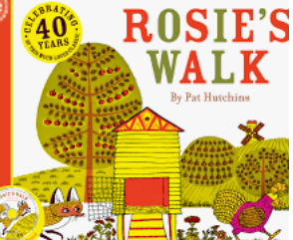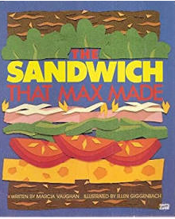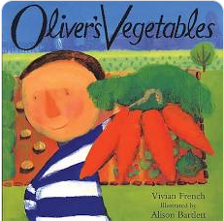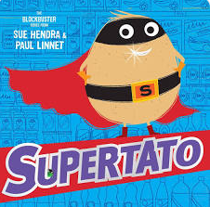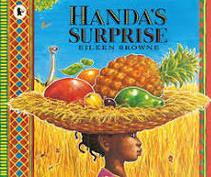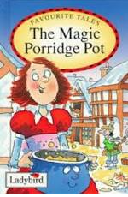
Children working towards expected | Children who have achieved expected |  | Children working at greater depth

Week 1 Bonfire  Remeberence Day | Bonfire Night  Recall past events and mark make in book.  What was dangerous and how did we stay safe?  Who can help us in a fire? The role of the fire fighter in our community.  History | Guy Fawkes Story- pp  Create a story map and sequence the story. Add to timeline.  History | Remembrance Day: Watch video on cbbc and discuss bravery and why these veterans are remembered. Make poppy activities and celebrate with families.  History/EAD | Visit to the church for Remembrance Service  History
Week 2  Diwali  Olivers vegetables-  Trip to the Coop | All Day  Rama and Sita book and discuss feelings and actions.  Parents in to discuss traditions?  Light over darkness and hope that good luck will happen. Learn how Diwali is celebrated.  https://www.bbc.co.uk/programmes/p02n5hl0 Discuss similarities and differences between our celebrations: gifts, candles, new clothes, cleaning house  Festival of light: discuss candles and light.  https://www.youtube.com/watch?v=KZU6M4EisyA  Make a Diwali holder from clay  PD/EAD/History/Geography  Learn how to do a Hindu dance  https://www.youtube.com/watch?v=DMRWmTnXBOU  EAD | Read Oliver’s Vegetables  Have carrots, spinach, rhubarb ,cabbage, peas, beetroot and potatoes.  Naming vegetables, where are they grown, describing textures, colours and differences.  Visit allotment and dig up whatever veg is there. What can we name and identify? Comments on garden environment and seasonal changes  C&l, Geography, Literacy | Sorting fruit and vegetables into groups.  Tasting raw vegetables and talking about our favourites/dislikes. Make a bar chart to show most popular vegetables. (carrot, peas, sweetcorn,radish,beetroot)  Look at first page of book and discuss patterns. Make vegetable print patterns.  Science/Maths | All Day  Walk to the shop together to collect vegetables to make soup. Comments on what they see in the shop. Fridge, fresh/tinned fruit a veg, freezer.temperature.  Role of a shop worker chat?  Discuss the differences between the shop and the allotment.  Geography/ C&L/ EAD/ PD  Afternoon with parents  Make vegetable soup with parent helpers.  Learning to read a recipe card and how to hold and use a knife/grater safely.  Literacy/PD
Week 3 Handas Surprise | Read Handas Surprise  Can they identify the different fruit in the basket? Banana , guava,orange,mango,pineapple,avocado,passion fruit,tangerine.  Slice the fruit and discuss how they all look different. Taste ach fruit and make a bar chart to show most popular.  C&L/Science/Maths/PSED | Science Investigation-floating/sinking  Have a selection of fruit and vegetables for children to explore. Can they predict which will float/sink. What are their findings? How can we conclude our findings?  Science/C&L | Read the sandwich that Max made: repeated language and intonation.  Everyone make a sandwich: cheese tomato, pepper, ham,sprouts and lettuce.  PD/PSED | Taking care of our body:food  https://www.twinkl.co.uk/resource/taking-care-of-my-body-food-powerpoint-roi-sphe-80  Then sort food into healthy /unhealthy groups.  PSED/Science
Week 4 The magic porridge pot  St Andrews Day | Read the story ad chn to join in with repeated phrases and intonation.  Dress up as characters to act out the repeated phrases: head scarf for Grandma, dirty apron and broom for the mum and a dirty dress for the girl.  Sequence the story and recall repeated phrases in floor book.  Geography/History/EAD/PD | Order recipe cards to make porridge then measure the ingredients and make the porridge together . Discuss how heat changes the mixture over time.  Add toppings; jam, honey, strawberries, nutella.  Discuss likes/dislikes.  Literacy/PSED/Science | Oral Health:  Chn to learn how to brush teeth  See Oral Health Plan  PSED/Science | Oral Health: Learning about the role of the dentist  See Oral Health Plan  C&L/PSED
Week 5  Tato  Hanuakkah | Oral Health:  1.Tooth Decay  2. What drinks can damage our teeth?  Drinks experiment: predictions  See Oral Health Plan  Science/PSED | Discuss Judaism :Topic box with artefacts: Shabbat  https://www.twinkl.co.uk/resource/t2-re-599-inter-faith-week-judaism-powerpoint Make the Star of David  Discuss birthday celebrations and candles on cake. Show photographs Diwali,Christmas trees, bonfire night.  Introduce Hannakah: https://www.twinkl.co.uk/resource/t-t-11772-eyfs-hannukah-information-powerpoint  Make Hanukkah Menorah  UTW/EAD | Super Tato Day  Morning  Read book: positional language  Plan Do Review: Design and make vegetable character.  Take our vegetables on an adventure and learn how to use Ipad to take photographs.  Afternoon  Review our plans and then make a picture book using our photographs. Retell our stories to our peers.  C&L/EAD/PSED | Oral Health: What drinks can damage our teeth?  Drinks experiment: our findings and conclusion.  C&L/PSED/Science
Week 6 Xmas | The Xmas Story  Chn to retell using floor book  C&L/History | All about Christmas and celebrations  https://www.twinkl.co.uk/resource/t-tp-5932-eyfs-all-about-christmas-powerpoint  Mark make in floor book  History/C&L | Christmas around the world  https://www.twinkl.co.uk/resource/t-t-7940-christmas-around-the-world-powerpoint Discussing similarities/differences between different countries  Mark make in floor book  Geography/C&L | Making Xmas gifts and cards  EAD
Week 7  Xmas | Making Xmas crafts with families  EAD | Xmas Party | Assessments of Learning
Comments

