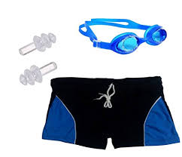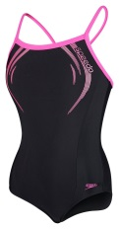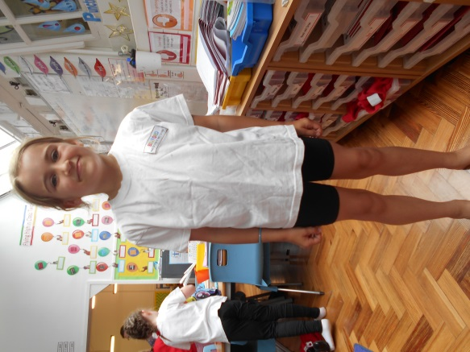

*School sweatshirts and PE shorts can be purchased from the school office*

Children should not wear nail varnish for school.

For safety reasons they should only wear studs in their ears and these must be removed for PE and Swimming.

**PE**

Children should wear a school PE T-shirt and black shorts for PE. In Winter or when doing outside sports they may need warmer clothes including a sweatshirt, trainers and jogging bottoms.

**All PE kits should be kept in school.**

Swimming

Girls should wear one piece swimming costumes (not bikinis). Boys can wear shorts but these must not go past their knees so swimming is not hindered.

Children will need to wear a swimming hat and can wear goggles if needed.

Children should wear their school sweatshirt, joggers and trainers to school on a Friday.

At Belford First School we like to look smart.

Black school shoes

Grey skirt or trousers

School sweatshirt

White polo shirt

Please write your child’s name in all uniform.