Theme: Space Term: Spring 1 Year: 2024
Key Knowledge and Skills |  | Key Questions
To be able to name some different planets.  To be able to describe earth and now that they live on this planet.  To be able to compare Earth to other planets.  To be able to explore how different medias can be mixed to create a different effect.  To be able to talk about why we have day and night.  To be able to talk about Neil Armstrong?  To be able to use chalks to create different effects. |  | What Planet do we live on. Can you tell me what the planet is made up of? What other planets can you name? How are they different to Earth?  What did Neil Armstrong do? Can you remember what his famous words were?  How are craters formed on the moon?  What do you predict will happen? What did find out from the experiment? So when we… this will happen…  Who is Vincent Van Goph? What was his job role? Can you talk about how you made your Starry Night Picture?
Key Vocabulary |  | Key Content
Mercury, Mars, Venus, Earth, Jupiter, Uranus, Neptune, Pluto, Moon and Sun  Galaxy, Space shuttle, rocket, satellite  Asteroids, comet, star’s,  Space suit, air,radiation, cold, hot, back pack, oxygen, carbon dioxide and space dust.  Gravity, engineer, experiments, launch  Neil Armstrong, Buzz Aldren, Michael Collins, Appollo 11  Shines, New Moon, Crescent Moon, Full Moon, rocky, hilly, dusty, craters and eclipse  Prediction, findings and conclusion |  | The children will learn about the different planets and compare their similarities and differences.  They will learn about how the Earth has air, water and plants.  The children will learn how Earth, sun and moon create day / night.  The children will be introduced to air pollution and this will help to make the community more aware of the impact this has on our village and how we can reduce the sir pollution for everyone.  The children will explore different materials and investigate gravity. They will study Vincent Van Goph and explore how to use chalks to create the same effects.
Links to Previous Learning:  The children have learnt how vegetables grow and that they need water, food and sun. They have learnt about the Seasons Autumn and Winter. |  | Cross Curricular Links:  Text  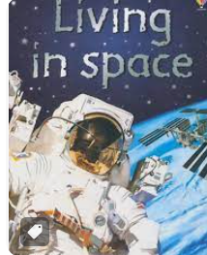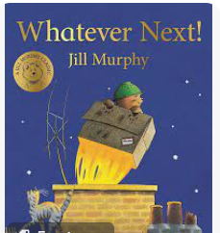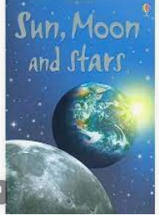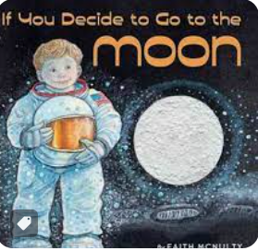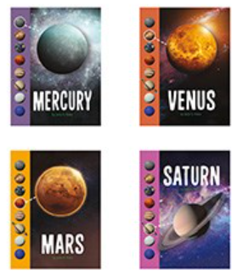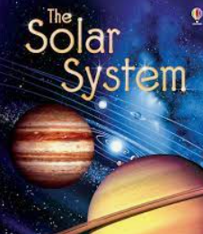  https://usborne.com/gb/quicklinks/quicklink/14562-living-in-space  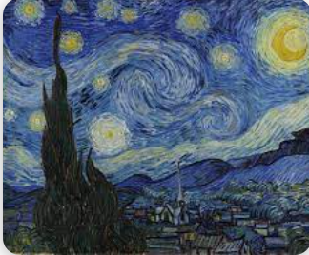 The Starry Night (1889) Vincent Van Gogh
Children working towards expected | Children who have achieved expected |  | Children working at greater depth

Week 1  Whatever Next | What do we know about Space? Where is it? What do you think is there?  Chn to mark make in floor book.  PSED/History | Read ‘Whatever Next’. Have a box with colander, wellies, picnic box, owl,teddy,apron for Mummy Bear,aeroplane.  Pick 3 chn to act out the story as we read it again. Order pics for floor book. Leave props in the Home Corner for chn to use.  Take props outside and use Ipad to create scenes.  PSED/C&L | Literacy: For Display  What shall we take on our picnic to the moon?  Revisit healthy eating in floor book and generate a list of items together.  Create a healthy picnic with cut and stick choices.  History/PSED | Literacy: For display  Chn to use photos from outdoor scenes to write their own story.  Sequence pictures from the story.  Write a list of props needed  Write and match initial sounds /cvc words of props
Week 2  What does an astrounaut do? | What is an astrounaut?  https://www.youtube.com/watch?v=jhD8GFwy734  Why do they wear a spacesuit?  https://www.youtube.com/watch?v=EN5OkKV7j5s  Mark make in floor book. Make spit pin astronauts.  Science/Geography | Why do astrounauts wear space suits?  https://www.youtube.com/watch?v=EN5OkKV7j5s  Talking about safety elements: cooling suit, helmets, glove, back pack,oxygen and boots.  Labelling a suit  Science | How do astronauts eat sleep and go to the toilet?  Twinkl PP Amazing Astrounats  Sample freeze dried bananas and space ice cream, talking about similaritires/differences.  How do astronauts eat custard?  https://www.youtube.com/watch?v=eYV4gl558xc  How do we wash our hair? Compare to how astronauts wash their hair.  https://www.youtube.com/watch?v=uIjNfZbUYu8 How to wash hair in space! Compare to  PSED/Science | Neil Armstrong: Add photo to timeline. Represent 55 years with cubes.  Why is he famous?  Look at photographs and discuss what they could be about?  Appollo 11 PP on Twinkl  First steps on the moon  https://www.youtube.com/watch?v=cwZb2mqId0A  Mark make in floor book.  History
Week 3 moon | Paxi visits the moon  https://www.youtube.com/watch?v=PxqltnER8E4&list=PLbyvawxScNbucdsnNdB9p89RmePmGv5cM&index=10  To live on the moon we need shelter, power, food and water.  Mark make facts in floor book then go into garden and build a moon shelter. Plant potatoes.  EAD/Science | What does it look like?  Read Sun, Moon and Stars book by Osborne, pg 14-21.  Why does he moon change shape? Can you name some of the different shaped moons? What is the moon made of? How are craters formed?  Craters of the moon experiment: Making predictions.  What happens when you drop pebbles into the mixture? Does the size of the pebble effect the size of the crater? Does the height you drop the pebble from effect the size of the crater?  Science Investigation | Read and discuss ‘If you decide to go to the moon’ book.  Make Shaving foam, pva glue and acrylic paint. Laye aper plates nad create craters. Discuss changes and rvisit yeaterdays learning.  https://rainydaymum.co.uk/diy-puffy-paint-moon/  Science/EAD | Robert Burns Day  History
Week 4 Earth | What is Planet Earth?  https://www.pbslearningmedia.org/resource/ddee6cc1-ba8e-4e46-8ca2-07432240853c/what-is-the-earth-young-explorers/  Draw Earth in floorbook and mark make facts around it.  Create planet Earth using shaving foam, pva glue and acrylic paints- colour-mixing techniques to match the globe.  EAD/Geography | What is the sun?  Mark make in floor book what we know.  Read Sun, moon and stars pg6-9. Use balls to represent how the earth turns as it moves around the sun: day and night.  Create a sun using college materials.  EAD/Science | Day and Night  Discuss the sun and moon and what happens at night/day time.  Sort pictures by day/night and discuss when we could do these both day and night.  Discuss healthy minds need sleep.  Science/PSED | The Starry Night (1889) by Van Gogh Photo, dark-coloured sugar paper (such as black or dark blue), chalks or pastels, charcoal.  How do you know that it is night time?  Show the children the The Starry Night Photo. Encourage them all to look closely at the piece of art.  Model swirls, circles and wavy lines using chalks. Create picture together.  EAD/History
Week 5  Solar system | Read The Solar System to pg7 and discuss how it started with swirling gas and dust. https://content.twinkl.co.uk/resource/ef/31/t-tp-2667369-early-years-topic-space-planets-in-the-solar-system-video-lesson_ver_1.mp4?__token__=exp=1690377215~acl=%2Fresource%2Fef%2F31%2Ft-tp-2667369-early-years-topic-space-planets-in-the-solar-system-video-lesson_ver_1.mp4%2A~hmac=926b7ebc18f5c286daf451578c6b9182a5db05d57533e78d591f2f800fca8ba6 Making a solar system using coat hangers EAD/Geography. | Use solar system craft from yesterday and discuss planets known: Moon, Sun and Earth.  Learn about Mercury and Venus using information books.  Science/Geography | Use solar system craft from discuss planets known: Moon, Sun Earth, Mercury and Venus.  Learn about Mars- What is a rover?  Create our own computer controlled rovers using recyable materials-Discuss what materials we need and how we can use different techniques to join it together. (flange,bending,folding)  Science/EAD | Use solar system craft from discuss planets known: Moon, Sun Earth, Mercury,Venus and Mars.  Learn about Jupiter and Saturn, using information books. A probe landed on Saturn and sent pictures to Earth.  Floor book facts.  Science/History
Week 6  Rockets and space ships | Use solar system craft from discuss planets known: Moon, Sun Earth, Mercury,Venus ,Mars, Jupiter and Saturn.  Learn about Uranus and Neptune. How are they the same or different?  Geography. | Climate Change: See Separate Planning  To be added on days: Chinese New Year and Pancake Day
Comments

