Autumn Term 2019
Issue 2 08.10.19
Macmillan Coffee Morning
It was fantastic to see so many of you at our Macmillan coffee morning on Tuesday 24th September. Thank you so much for all your kind donations of cake and money. We raised a grand total of £165 for this very worthwhile charity, which is fantastic!
School Parliament Visit to Alnwick
On Wednesday 2nd October, our school parliament and Mrs Dunn went to visit other children in our area that are also members of a school parliament. They had opportunities to learn about the parliament in the UK, make rosettes and present information to the whole group. Thank you to Mrs Dunn and to Swansfield Park Primary School in Alnwick for hosting this event.
Class 1 Soup Making  Thank you to class 1 and their parents and grandparents who were busy making soup this morning as part of our harvest celebrations. Great fun was had by all! | 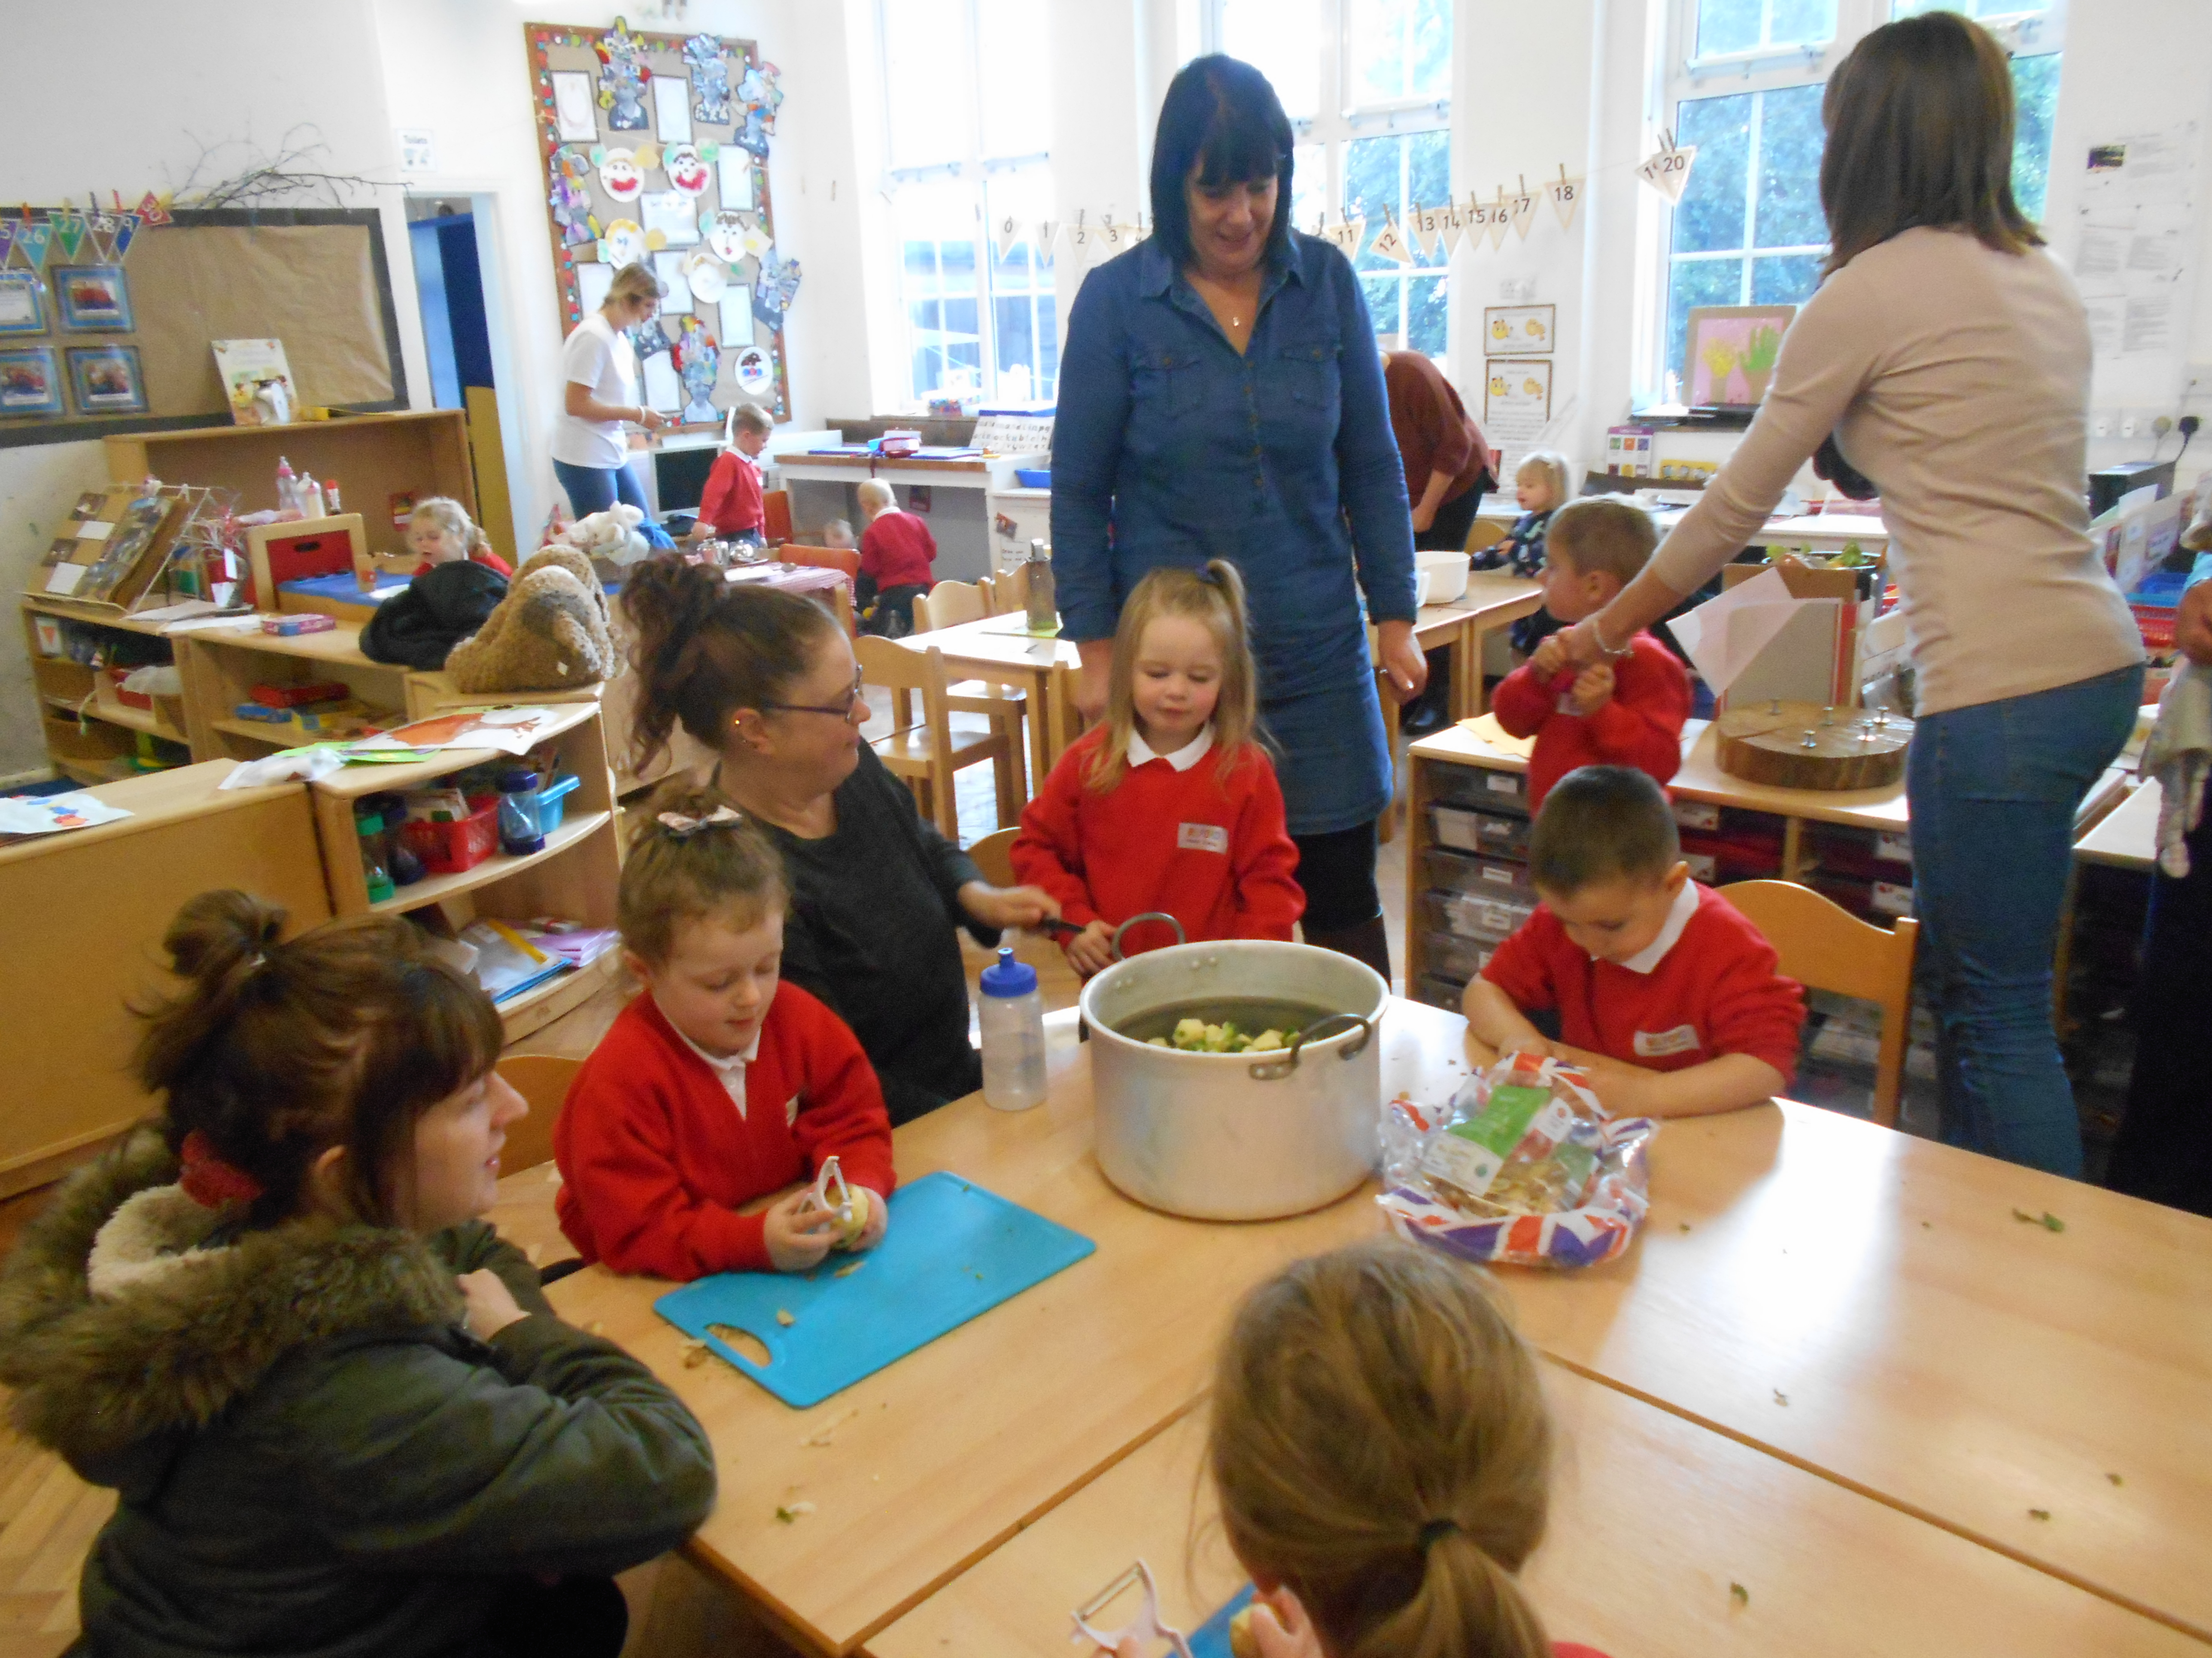
Class 2 Shared Lunch  The families of children in class 2 were in at lunchtime today to share a meal with their children. Our thanks go to Mrs Vallance and Mrs Dollin for making this a super experience! There will be other opportunities to share lunch with the children throughout the year. | Eco Council Elections  We had our first Eco Council meeting last week with our new school Eco Council. Congratulations to all the children that were successful in their class elections. The children are considering ways to improve recycling and reduce littering in the area.
Belford Show
Huge congratulations to all the children for their wonderful art work displayed at the Belford Show on the 28th September.
New Children  We are delighted to welcome three new children into our school, Oscar, Finn and Jess. We hope that they will be very happy at Belford Primary School. | Dates for the diary:  Thursday 17th October  Class 3 visit to The Sill, Hexham.  Friday 25th October  Class 3 family assembly at 9.00am  Class 1 Stay and Play session  9.20-10.30am  Wednesday 23rd October  Parent Consultation  Evening 3.30-6pm  An opportunity to meet with your child’s class teacher and see how they have settled into the new academic year. Letters will be sent home and you will be ask to select a convenient time slot.  Friday 25th October  Break up for half term at 3.15pm  Monday 4th November  Training Day for Staff  Tuesday 5th November  Return to school for children  Wednesday 6th -8th November  Year 6 residential to Kielder |  |  | Dates continued:  Monday 11th November  Whole School and Family Remembrance Service. St Mary’s Church, Belford.  10.30-11.30am.  Parents, carers and grandparents are very welcome to join us in the church at 10.30am.  Wednesday 20th November  Drop-in session for Operation Encompass.  3-4pm  Wednesday 11th December  Class 3 and 4 Christmas Production.  2pm in the school hall.  All are welcome to come and watch.  Friday 13th December  Class 1 and 2 Nativity.  9.30am  All are welcome to come and watch.  Tuesday 17th December  Pantomime day  Wednesday 18th December  Christmas Dinner and Christmas Jumper Day.  Friday 20th December  Christmas Carol Service  St Mary’s Church 9.30-10.30am
Harvest Festival Assembly
Thank you to all the parents, carers, grandparents and family friends who attended our harvest assembly this morning. It was a lovely to see so many of you here.
Thank you also for the donations of tinned and dried food which will I know be gratefully received by the Alnwick district food bank and elderly people in our community.

