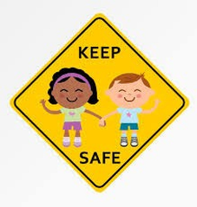
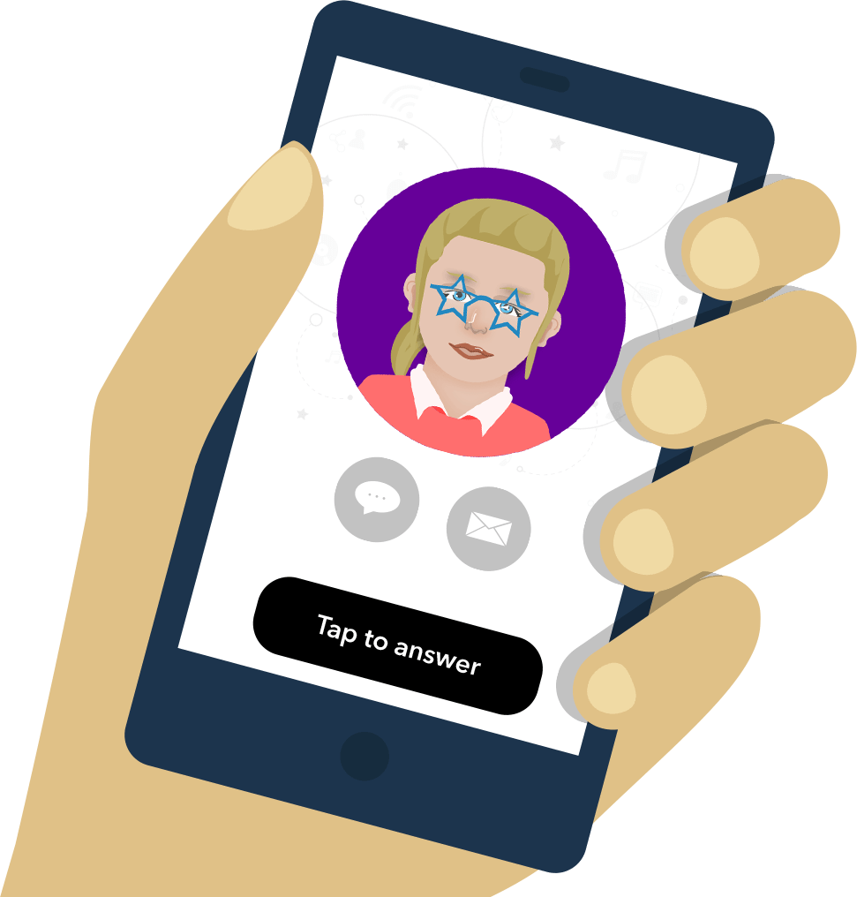
E–Safety Survey Results
February 2022
All children of Belford Primary School have access to the internet at home.
79% of children have a tablet/iPad at home, 27% of children have their own laptop at home, 42% of children have their own mobile phone with access to the internet and 33% of children have their own games console which has access to the internet.
18% of children access the internet in a shared family space, 15% of children use the internet in a shared bedroom and 67% of children use the internet in their own bedroom.
78% of children spend over 3 hours a day on the internet, 12% spend between 2-3 hours a day and 10% of children spend less than 2 hours on the internet.
89% have privacy control set up on their devices they use at home.
14% of children talk regularly to adults about how to stay safe whilst using the internet, 35% talk to adults sometimes and 61% of children never talk to adults about e-safety.
64% of children play games on the internet, 23% of children use the internet to chat to friends, 13% use the internet to help with their homework.
All the children who play games with their friends on the internet know them offline too.
All the children know what personal information must never be shared online.
None of the children have seen anything online they have felt uncomfortable with, and they all know to speak to an adult either in school or at home if they did.
All the children in Belford Primary School say they learn sufficient about online safety.
