Spring Term 2022
Issue 5 07.04.2022
World Book Day  On Thursday 3rd March, the children and adults across school enjoyed a fun packed and book filled day, with many dressing-up as their favourite book character.  The books by well-loved author, Julia Donaldson formed a focus for the day.  We have been delighted to see an increased interest in the children towards sharing books and reading and have recently purchased many new beautiful books for our school library. Happy reading everyone! |  | First Aid Training  As part of our Personal, Social and Health Education curriculum, the children in class 2, 3 and 4 learnt some very important life skills on the 23rd March – how to give First Aid and administer CPR.  The training was delivered by Ashleigh from Northern Training and was free of charge to school, which was incredibly kind and generous.  We were very impressed with how well the children listened and followed Ashleigh’s guidance throughout the day.
Cross Country  Great resilience and determination were shown by the children in years 1, 2, 3 and 4 who attended a large inter-school cross-country event at Longridge Towers on the 16th March.  Although we didn’t come away with any medals, we did come away with the knowledge that every child had tried their best and enjoyed the experience.  Well done to all the children who took part.  Football  The children are enjoying our new football posts, which were very kindly erected by several members of the Fairbairn family.  They are also continuing to have opportunities to compete with other schools in the Alnwick area, which is fantastic.  Netball  We now have a KS2 netball team and they have been training hard for their first match, which is next half-term. Good luck to them!  Mrs Moscrop will be running regular training opportunities after school on Wednesdays after the Easter holidays. This will be open to boys and girls in class 3 and 4.  Rugby  After Easter, the children in Class 3 and 4 will be having additional PE sessions every Wednesday afternoon. These will have a rugby focus and will be delivered by rugby coach Dougie, who the children know well. | Dates for the Diary:  Friday 8th April - Break for the Easter holiday  Monday 25th April – Back to school  Tuesday 26th April – Enterprise Day Class 4  Wednesday 27th April - Enterprise Day Class 2  Thursday 28th April - Enterprise Day Class 3  Friday 29th April – Class 2 first day swimming  Saturday 30th April – PTA stall at Belford Market  Monday 2nd May – Bank holiday (school closed)  Tuesday 3rd May – Parent meetings Class 3  Wednesday 4th May – Class 2 Alnwick Gardens  Thursday 5th May – Parent meetings Class 4  w/c Monday 9th May – SATs week for Year 6  Monday 9th May – Parent meetings Class 2  Wednesday 11th May – Parent meetings Class 1  Friday 13th May – Pjamarama Day (story telling)  w/c 16th May – Walk to School Week  Tuesday 24th May – Platinum Jubilee celebration  Friday 27th May – Break up for half term  Monday 6th June – Training day  Tuesday 7th June – Back to school  Tuesday 7th June – Class 4 trip to SJP (NUFC)  Saturday 18th June – Family Football Fun (PTA)  Wednesday 6th July – Year 6 visit to DCHS  Thursday 7th July – Year 6 Beach School with Seahouses Year 6 children.  Friday 22nd July – Break up for summer holiday
Amazing Africa!
What a wonderful week we have had learning about the incredible continent of Africa.
On Monday we learnt about Islam from Ismael and Daniel, who work for the Islamic Diversity Centre in Newcastle. They were very informative and kind.
Dancing and music were the focus on Tuesday. All the children across school enjoyed learning about the music and dance of Zimbabwe from a very special visitor, Butshilo.
On Wednesday morning we learnt about life in Kenya from Jos and Maggie’s grandparents. They delivered a fascinating assembly about their time living in Kenya.
We have also used a variety of beautiful picture books to enhance our learning and have created some super writing and art work.

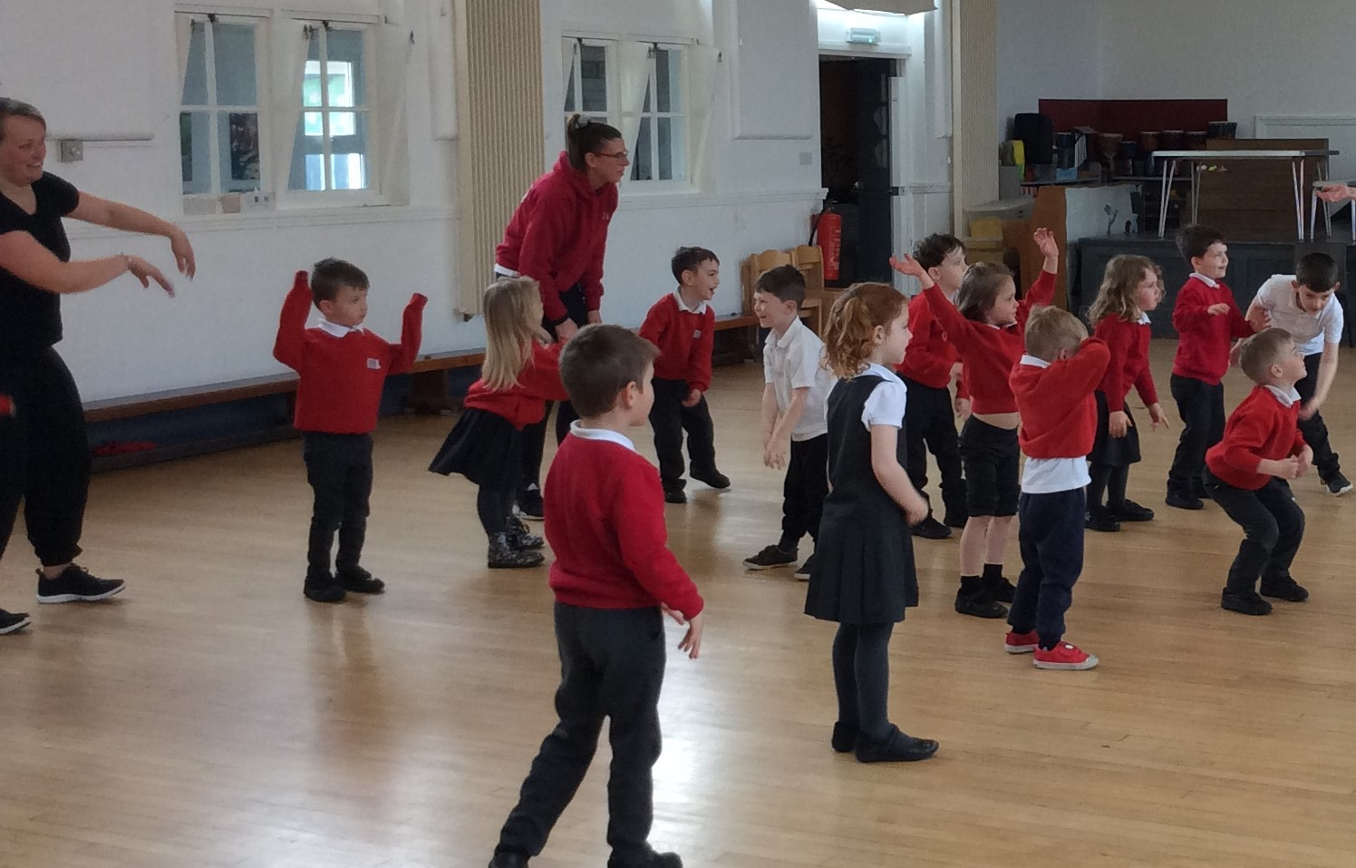
Class 1 enjoying their dance workshop with Butshilo.

Egg Decorating Competition
Thank you to all the children and their families for the wonderful entries to our decorate an egg competition.

We are pleased to announce the following winners:

Class 1: Oscar, Corey and Dexter
Class 2: Emily, Daizie and Flo
Class 3: Jesse, Amy and Faye
Class 4: Megan, Mason and Rosie

Our thanks go to the Co-op who generously donated the Easter egg prizes.
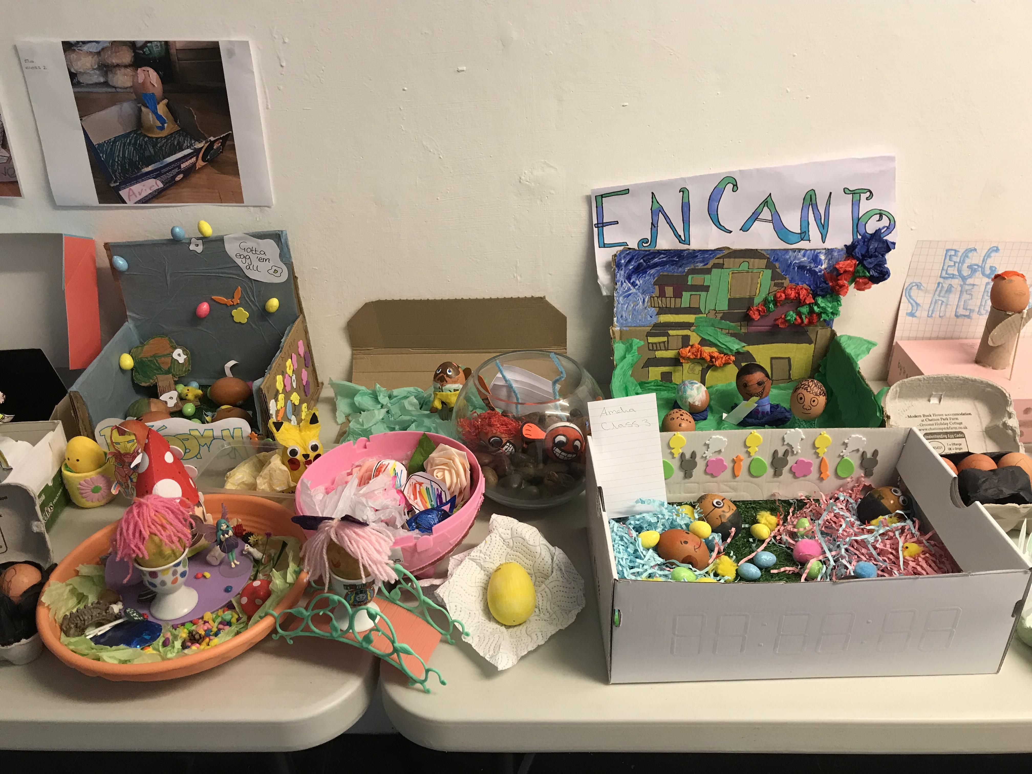

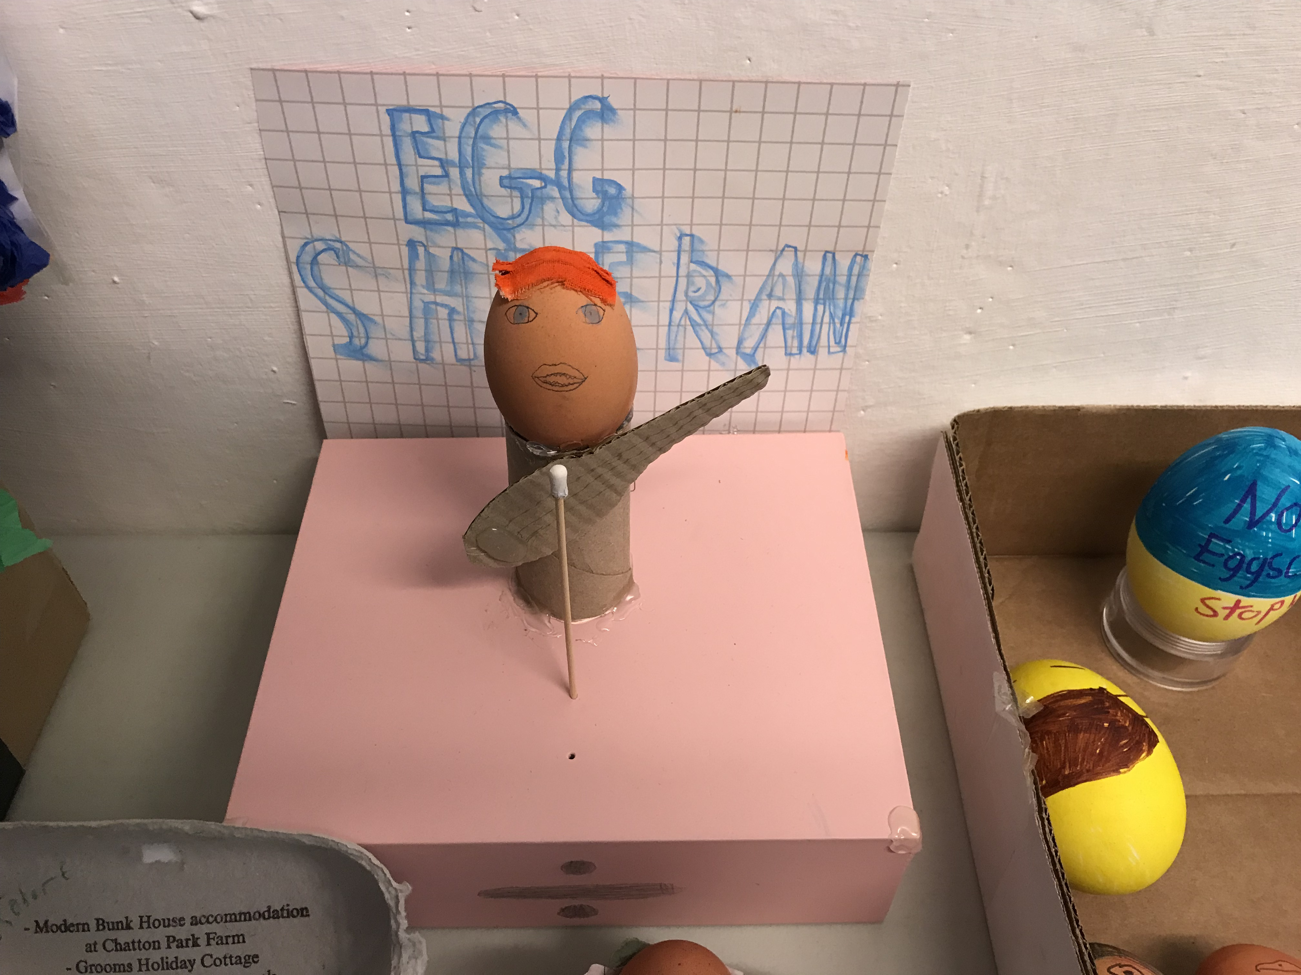

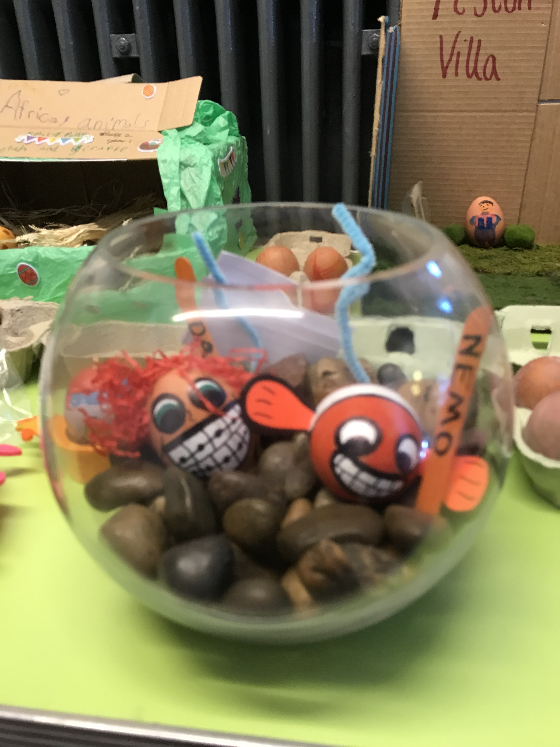

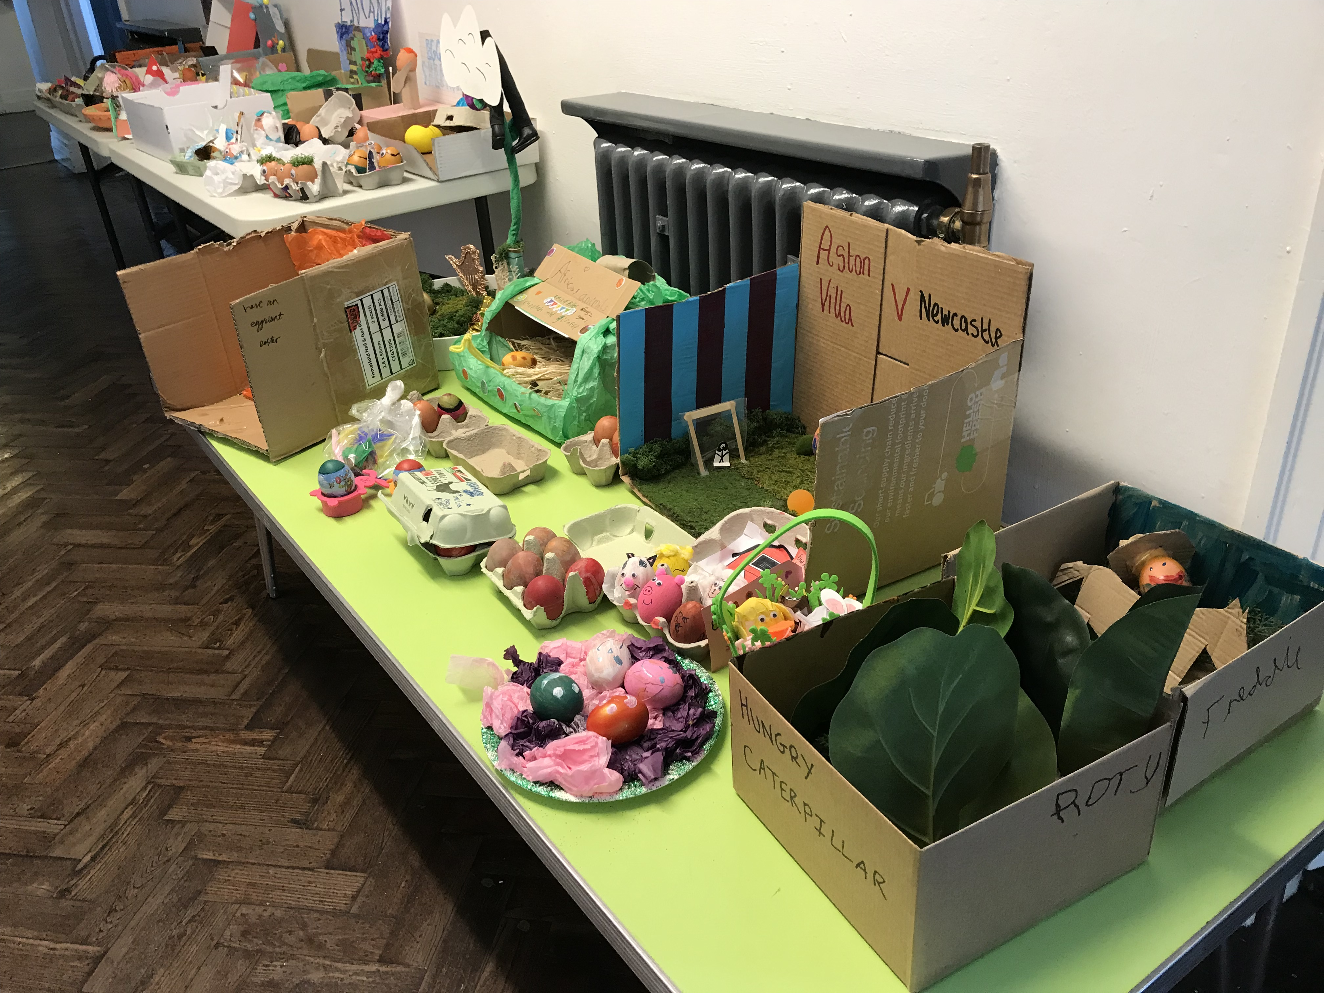

Cake Sale
Thank you to the Eco Council and to all who generously donated cakes for our cake sale last week and to the children who bought and enjoyed them.
£105. 87 was raised and has this been donated to the Marine Conservation Society.

 | Quilting Workshops  Class 4 enjoyed a special quilt-making day with local artist, Pat on the 7th March.  Pat was impressed with the stitching and finished pieces of work created by the children.  This completes our work with The Granary Gallery in Berwick for this academic year.  Our thanks go to Val who organised the quilting project and to Pat who shared her expertise with great patience |  | Litter Pick  Thank you to the Eco-Council, children, parents and staff who worked together to pick litter around Belford on Saturday 2nd April.  We collected 7 bags of rubbish in total!
 | Outstanding Achievement Awards  Congratulations to the following children who have demonstrated outstanding achievement this half term: James, Jay, Mason, Alfie, William, Rosie, Megan, Emelia, Elliott, Corissa, Jazmin, Isobel, Eva, Ava, Faye, Tom, Jesse, Archie, Harrison, Oscar, Olly, Ethan, Isla G, Demi, Jacob, Caelan, Lukas and Liam. |  | Happy Easter  Have a wonderful Easter everyone.

