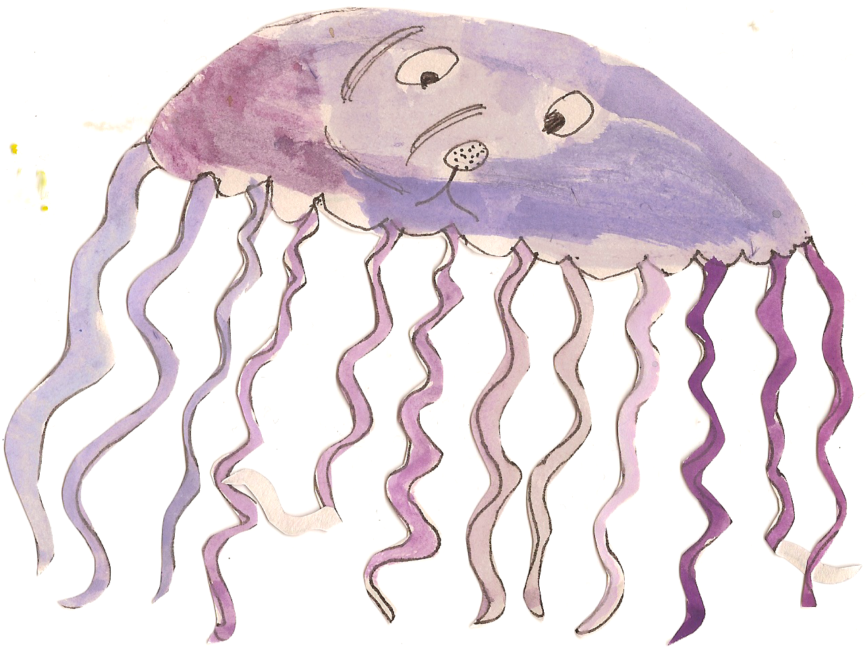

**Our topic this Term will be: Are we there yet? Where does the snow go?**

**Personal Social and Emotional Development**

Bike wash- Can describe self in positive terms.

Read ‘Emperors Egg’- discuss what makes a family and how we are all different.

Bother and Best Book- Introducing a book where the children can record their problems and show how they have solved them.

**Communication and Language**

Read ‘The journey’- play I spy games.

Read Past Times and discuss different forms of transport over the years.

Children to explore a winter box-using topic related language and retelling events.

Reading Jack Frost- talking about what we know of frost and ice



**Numeracy**

Measuring- using non standard units to measure heights of penguins.

Traffic tally in the village.

Bar chart- most popular form of transport to get to school- language of more/fewer.

**Physical Development and Health Care**

Traffic light games- stopping and starting games-following instructions.

Visit from Local Policeman- Learning about how they help us. Teaching us how to cross the road safely and to be more aware of the dangers around the road.

Weekly gymnastics session.

Weekly swimming sessions.

Taking care of our teeth- show an understanding of healthy practises.

**Expressive Arts and Design**

Designing and making egg cosies, investigating different materials.

Learning a repertoire of songs- five little spacemen, the runaway train, she’ll be coming round the mountain.

Designing a super car- planning, problem solving and joining materials, choosing colours for

a purpose.

Making a dragon puppet- Using a variety of materials.

Make a shield and decorate it with different materials- Using tools safely.

Dragon dust leads trail into the Forest School- Being imaginative.

Find a nest of dragon’s eggs? What shall we do? - Sustained shared thinking.

**Literacy**

Power of Reading- The Emperors egg. Exploring descriptive language and learning about different settings.

Read ‘Going on a bear hunt’ sequence story without props. Re tell the story Pie Corbett Style. Using instruments to compliment the story.

Read ‘The journey’- interest in illustrations, using vocabulary influenced by books.

**Understanding the World**

Freezing and melting- investigating how to make ice and what makes it melt.

Habitats- Exploring how animals are adapted to the environment in Antartica.

Police Visits- interested in occupations, safety, law of the land.

Discussing trips been on with family-forms of transport, retelling a past event, understanding we are different.

Bee Bot journey- programming bee bots linked to We’re going on a bear hunt.