Autumn Term 2020
Issue 4 18.12.2020
Panto Week  The children really enjoyed watching Jack and the Beanstalk on the 7th December. They created some wonderful art work and imaginative pieces of writing linked to the pantomime. Our thanks go to our fabulous PTA (the Friends of Belford), who funded this for the children. |  | Christmas Music Afternoon  Our class bubbles enjoyed an afternoon performing Christmas carols and songs on Monday 14th December, led by Mrs Humphries (our specialist music teacher).  They may not have had an audience in the traditional sense of the word, however each class sang their hearts out and each performance was recorded and put on our school Facebook page. We hope you enjoy listening…  https://www.facebook.com/BelfordPrimarySchool/
Christmas Dinner Day
We enjoyed a delicious Christmas dinner on Wednesday 16th December and our sincere thanks go to Mrs Vallance (AKA Cookie) and Mrs Dollin. Sadly, our class 2 bubble (including Mrs Moscrop and Mrs Dunn) missed out on this, but Cookie has promised to give them a treat in the New Year to make up for it.
Christmas Party Days  It has been lovely to see all the children enjoying their class Christmas parties this week. Here are class 1 tucking into their party food:  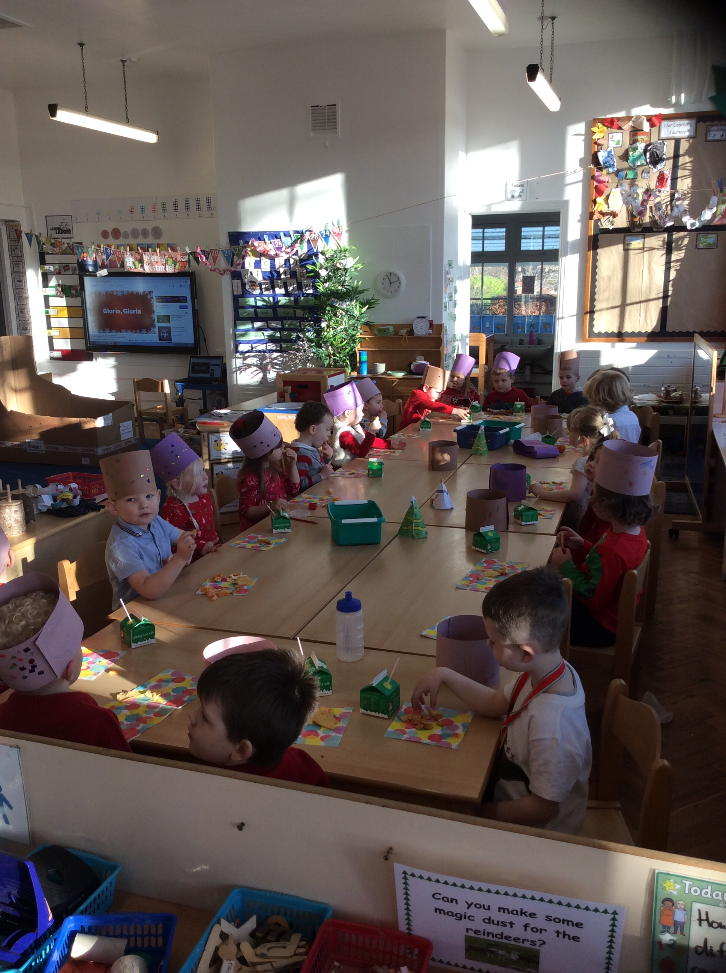 | Community Spirit  We have been overwhelmed with the generosity of our local community over the past two weeks. Staff members from our local Co-op have worked with the children in class 1 to create amazing bird feeders, members of St Mary’s, St Hilda’s and St Aidan’s church have created beautiful gift bags for the children, our ‘Open the Book’ assembly team have donated books and George Morrison has provided a selection box for every child in school. Our sincere thanks go to them all. |  | Santa Fun Run  We have really enjoyed taking part in a Santa fun run this week. The run was kindly organised by Mrs Dunn and the aim if the run was to promote physical activity. The children embraced this opportunity with enthusiasm and each child was awarded a fantastic medal at the end.  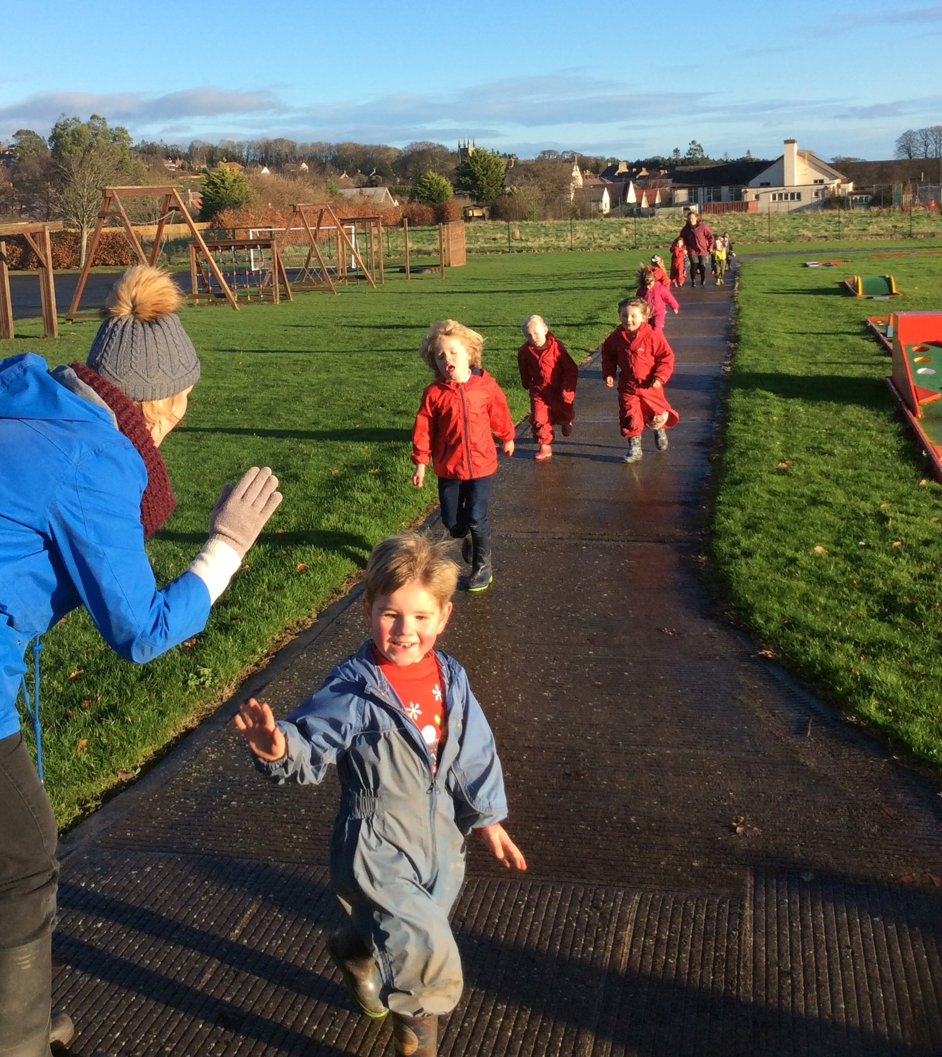
Merry Christmas
I’d like to take this opportunity to wish you all a wonderful Christmas and a very happy 2021.
I feel very fortunate to be the headteacher of Belford Primary and would like to thank all the staff at the school, the children and their parents for making our school what it is; a happy place to learn and grow!
Reading Challenge
We would love to know what your children will be reading over the Christmas holiday and have a little competition for them.
Please could you take a photo of your child with any books or magazines that they have read and either share it on their class Facebook page or bring the photo to school in January. There will be a class prize for the children who go above and beyond with their reading! Happy reading everyone.

