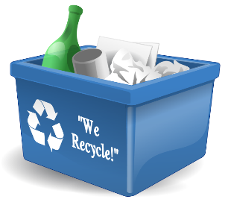
Top 10 Recycling Tips

Top Tip 1  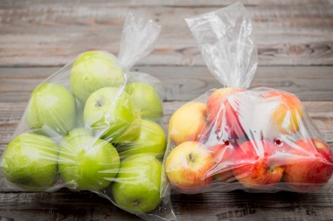  Buy fruit not in plastic bags | Top Tip 2  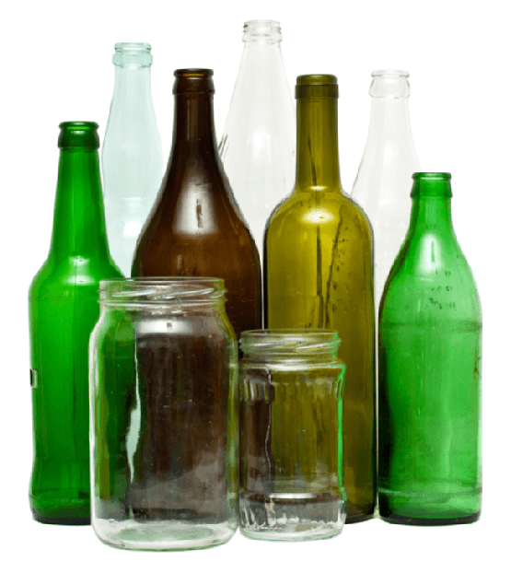  Take glass jars and bottles to the bottle banks | Top Tip 3  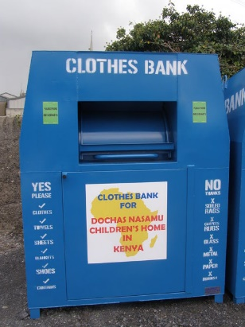  Put old clothes in clothing banks | Top Tip 4  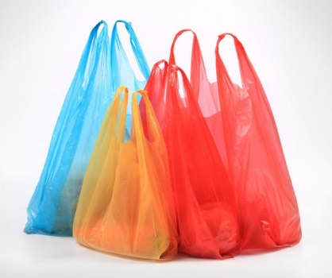  Reuse plastic carrier bags | Top Tip 5  Use scrap paper for notes
Top Tip 6  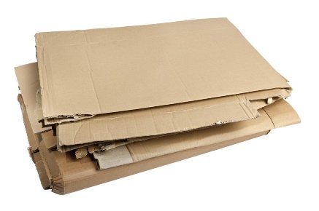  Flatten cardboard boxes so you can fit more in your bin | Top Tip 7  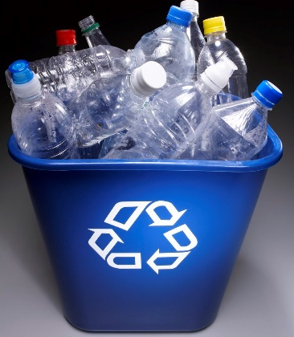  All plastic bottles can be recycled | Top Tip 8  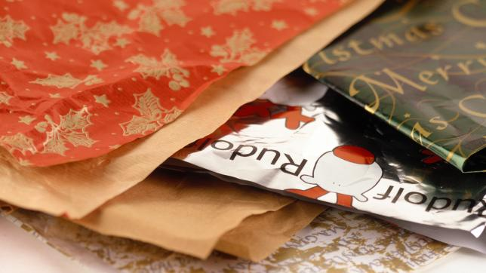  Recycle wrapping paper, envelopes and card | Top Tip 9  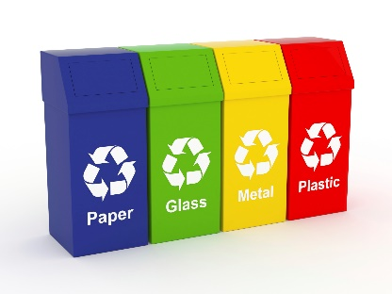  Make sure you use the correct bins when recycling | Top Tip 10  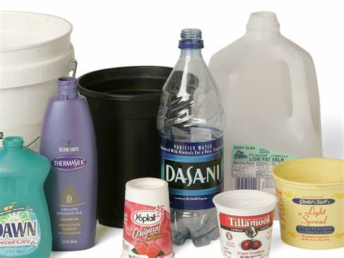  Wash out recyclable food containers. Use the end of your dish water to quickly rinse out milk cartons, tin cans, jars etc, this saves water too!
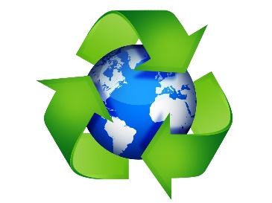
Created by Belford Primary School’s Eco Council

