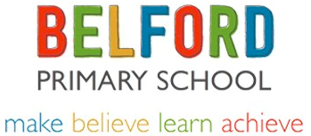
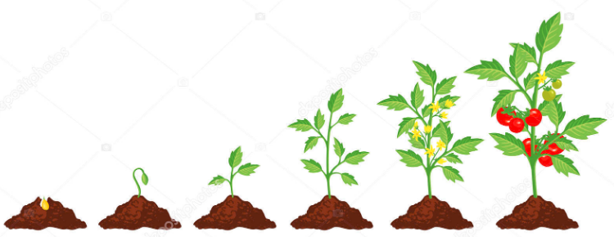
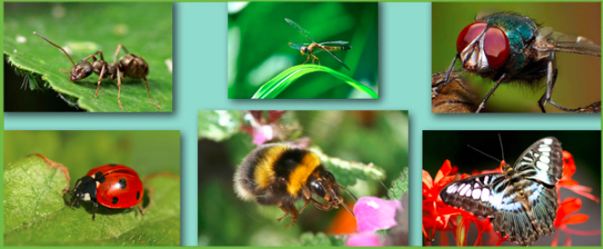
Class 2 – Summer Term

Topic / Science Work
Our Summer topic is Wriggle and Crawl and we will be learning about the variety of plants and animals in our local environment. We will explore the difference between things that are living, dead, and things that have never been alive. We will look at the different habitats we have in our local area and how they may be similar, or different, to habitats else where in the world. Children will be able to describe how animals obtain their food from plants and other animals, using the idea of a simple food chain.
To help develop children’s knowledge and skills even further, they will continue to investigate different hypothesis. During this they will be asking questions and recognising that they can be answered in different ways. They will perform simple tests and be able to explain how changing variables can affect the data they gather.
In art, children will develop their observational drawing skills further and use our surrounding environment to improve their sketching and shading skills.

Literacy
Children will continue to work on developing their language, grammar and sentence structures this term.
Children will carry out a range of writing tasks linked to this term’s topic and also look at a selection of fiction and non-fiction books to give children an engaging stimulus to write.
Children will be taught how to use a range of ambitious punctuation in their writing and how to extend their sentences to give more information to the reader.
In phonics, children will be working on many spelling rules and high frequency words needed to help them become successful spellers.
Numeracy
This term, children will continue building their confidence in the four operations of number (addition, subtraction, multiplication and division) during morning work, starter activities and arithmetic sessions throughout the week.
In Maths lessons, children will learn about different units of measurement and the equipment needed to measure weight, length and height, and capacity. Children will carry out practical experiments to help deepen their understanding.
Over the term, children will be practicing all the skills they have learnt this year in maths and applying these skills to help them solve problems and puzzles.
Children will be introduced to a new times table programme called Timestable Rockstars. This programme helps improve children’s confidence when recalling multiplication and division facts and also is proven to improve the speed and accuracy when answering calculations. This programme is an engaging and very successful programme and we are very excited to get all the children signed up to it. Children’s log in details will be sent home to give children the opportunity to improve their skills at home too.

PE and Swimming
Class Two will have PE twice a week.
Tuesday outdoors – Rugby- Children to bring jogging bottoms, a hoodie, a white t-shirt and trainers.
Friday at the Swan Centre- children to come into school in jogging bottoms and trainers, and bring a swimming costume to change into.
Class 2 children are enjoying the Active Mile initiative and we have seen a great improvement in the children’s stamina when running a mile. We will continue to work on improving our speed and stamina.

Homework
Children will receive homework linked to work they have been doing in class that week. Homework will go out on a Wednesday and should be returned no later than Tuesday the following week.

