**Scavenger Hunt**

Come up with a list of hard-to-find or hidden things in your house and give it to your child. Searching for the items can help keep both body *and* brain moving. Just be sure you match the quest with your child’s age and abilities. Here are some age-specific ideas:

**Variation for preschoolers:** Use pictures to show your child the things to try to find.

**Variation for grade-schoolers**: Write down a list of things for your child to look for, but leave some open-ended, such as “something you can draw with.”

**Variation for tweens**: Use riddles as clues. For example: Find something that gets wetter the more it dries. (A towel)

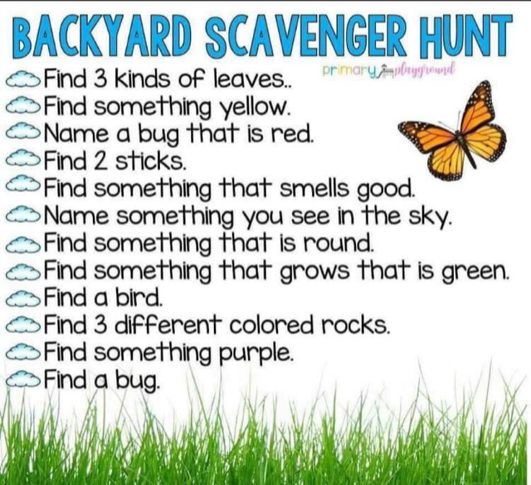

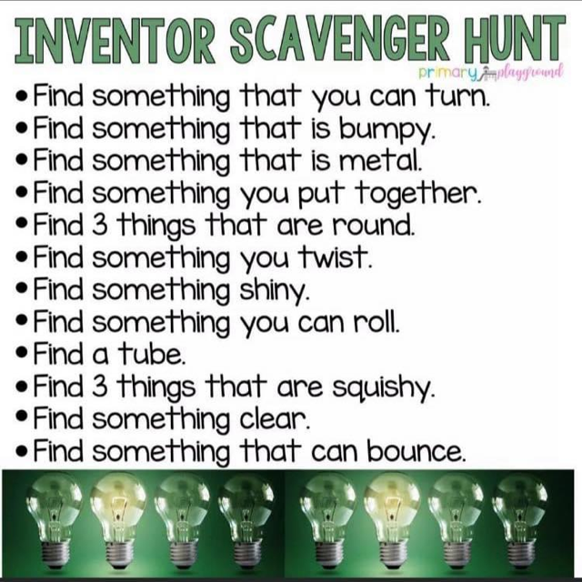

**Water-Bottle Bowling**

With five to 10 empty plastic water bottles and a soccer ball (or another ball about the same size), you can create a home bowling alley in your hallway. Use tape to mark where each bottle should go. And if you can, pour a little sugar, salt, sand, or even unused kitty litter into each bottle so they don’t tip over too easily.

**Variation for tweens:** Your child might enjoy “glow bowling” in the dark! Just add a glow stick to each bottle and turn the lights out.

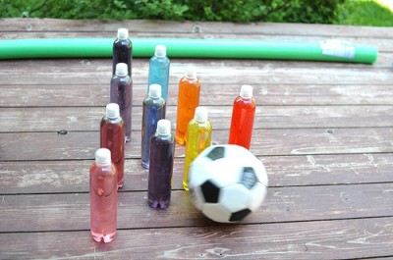

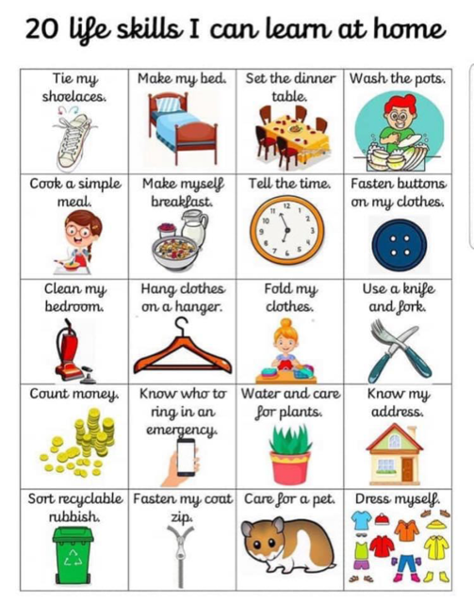

**WORD SEARCH, CAN YOU FIND THEM ALL?**

[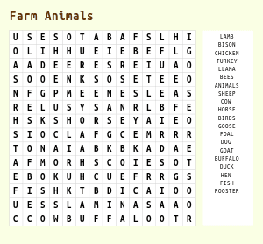](https://www.google.co.uk/url?sa=i&url=https://thewordsearch.com/printable/&psig=AOvVaw17f87C_pRPls8JlbcM0rl5&ust=1587114910840000&source=images&cd=vfe&ved=0CAIQjRxqFwoTCMjAuPbN7OgCFQAAAAAdAAAAABAE)

I LOVE CODES, CAN YOU WORK IT OUT?

[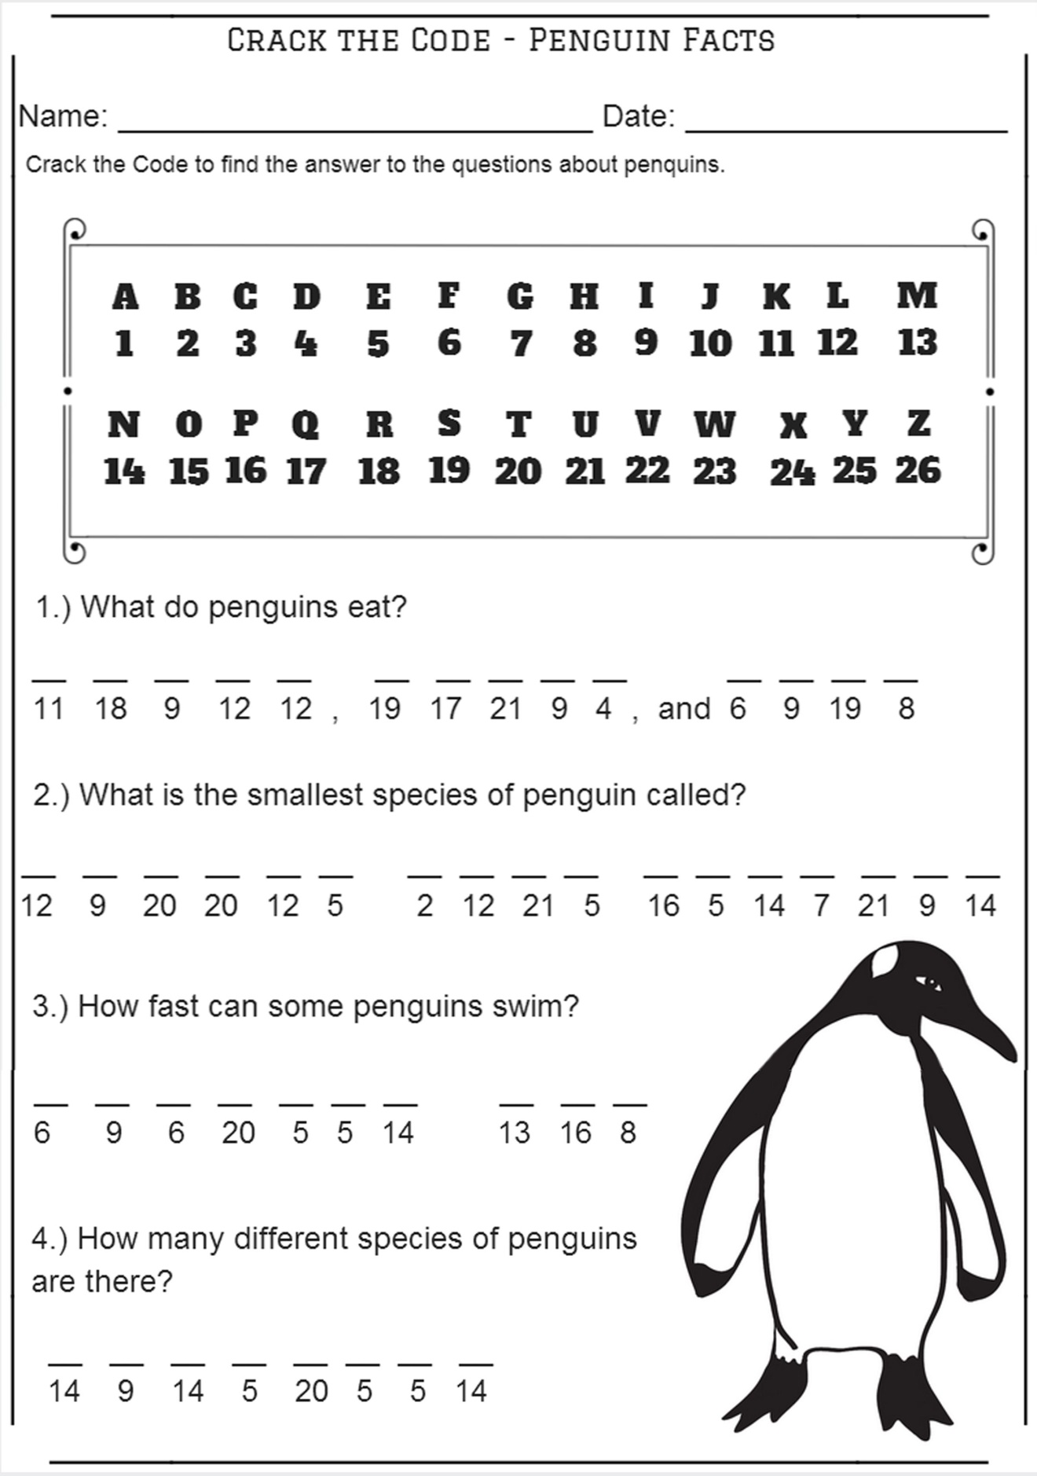](https://www.google.co.uk/url?sa=i&url=https://www.pinterest.com/pin/234679830558667943/&psig=AOvVaw06rTVSkDjT_1O4K_AKOLYD&ust=1587116819171000&source=images&cd=vfe&ved=0CAIQjRxqFwoTCNjw1oTV7OgCFQAAAAAdAAAAABAK)

**Craft fun**

Toilet roll animals, monsters, unicorns, wind socks, whatever you want to make.

I’m sure everyone will have loads of toilet rolls lying around!!!

[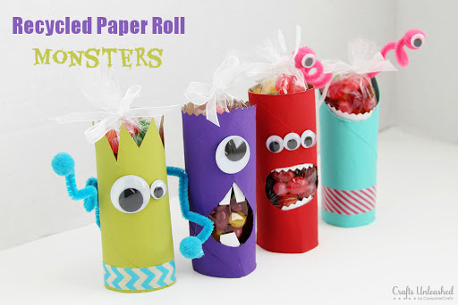](https://www.google.co.uk/url?sa=i&url=http://blog.consumercrafts.com/kids-stuff/toilet-paper-roll-crafts/&psig=AOvVaw0grWEYSGb_XKualOj5xPno&ust=1587118845284000&source=images&cd=vfe&ved=0CAIQjRxqFwoTCIjPxcrc7OgCFQAAAAAdAAAAABAE)

[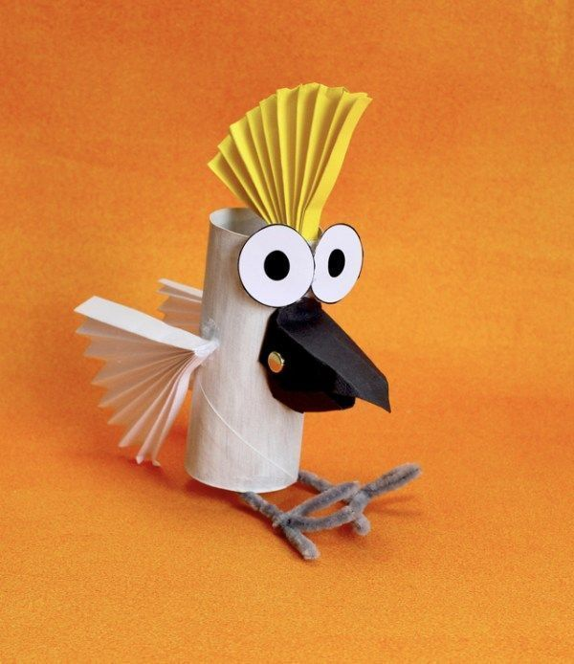](https://www.google.co.uk/url?sa=i&url=https://www.pinterest.com/pin/514395588688817967/&psig=AOvVaw0grWEYSGb_XKualOj5xPno&ust=1587118845284000&source=images&cd=vfe&ved=0CAIQjRxqFwoTCIjPxcrc7OgCFQAAAAAdAAAAABAi)

[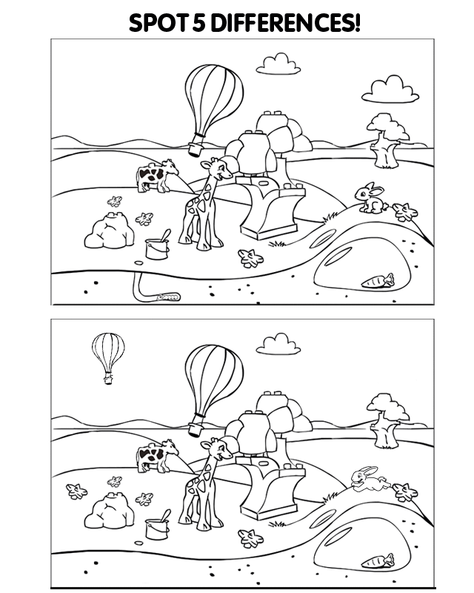](https://www.google.co.uk/url?sa=i&url=https://coloringhome.com/coloring-page/59468&psig=AOvVaw06BDME5IDofReVttfVBNWB&ust=1587117583420000&source=images&cd=vfe&ved=0CAIQjRxqFwoTCJi49fDX7OgCFQAAAAAdAAAAABAb)**GET YOUR CHALKS OUT**

[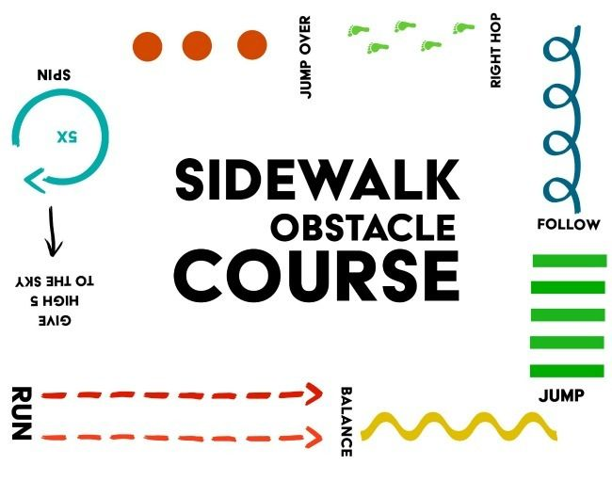](https://www.google.co.uk/url?sa=i&url=https://www.pinterest.com/pin/15833036172206028/&psig=AOvVaw2tDz8wkbxzDLjD1pij9-jV&ust=1587121233403000&source=images&cd=vfe&ved=0CAIQjRxqFwoTCJjZgr_l7OgCFQAAAAAdAAAAABAE)

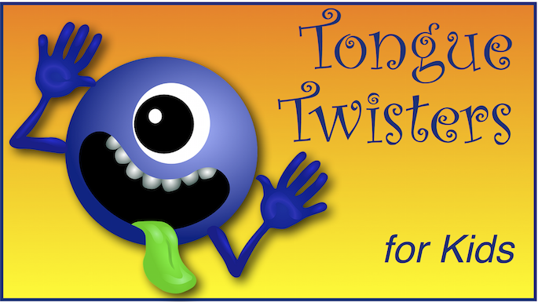

**Try these with your kids!**

* A cheap ship trip.
* I can think of six thin things and of six thick things too.
* Sam’s shop stocks short spotted socks.
* Fat frogs flying past fast.
* Red leather, yellow leather.
* Selfish shellfish.
* Shredded Swiss cheese.
* The crow flew over the river with a lump of raw liver.
* Red bulb blue bulb, red bulb blue bulb
* Peter Piper picked a peck of pickled peppers.
* Which wristwatches are Swiss wristwatches?
* Purple Paper People, Purple Paper People, Purple Paper People
* Six slippery snails, slid slowly seaward.
* Freshly-fried flying fish.
* How much wood could a wood chuck; chuck if a wood chuck could chuck wood
* She sells sea shells by the sea shore

**Just a few ideas to keep you going……**

Hunt for bugs

Paint the outside of the house with water

Make a ring toss game

Make a river out of aluminum foil

Build a tent using blankets

Draw around each other with chalk and color them in

Make shadow puppets

Attach ribbons to a stick and dance to your favorite music

Make tin can stilts

Have a picnic in the garden

Collect moss, bark and leaves and make a fairy/elf house

Draw a target on the ground and throw sponges or balls at it

Play balloon ball (like tennis)

Set up a tent indoors and have a sleep over with your toys

Make a necklace with macaroni

Colour Scavenger hunt, find and take photos of things the same colour as the rainbow