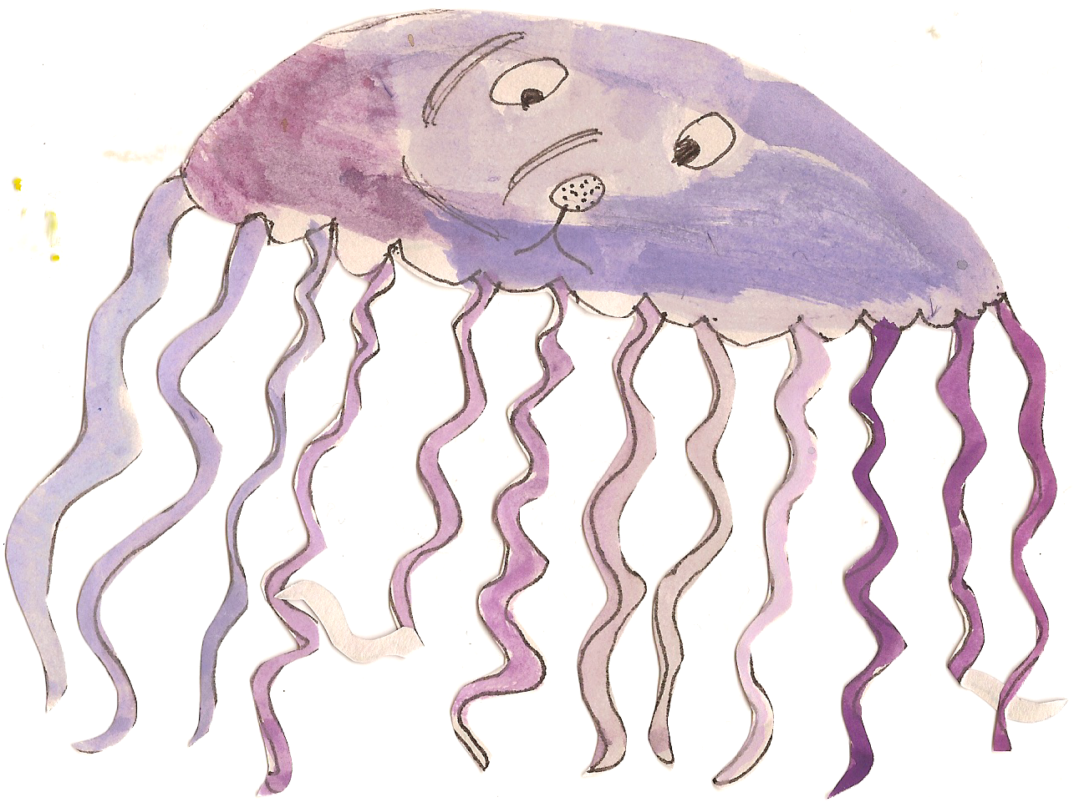

**Our topic this Term will be: What happens when I fall asleep?**

**Communication and Language**

Reading ‘Lauras Star’ by Klaus Baumgart- Discussing bedtime routines, the night, darkness, planets and stars.

Reading a letter from Mother Owl, who is not coming back. Philosophical thinking about the effects of this and how we can solve this problem.

Hot seating with Mother Owl and asking her questions- developing an understanding of a different opinion.

**Personal Social and Emotional Development**

Read ‘Owl Babies’ by Martin Waddell-Understanding actions affect others,

Working together to find class teddy and deciding what to do with it- sustained shared thinking.

Introducing feelings display- Aware of our own feelings.

Discussing Bother and Best- Learning how to solve problems fairly.



**Numeracy**

Sequencing bed time routines and talking about differences.

Counting how many owls on each page of book- estimating and comparing.

Moons and Stars- Children learn to use Paint on the computer to create different sized stars.

**Physical Development and Health Care**

Setting up bedtime challenges- Put on button up pyjamas, brushing teeth, washing face, put slippers on correct feet.

Gross motor skills outdoors- Painting the fence, throwing bean bags through hoops/ buckets, weeding the garden.

Learning to dress independently for PE/Outdoors.

Writing their name.

Weekly swimming sessions.

Taking care of our teeth- show an understanding of healthy practises.

**Expressive Arts and Design**

Drawing dramatic scenes using charcoal- exploring different media.

Building nests with sticks- problem solving.

Sing a song of sixpence nursery rhymes- building repertoire of songs.

Making a dragon puppet- Using a variety of materials.

Make a shield and decorate it with different materials- Using tools safely.

Dragon dust leads trail into the Forest School- Being imaginative.

Find a nest of dragon’s eggs? What shall we do? - Sustained shared thinking.

**Literacy**

Power of Reading - Owl Babies. Writing labels/captions about emptions throughout the story.

Designing a wanted poster asking for the Mother Owl to return.

Shared writing- writing letter to Mother Owl and waiting for a response.

Clapping out syllables of names.

**Understanding the World**

Sorting nocturnal /

crepuscular animals- Differences/similarities.

Researching owls and common garden birds - Using the internet/books.

Talking about sleep. Completing a sleep diary at home and sharing results with peers.

Why is it dark at night? Exploring the absence of light, using card bard boxes and torches. Making dens, using various resources to explore creating more light/ reducing light