CALLING ALL CRISP LOVERS
Did you know it takes 80 years for a crisp packet to decompose? Did you know that 150 of them can be ironed together and turned into a survival blanket for a homeless person and will help to keep their sleeping bag dry and insulated?
The iron man are collecting crisp packets and will be making these blankets. If you can collect them between now and Christmas we would be happy to take them off your hands! (Preferably washed first in warm soapy water)
Let’s try get as many in by the 3rd of December!!
If you would like to help this fantastic cause, please save your crisp packets, wash them out and put them in the box out side Belford Primary School’s front door.
Thank you
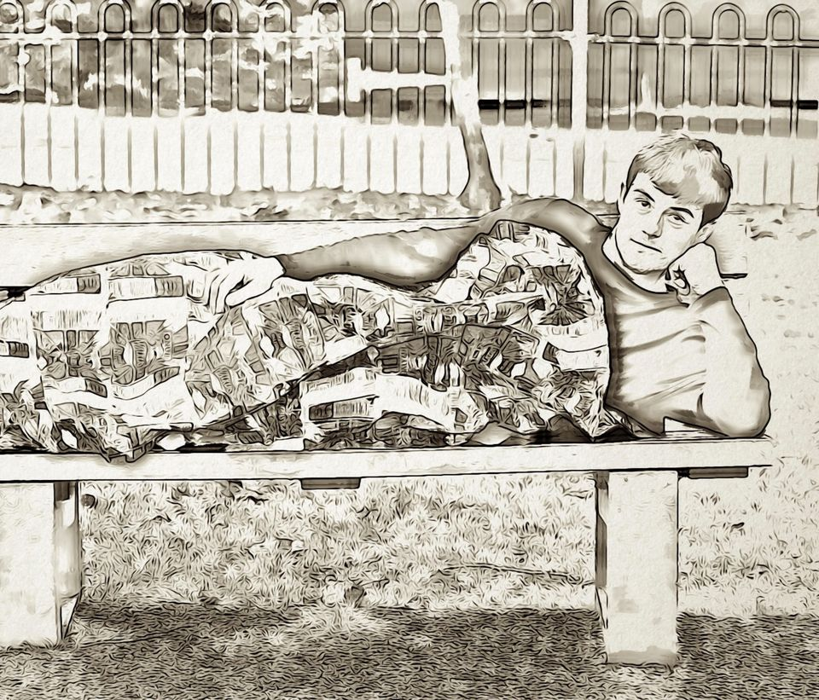

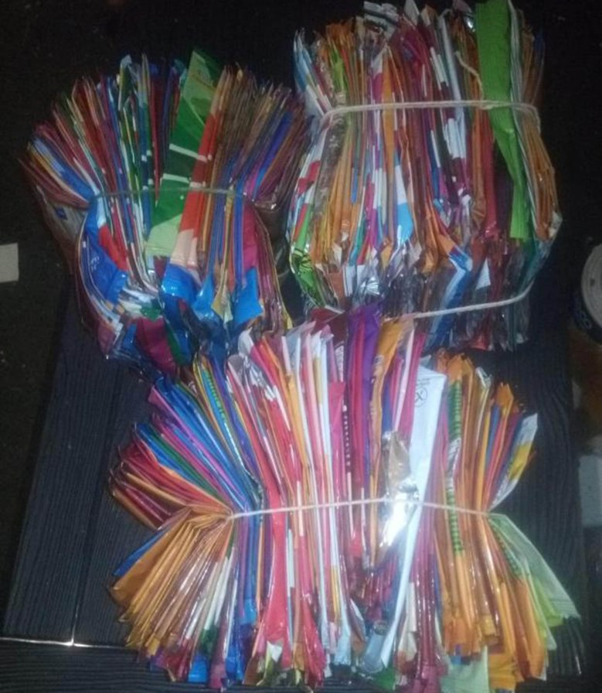
During November and December Belford Primary School’s Eco council started collecting crisp packets to send to the ‘Iron Man’ who uses them to create survival blankets for homeless people. The children created poster that were shared around Belford so the whole community could take part.

