Autumn Term 2023
Issue 1 22.09.22
New Music Teacher  We are delighted to welcome Mr Easton to the Belford staff team. He will be teaching ukelele to the children in Class 3 and Class 4 every Thursday morning.  Mrs Cochrane is busy working on her PhD studies this year, so we won’t be seeing as much of her I’m afraid. We wish her well though and hope that she will pop in and see us from time to time. |  |  | Yoga  The children in Nursery, Reception, Year 1, Year 3 and Year 4 have really enjoyed their weekly yoga sessions with Rhiannon from Yogibairns. Sessions are every Wednesday morning.
Safeguarding Updates:
All staff attended safeguarding training on Monday 4th September. Every member of staff now has a clear understanding of their safeguarding responsibilities and is aware of the updated DfE document: Keeping Children Safe in Education 2023 (statutory guidance produced for schools and colleges).

KS2 Play Leaders:  This half term, a group of class 4 children have volunteered to be play leaders. Thank you to Faye, Robert, Anastasia, Connor, Oliva G, Amy, Arron, Eva, Grace and Ava.  They will be helping our younger children learn new games and activities at playtime. | 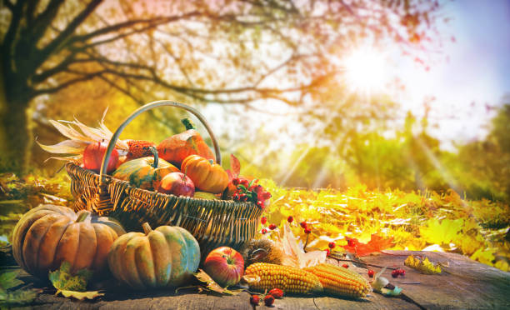 | Harvest Assembly and Food Donations  We would like to invite parents and family members to join us on Friday 20th October for a special Harvest assembly. The assembly will start at 9.00am.  If you are able, we would welcome any tinned food donations on the day, which we will then donate to our local food bank to support local families in need.
Macmillan Coffee Morning
We are holding a coffee morning on Friday 29th September at 10.00am to raise money for Macmillan, who do a fabulous job supporting people living with cancer.
This will be the perfect chance to catch up over a cuppa and a slice of something delicious for a great cause.
he coffee morning is open to parents and grandparents and will be held in the hall. We are making this an adult only coffee morning. The children will all have an opportunity to buy cake at playtime, if they wish.
If you are able to make a cake donation and / or come along and join us on the day, that would be wonderful.

School Parliament Representatives
Congratulations to the following children who have been voted onto our new School Parliament: Faye, Olly, Rowan, Alexander, Emily, Devin and Zara.
They were presented with their special badges in assembly this morning. We are certain that they will do a super job representing the children across school.

Eco Council
Representatives
Congratulations to the following children who have been voted onto our new Eco-Council; Nathaniel, Willow, Anna, Rogan-Lee, Carson and Dawson.
They were presented with their special badges in assembly this morning.
These children have a special interest in looking after our school, community and our planet!
Well done to them!

Dates for the Diary
October is Walk to School Month

Thursday 2.45pm Class 2 Information Session for Parents and Carers

Saturday 30th September, Belford Show

Tuesday 10th October, First Aid Training for children across school

Friday 20th October, Harvest Assembly at 9.00am

Thursday 26th October, Children break up at the end of today for Half Term.

Monday 6th November, Back to School

Wednesday 15th November, Into Film Festival at Seahouses for all children from Reception to Year 6.

Wednesday 13th December, Pantomime morning for all children from Reception to Year 6.

Friday 22nd December, Break up for Christmas holiday

