Mental Health and Wellbeing
Signposting for Families

Five Ways to Wellbeing
https://www.nhs.uk/mental-health/self-help/guides-tools-and-activities/five-steps-to-mental-wellbeing/
Five ways to improve your mental health and wellbeing. Trying these things could help you feel more positive and able to get the most out of life.

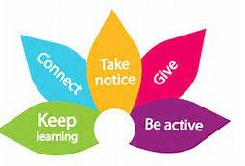

Home CAMHS Resources
https://www.camhs-resources.co.uk/
For young people, carers and professionals. lots of helpful resources from across the internet that are available to help support your mental health and well-being

Apps
A range of apps are available to support young people, adults and families with their mental health and well-being. Home CAMHS has a helpful guide.
APPS | CAMHS Resources (camhs-resources.co.uk)

BBC Parents’ Toolkit: Wellbeing advice for parents to support their child
https://www.bbc.co.uk/bitesize/articles/znsmxyc
Health and wellbeing advice for parents to support their child - from food and sleep, to anxiety and the online world

Mind
https://www.mind.org.uk/
Mental Health information and support for adults, children and teenagers. Find local services.

Young Minds
https://www.youngminds.org.uk/parent/parents-a-z-mental-health-guide/
A charity supporting children, parents and those working with children and young people.
Anna Freud National Centre for Children and Families
https://www.annafreud.org/
A mental health and wellbeing charity that offer evidence-based advice to young people, parents and teaching professionals. They also signpost to local services.
Place2be
https://www.place2be.org.uk/our-services/services-for-schools/mental-health-resources-for-schools/
Mental health resources for schools.

