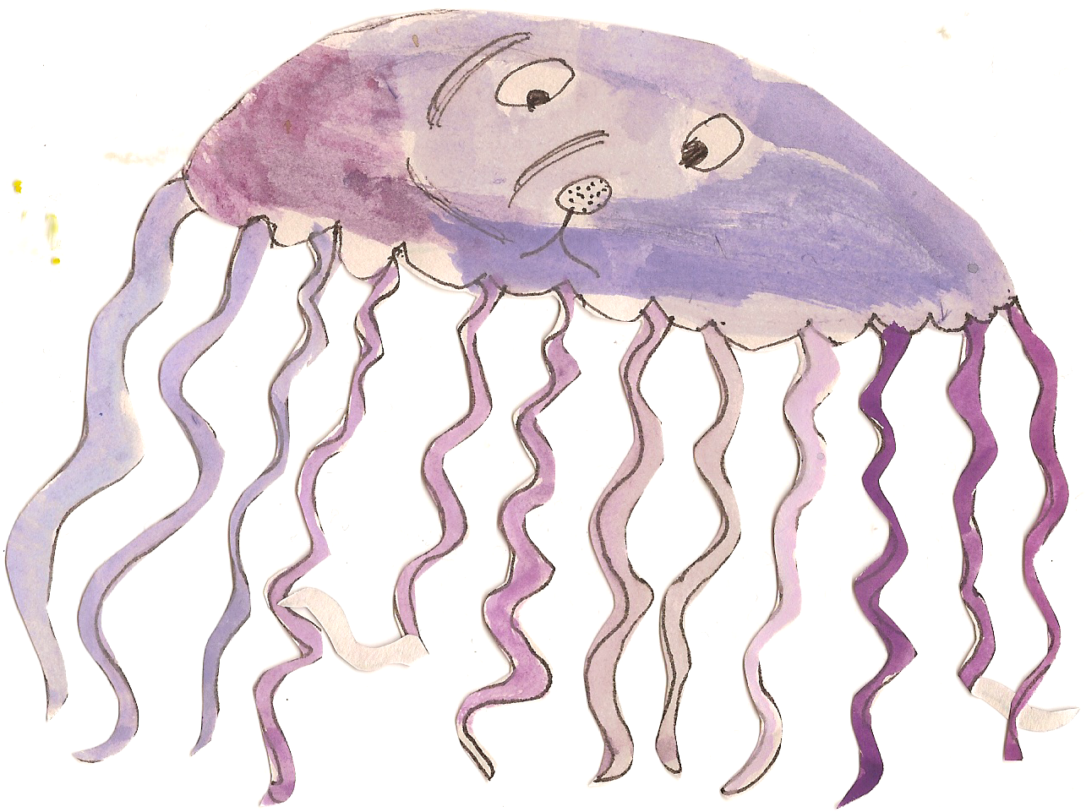

**Science Work**

Children will be learning to:

* identify common appliances that run on electricity
* construct a simple series electrical circuit, identifying and naming its basic parts, including cells, wires, bulbs, switches and buzzers
* identify whether or not a lamp will light in a simple series circuit, based on whether or not the lamp is part of a complete loop with a battery
* recognise that a switch opens and closes a circuit and associate this with whether or not a lamp lights in a simple series circuit
* recognise some common conductors and insulators, and associate metals with being good conductors

**Topic Work**

Class Three will be learning all about the ‘Ancient Egyptians’. In our topic sessions the children will be learning:

* To locate ancient Egypt in time.
* To learn about how the Egyptian landscape impacted on people’s lives in Ancient Egypt.
* To find out about Tutankhamen and how artefacts can teach us about the past.
* To understand the importance of artefacts in helping us find out about the past.
* To find out about the way of life in ancient Egypt.
* To learn about Egyptian tombs, pyramids and burial sites.
* To explain the location of Egypt using geographical language.
* To describe the climate of Egypt and explain some of the contributing factors.
* To compare the uses of the River Nile for Ancient Egyptians compared to modern day people.
* To understand how the Sahara desert affects the people of Egypt.

**PE and Swimming**

Class Three will have PE twice a week.

**Monday - Indoors or outdoors depending on the weather -** Children to bring shorts, white t-shirt, jogging bottoms, a warm jumper and trainers. This half term a NUFC coach will be teaching the children.

**Thursday – Indoors.** Children to bring shorts and a white t-shirt for gymnastics with Mrs. Rainey.

**Numeracy**

At the beginning of the half term the children will be focussing on their understanding of number through place value. We will be looking at place value in negative numbers, 2 digit, 3 digit and 4 digit numbers.

We will also be learning to read Roman numerals up to 100.

We will then be moving on to mental and written addition and subtraction and looking at the relationship between the two operations. The children will also be applying these skills by solving problems which involve money and measures.

**Literacy**

Initially, we will be focussing on basic skills. We will spend time re-capping and practising simple punctuation, spellings, handwriting and sentence structures.

Then we will move on toplanning, drafting and writing extended pieces of writing in a variety of genres based around a fiction book. We are going to focus on writing for a purpose, for example to write a setting and character description to include in a story. We will also be practising our grammar and punctuation and including these in our independent writing.

Please continue to practise spellings each week at home. Children each have a spelling book to take home and will be tested every Friday.