Theme: Homes around the World Term: Spring 2 Year: 2024
Key Knowledge and Skills |  | Key Questions
To be able to name some of the countries that are in the United Kingdom.  To know that Northumberland is a County made up of towns and villages.  To know that they live in a village called Belford.  To be able to look at a map of the village and identify roads, rivers and fields.  To know that houses are built from different materials around the world. |  | Which countries make up the United Kingdom? Which country do you live in? What is the village called where we live?  Can you tell me some of the facilities that are in the village?  Where is the road, river or fields on the map?  What different types of materials is this house made from? How do you know that?  What can you tell me about the Easter Story?
Key Vocabulary |  | Key Content
United Kingdom, England, Scotland, Wales and Northern Ireland.  Globe,atlas, map,  Country,County,City,Town, village, countyside, rural,urban  Cottage, bungalow, detached, semi-detached, flats,appartments  Wooden frame, thatched roof, leaves, mud, clay, ice  Roma,gypsey, traveller, horses,caravan  Fire fighter,electric,hair straighteners, lighter, matches, fire, flame, plug socket, phone charger , 999  Easter,God, Jesus, cross, reserection, Palm Sunday, Good Friday |  | The children will learn that Belford is a village in Northumberland. They live in England which is one of four countries that make up the United Kingdom.  They will be given opportunities to compare past and present homes and toys. They will compare and sort their own toys to Victorian toys.  The children will be introduced to different types of houses around the world and learn why they are made of different materials. They will compare these to their own homes.  They will learn what objects can harm them at home and how to stay safe in the home environment.  They can experience life as a Roma Traveller and compare it to their own lives.
Links to Previous Learning:  The children have learnt about the Solar System and know that Earth has air, water and plants. |  | Cross Curricular Links:  Text Cbeebies  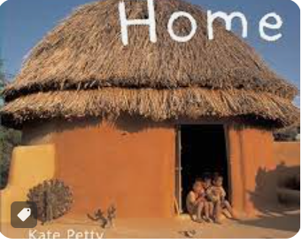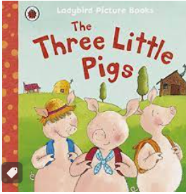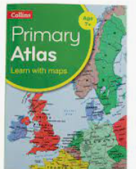
Children working towards expected | Children who have achieved expected |  | Children working at greater depth

Week 1  The United Kingdom | Globe  Revisit what a globe shows us: Earth is land and sea.  Discuss continents and oceans. Find the Uk and discuss Mrs Rainey’s trip to Australia. Make a large college showing the continents.  Geography | Atlas  Let the chn explore the atlas’ and talk about what they think it is.  Learn that the UK is made up of 4 countries.  https://www.youtube.com/watch?v=kU_SpzWKtqE  Who has been to London or Lake District? Castles and Lakes. Edinburgh and Loch Ness. Wales, Cardiff and Snowden. Ireland, Belfast and ships.  Use different coloured bottle lids to create a map of the UK. Learning how to use a spatula.  Geography. | Map of Belford/google maps  Explore google maps, satellite view: what places can we find? Can we find our homes, shops, churches, park etc  Map view: I wonder what the blue blues represent? How about the white lines, the tags etc.  Chn to create their own maps drawing the roads, the burn, tags for Coop, school, church and park.  Geography/EAD | Comparing a village and town: Belford and Alnwick  Sorting photographs and different facilities in Belford and Alnwick. Which has more? What does Belford not have?  Geography
Week 2  Different types of houses | St Patricks Day/ Ramadam | Comparing different types of homes and their surroundings. Twinkl PP  Mark make type of house they live in and with whom. Comparing similarities and differences.  Geography | Dangers in the home PP  Can we spot all of the dangers in each room? How do we stay safe at home? What dangers do you have in your house?  https://www.twinkl.co.uk/resource/dangers-in-the-home-powerpoint-t-tp-2682519  PSED | Walk to Fire Station to learn about smoke alarms and fire hazards found around the home.  PSED
Week 3 Belford Village | Visit to Belford Museum and learn about the ‘lost houses’, period clothes and why the village is known as the stage coach village.  Picture for timeline  Geography/History | Recall visit and new vocabulary. Create fact sheets about the Stage Coach Village or the artefacts that we seen. Print off pictures from visit.  Literacy/C&L | Topic Box-Items from the past  Picture for timeline  Let children explore the items and guess what they were used for. Compare with modern objects found around our homes.  Pics in floor book for chn to mark make.  History/C&L | Topic box-Toys from the past  Picture for timeline  Chn to bring in their favourite toy.  Watch videos on Toys from Past PP  Let children explore the items and guess what they were used for. Compare with chns favourite toy that they brought in. Sort by different criteria’s.  Pics in floor book for chn to mark make.  Play dominoes, snakes and ladders or ludo.  History/C&L/PSED
Week 4 Homes around the world | PP Homes around the World  America-tepees  Japan-wooden frame with slanted roofs for rain  Ethiopia-mud and clay hut  Northern Cananda-igloos  Compare to traditional brick house. Make a tepee in garden with string, canes and blankets.  Geography | Which home would you like to live in and why?  https://www.teachertube.com/videos/little-human-planet-homes-around-the-world-386131  treehouse, house on stilts, beach hut or jungle wooden hut?  Design your perfect house on a template and label- sticks, leaves etc  Geography | Make plasticine as a base to build our models on.  Chn working from their perfect house plans.  Review models and discuss what went well and what we can improve/add on.  EAD/C&L | Gypsy, Roma Traveller’s  https://www.twinkl.co.uk/resource/t2-t-16580-gypsy-roma-and-traveller-history-month-assembly-pack  A visit from a Gypsy to discuss their culture, life style, dancing and tell some stories.  History
Week 5  Easter | The Easter story  Chn to learn the story and draw a story map in floor book.  HIstory | How do we celebrate Easter?  Watch cbbc and discuss activities and going to church.  Make an Easter cross and decorate it with daffodils.  History/EAD | Walk to church with cross. Explore different artefacts in the church.  History | Easter baking

