

Belford Primary School

Compare your good level of development (GLD) data

November 2025

Version history
This page gives details of changes made to these reports.
Version | Changes | Date
1.2 | Updated to reflect 2024/25 Early Years Foundation Stage (EYFS) Profile data | November 2025
1.1 | First version of the report | September 2025

Summary
This report is specific to your school. It is a summary of your good level of development (GLD) data for the 2024 to 2025 academic year.
This data is based on the Early Years Foundation Stage (EYFS) Profile assessment completed by teachers at the end of the academic year in which a child turns 5. Children are assessed against the early learning goals (ELGs) set out in the EYFS statutory framework.
The report includes your school’s:
- overall percentage of children with a GLD compared to local authority (LA), regional and national averages
- overall percentage of pupils reaching each ELG compared to LA, regional and national averages
- GLD results for different pupil groups compared to LA, regional and national averages
- contextual GLD score, which is an estimate of your school’s GLD that considers your school’s context
- summary of areas where you are performing relatively well and areas to focus on
The supplementary tables provided alongside this report cover each of the twelve ELGs contributing to your GLD results. They provide more detail on GLD and certain ELGs by pupil groups, compared with LA, regional and national averages.
Data that is too small for meaningful comparison has been removed.

How to use this report
In the Plan for Change, published in December 2024, the government set a target for a record 75% of children reaching GLD at age 5 by 2028, an additional 40,000 - 45,000 children reaching GLD each year. School leaders are key partners in delivering on this ambition.
This report is designed to support you in driving improvements in the quality of early education, including to help you understand your school’s EYFS Profile data and how it compares to local authority (LA), regional and national averages. It can support you in identifying areas where children are doing well and where there may be opportunities to strengthen your school’s early years practice.
Please interpret the data with care. The data provides useful insights but does not tell the full story. Always triangulate data in this report with other information, such as observations of and conversations with children and teachers. Where needed, invest time in upskilling senior leaders in early years and child development.
You are encouraged to share this report with colleagues in your school, including governors, your academy trust, your LA, and other school improvement partners. Trusts will receive a separate GLD report for all schools in their trust, and LAs will receive two separate reports: one that covers all schools for which they are the responsible body, and one for all schools in their geographical area (i.e., LA-maintained and academy schools).
To support local mission-centered delivery, the Department for Education has agreed statutory targets for each LA to raise the proportion of children achieving a GLD at the end of reception by 2028. Targets will be considered achieved if disadvantaged children, that is children eligible for free school meals (FSM), have benefitted at least equally from this improvement. LAs are expected to develop ambitious Best Start local plans, setting out their approach to improving early child development and health outcomes locally, including achieving and measuring progress towards their 2028 targets and beyond.
The target is across the whole LA for 2028 and is not being set at school level. An individual school’s 2028 GLD may look different to their LA’s target depending on the school’s context. Local authorities will work with delivery partners across the 0-5 age range in education, health, and wider, to drive improvements in GLD attainment and reduce the gaps that exist between different cohorts of children. It is important that schools engage with their LA to understand how they can contribute to these efforts and support achievement of their LA’s overall target.
Further guidance on how to access these reports and interpret the data is available on the GOV.UK user guide webpage. Responses to Frequently Asked Questions (FAQs) are also included in this document at Annex A.
Your feedback matters. Help us improve future reports by sharing your experience through the Report Feedback Form.
Note: This report is not intended for Ofsted. Any data shared with Ofsted by the Department for Education (DfE) is outlined in the Early years foundation stage statutory framework.

How we calculate your results
Your school’s GLD percentage is based on the number of children who are assessed as being at the ‘expected’ level in 12 ELGs across the prime areas of learning:
- Communication and language
- Personal, social and emotional development
- Physical development
Plus the specific areas of:
- Mathematics
- Literacy
There are five additional ELGs that are not included as they do not contribute to the GLD measure. These still play an important role in igniting children’s curiosity and enthusiasm and should continue to be assessed. These 5 ELGs are covered in more detail in the Early years foundation stage statutory framework.
You can learn more about how we use EYFS Profile data to calculate your results on Explore Education Statistics.
Benchmarking your results
We compare your results with local authority (LA), regional and national averages to help you understand how you are performing.
Your contextual GLD score
Your contextual GLD score is an estimate of your GLD with certain cohort characteristics taken into account.
“Contextual GLD” scores have been calculated using a “linear regression model”. In other words, this model uses actual GLD scores and contextual cohort information from schools across England, to establish the general relationship between all of these variables. This then allows us to estimate what a school’s GLD score would be, given the specific characteristics of that school’s cohort, if that school followed the pattern seen in the data as a whole. That estimate is what we call the “contextual GLD score”.
For example, summer born children are less likely to achieve GLD. Imagine there are two schools (School A and School B) with an identical cohort, except that school A has a relatively younger cohort. The model will predict that School A will have a lower contextual GLD score than School B.
A full list of the contextual data that is used for this model can be found in Annex B. The score is based on an average for each contextual variable. Because the score reflects the current national picture, it may change each year.
It’s important to remember that this score is an estimate, not a precise measurement. Schools are complex, and not all influencing factors can be captured in the model.
You can compare your contextual GLD score with your (three-year average) actual GLD percentage to see whether your results are:
- Better than predicted
- At the predicted level
- Lower than predicted.
Your contextual GLD score is not a target you are predicted to meet, a benchmark to compare against, or a minimum standard. It is a tool to help you reflect on your school’s outcomes with context taken into account. It should not be used for staff performance management.
Even if your average actual GLD is better than your contextual GLD, there may still be areas for improvement. The Department for Education (DfE) defines what counts as ‘better than predicted’ based on how schools across the country are performing at the time. This definition can change as national results change.
This means that even if your school is performing well currently, that may change as national performance changes, so it is important to continue improving. All schools are encouraged to review their outcomes regularly and make progress over time.

Your good level of development (GLD) data

Children with a good level of development
Figure 1: Overall percentage of children with a good level of development in your school compared with the local authority, regional and national averages for the 2024 to 2025 academic year.
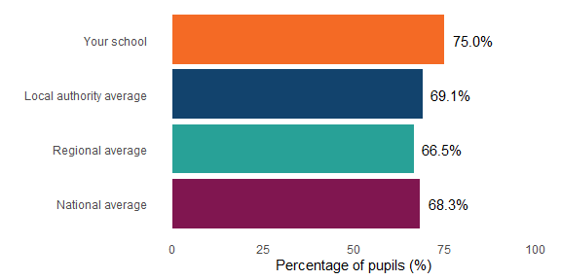
Sources: Early Years Foundation Stage Profile 2024/25 results for your school and national, regional and LA 2024/25 data from the DfE.
Your school had 75.0% of children at a good level of development in the 2024 to 2025 academic year. This is compared to the Northumberland average of 69.1%, the North East average of 66.5% and the national average of 68.3%.

Figure 2: Overall percentage of children with a good level of development in your school for the last three academic years.
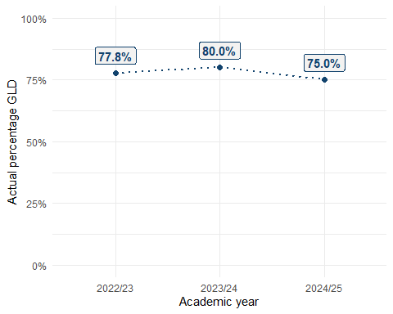
Your GLD for the 2024 to 2025 academic year is lower than your GLD for the 2023 to 2024 academic year, where your school had 80.0% of children reaching GLD.
Graph alternative table
Academic year | Actual percentage GLD
2022/23 | 77.8%
2023/24 | 80.0%
2024/25 | 75.0%
Sources: Early Years Foundation Stage Profile 2024/25 results for your school
Notes:
- If, for any of the last three academic years, your school didn’t report EYFSP data or reported EYFSP data on five or fewer children you may be missing data above.

Children reaching each early learning goal (ELG)
Figure 3: Percentage of pupils reaching each early learning goal (ELG) in your school compared with the local authority, regional and national averages for the 2024 to 2025 academic year.
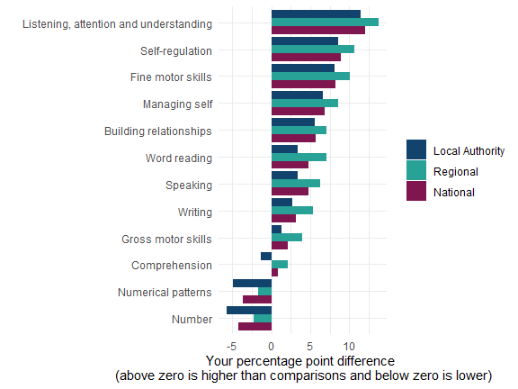
Sources: Early Years Foundation Stage Profile 2024/25 results for your school and national, regional and LA 2024/25 data from the DfE.
Notes:
- Any bar chart line that is above 0 (positive) shows that the proportion of children in your school who achieved this ELG was higher than LA, regional or national averages. Any bar chart line that is below 0 (negative) shows that the proportion of your children reaching this ELG was lower than those averages.
- ELGs have been ordered from the highest performing ELG in comparison across different geographies.

Graph alternative table
Early learning goal | Difference with local authority averages | Difference with regional averages | Difference with national averages
Listening, attention and understanding | +11.5ppt | +13.8ppt | +12.1ppt
Self-regulation | +8.6ppt | +10.6ppt | +8.9ppt
Fine motor skills | +8.1ppt | +10.1ppt | +8.2ppt
Managing self | +6.6ppt | +8.6ppt | +6.8ppt
Building relationships | +5.6ppt | +7.1ppt | +5.7ppt
Word reading | +3.4ppt | +7.0ppt | +4.8ppt
Speaking | +3.4ppt | +6.3ppt | +4.8ppt
Writing | +2.7ppt | +5.3ppt | +3.2ppt
Gross motor skills | +1.3ppt | +3.9ppt | +2.1ppt
Comprehension | -1.3ppt | +2.1ppt | +0.9ppt
Numerical patterns | -5.0ppt | -1.7ppt | -3.7ppt
Number | -5.8ppt | -2.3ppt | -4.3ppt

Different pupil groups reaching a good level of development
Figure 4: Graph showing the differences between your good level of development percentage for specific pupil groups in your school compared with the local authority, regional and national averages for the 2024 to 2025 academic year.
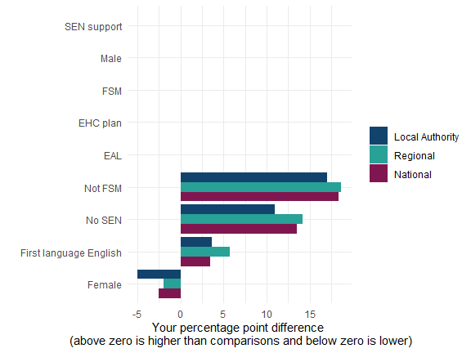
Sources: Early Years Foundation Stage Profile 2024/25 results for your school and national, regional and LA 2024/25 data from the DfE.
Notes:
- Any bar chart line that is above 0 (positive) shows that the proportion of children from this pupil group who achieved GLD in your school was higher than LA, regional or national averages. Any bar chart line that is below 0 (negative) shows that the proportion of your children reaching GLD was lower than those averages.
- If there are 5 or fewer children in a group, we have not included comparisons with LA, regional or national averages. These will appear as blank in the chart above and as ‘NA’ in the table below.
- Where data is presented for pupil groups, these have been ordered from the highest performing groups in comparison across different geographies.
- The rank order of the graph does not necessarily indicate the lowest performing groups in your school. This is because the data for some smaller groups (for example children eligible for FSM, with SEN, or English as an additional language pupils) might be suppressed in line with standard data protection approaches. So, for example if your chart shows “not FSM” or “no SEN” groups as the lowest performing, it might be that other groups would be placed lower on the chart had this data not been suppressed. We encourage you to review your data with your staff in order to fully understand the picture for all cohorts in your school.

Graph alternative table
Pupil group | Difference with local authority averages | Difference with regional averages | Difference with national averages
SEN support | NA | NA | NA
Male | NA | NA | NA
FSM | NA | NA | NA
EHC plan | NA | NA | NA
EAL | NA | NA | NA
Not FSM | +17.0ppt | +18.7ppt | +18.4ppt
No SEN | +10.9ppt | +14.2ppt | +13.5ppt
First language English | +3.6ppt | +5.7ppt | +3.4ppt
Female | -5.0ppt | -2.0ppt | -2.6ppt

Your contextual good level of development (GLD) score
Figure 5: Graph showing your contextual good level of development score compared to your actual good level of development score. Actual GLD percentage is an average over a maximum of three years, 2022/23 to 2024/25. Contextual percentage GLD is also based on averages across this time period.
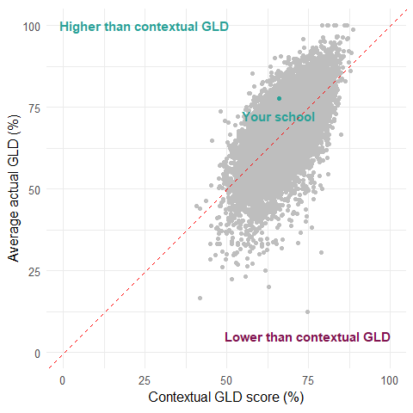
Sources: Early Years Foundation Stage Profile results from 2022/23 to 2024/25 alongside contextual GLD score data from the DfE.
Average number of pupils | 11.7
Average actual percentage GLD | 77.6%
Contextual percentage GLD | 66.1%
Difference | +11.5ppt
Your actual percentage GLD based on a three-year average is 77.6%, which is 11.5ppt higher than your contextual GLD score of 66.1%. Your actual percentage GLD is better than predicted.
In your previous report, which covered the 2021/22 to 2023/24 time period, your average actual percentage GLD was 73.4% which was 11.8ppt higher than your contextual GLD score of 61.6%.
Reminder: Even if your average actual GLD is better than your contextual GLD, there may still be areas for improvement. The DfE defines what counts as ‘better than predicted’ based on how schools across the country are performing at the time. This definition can change as national results improve.
Notes:
- Figures may not appear to sum due to rounding.
- ‘Number of pupils’ is averaged over three years, 2022/23 to 2024/25, where data exists for more than five pupils in each year. Some schools may have an average over two years or just a single data point.
- ‘Actual percentage GLD’ here is an average over three years, 2022/23 to 2024/25, where data exists for more than five pupils in each year. Some schools may have an average over two years or just a single data point. This figure is likely to differ from the 2024/25 GLD in figure 1.
- A school is considered ‘as predicted’ if their actual GLD is within a certain distance of their contextual GLD score. This distance is unique to each school. For most schools, this distance is based on the percentage point difference that one child makes to the overall score, known as the child’s difference. However, if a school’s 95% confidence interval around the predicted score is wider than the child’s difference, then the confidence interval is used instead. For example, if a school has 10 children in the cohort, the child’s difference would be 100/10 = 10ppt. If a school has 25 children in the class, the child’s difference would be 100/25 = 4ppt. The larger the cohort, the smaller the child’s difference.
- Refer to the ‘How we calculate your data’ section and Annex B for information on how we have calculated your contextual GLD score.

Areas of relative strength and areas to focus on
Based on your good level of development (GLD) data, we have suggested areas where you are performing relatively well and areas to focus on. There may be other areas of relative strength and areas to focus on beyond those outlined below. Please note that early learning goal (ELG) and pupil group suggestions are based on straightforward comparisons to local, regional and national averages and may not be statistically significant - which means the difference might not be large or meaningful.
Even if a pupil group is performing well compared to national averages, that doesn’t mean there isn’t still a development gap between them and other groups in your school. For example, we may suggest you’re doing well with boys against national averages, but that doesn’t mean there isn’t still an attainment gap between boys and girls in your cohort. It’s important to keep supporting all groups and consider how they compare to each other, not just to national benchmarks.
Areas of relative strength
Given the context in which your school operates, children are suggested to develop well at your school and actual GLD is 11.5ppt higher than your contextual GLD score.
Children are suggested to develop well across most ELGs compared to local, regional and national data. Your strongest ELGs are:
- Listening, attention and understanding: 13.8ppt difference when compared to regional averages.
- Self-regulation: 10.6ppt difference when compared to regional averages.
Children are suggested to develop well across most child characteristic groups shown compared to local, regional and national data. Your strongest child characteristic groups are:
- Children who are not eligible for free school meals: 18.7ppt difference when compared to regional averages.
- Children with no special educational needs: 14.2ppt difference when compared to regional averages.
Areas to focus on
Children are suggested to develop less well across some ELGs compared to local, regional and national data. Your weakest ELGs are:
- Number: -5.8ppt difference when compared to local authority averages.
- Numerical patterns: -5.0ppt difference when compared to local authority averages.
Children are suggested to develop less well in one or two child characteristic groups shown compared to local, regional and national data. Your weakest child characteristic groups are:
- Children with English as their first language: 3.4ppt difference when compared to national averages.
- Female children: -5.0ppt difference when compared to local authority averages.
Reflect on early years practice in your school
We encourage schools to use this data to evaluate children’s development at the end of Reception, identify strengths and areas of concern, and compare outcomes against local and national benchmarks to inform improvement plans. Looking ahead, you can consider how differences in the incoming cohort may impact staffing, curriculum planning, and targeted support for the new academic year.
You can use this data to reflect on:
- What your Early Years Foundation Stage (EYFS) Profile data shows you about how your children are developing at the end of Reception
- Which areas of learning show strong progress, and which suggest a risk of children falling behind their peers
- How your EYFS Profile data compares to local authority, regional and national averages and how differences in outcomes may be explained by factors within the school setting
- If assessment practices and internal quality assurance could be more consistent and robust
- Staff insights and how they can help explain the data and highlight factors not shown in the numbers
- What has changed between this report and your report for the 2023 to 2024 academic year, including areas where outcomes have improved and areas where performance is lower
- How you could adapt provision in Year 1 and 2 to address gaps in learning
For the new academic year, you could consider:
- How the characteristics of the incoming cohort for the 2025 to 2026 academic year differ from the cohort for the 2024 to 2025 academic year
- How these differences could affect staffing, curriculum planning and targeted support
Actions you could take
Schools are encouraged to collaborate with staff and other local schools to review EYFS Profile data, identify priority areas for improvement, and plan targeted professional development and transition strategies.
- Consider which parts of the reception improvement offer, set out on the RISE reception website, you could access to support your school improvement priorities.
- Discuss this report and your EYFS Profile data with your Reception staff to understand their experiences and how they have applied their professional judgment in their observations.
- Identify one or two priority areas for early years improvement and include them in your school improvement plan. For those areas of particular underachievement, set a plan to address through looking at best practice, research based evidence and investment in CPD and resources.
- Set up a joint meeting or informal visit to a nearby school, to compare trends and priorities in your EYFS Profile data, share strategies that have worked well in supporting early development, and/or explore opportunities for joint continued professional development (CPD).
- Arrange meetings with local early years providers to discuss the EYFSP data trends and share insights on children’s prior learning experiences. Use these conversations to identify common areas for development and agree shared strategies for improvement.
- Offer to share resources, training opportunities, and expertise with local early years providers to build capacity and improve outcomes collectively.
- Plan targeted CPD for staff based on identified needs (for example, communication and language skills or early maths) and consider extending this offer to local early years providers.
- Review transition practices between early years providers and Reception, and Reception and Year 1 to ensure continuity in learning and development, including for specific early learning goals (ELGs) where children are developing less well and may need more support to fill gaps in learning.
- Set your expectations for how reception year teachers and leaders will use the data to inform practice in Year R and in Year 1 (for those children who have now moved into Year 1).
- Set a timeline for your senior leadership team to monitor and review improvements throughout the academic year, in order to achieve GLD improvements by the end of the year.
- Ensure the early years census data continues to be completed as fully as possible to improve data quality in this report.
- Contribute to your LA’s Best Start local plan, for example by making them aware of any actions you plan to take to drive improvements to the quality of early years education.
- Inform wider conversations about your LA’s Best Start local plan and understand how you can support the actions being led by other delivery partners in your area.

Annex A - Frequently Asked Questions (FAQs)

Can I share my report with other staff members?
Yes. In order to access the report on VYED, they will need to have a DfE Sign-in account, request access to the VYED platform and the sub service ‘Monitor your child development data’, and be approved by your organisation’s approver. You can also download a copy of the report and share it directly with others in your organisation, such as your governors, without them having access to VYED.

What is different for the November reports?
The November reports include the following changes:
- 2024/25 Early Years Foundation Stage Profile (EYFSP) data
- New time series statements and graphs
- A link to the user guide and online feedback form
The supplementary tables for responsible bodies now contain additional school-level data, including ELG data. This aims to give trusts and LAs more information to support decision making.
We have also produced a new area-based report for local authorities that covers all schools, both LA-maintained and academies, within each LA’s geographical boundary. We have provided this area-based report to give LAs a complete picture of performance in their area to support with the development of their Best Start local plans to raise GLD levels by 2028.

How many years of data does the report include?
The first part of the report, ‘Your good level of development (GLD) data’, focuses on 2024/25 EYFSP data.
The second part of the report, ‘Your contextual good level of development (GLD) score’, includes the most recent three years of data: 2022/23, 2023/24 and 2024/25 where available.
However, for some schools, some years of data have been removed due to data quality. For example, if a school has five or fewer pupils in a given year or is missing data for particular fields used by the contextual GLD score calculations, that year of data won’t feed into the model.

My data looks wrong. Who do I tell?
Report any issues through the DfE Customer Help Portal. You should include your school URN, a description of what looks incorrect and for which year of data. Provide a screenshot if possible.
Please note, however, that the Early Years Foundation Stage (EYFS) Profile 24/25 data collection closed on 31 July. Final cuts of data have been taken and analysis has begun, so we are unable to accept late amendments to the data.

Annex B - How your contextual good level of development (GLD) score is calculated
Your contextual GLD score is based on data averaged across a maximum of three years (2022/23, 2023/24 and 2024/25) and has been calculated using the:
- Proportion of children in the reception cohort on free school meals
- Proportion of children in the reception cohort with special educational needs support
- Proportion of children in the reception cohort with an Educational Health Care plan (EHCP)
- Proportion of female children in the reception cohort
- Proportion of children in the reception cohort with English as an additional language (EAL)
- Mean age at the start of the academic year (in months) of the reception cohort
- Mean Income Deprivation Affecting Children Index (IDACI) score of the reception cohort – this is currently based on the 2019 IDACI index, but we will look to update this with the new IDACI index in future iterations
- Major ethnic groups, including % Asian, % Black, % Mixed, % White of the reception cohort
- Proportion of children in the school on free school meals
- Proportion of children in the school with special educational needs support
- Proportion of children in the school with an EHCP
- Mean urban/rurality score for reception cohort children, with 1 representing children in the most urban areas and 10 children living in the most rural areas.
- Proportion of children in the reception cohort who were not present at the start of the year
- The spread of attainment of early learning goals in the reception cohort
In a future iteration of this model, we are hoping to include the:
- Proportion of children in the reception cohort who have received pre-reception formal childcare
There are a number of variables that we have not included in the calculation for contextual GLD due to those variables closely aligning with other variables already included in the model, a lack of available data, or due to those variables not relating to cohort characteristics. For example, we have not included:
- Minor ethnic groups
- Local authority
- Mean overall absence rate
- School funding per pupil
- Immigration status
- Proportion of children in need in the reception cohort, including those on child in need plans, child protection plans, children looked after by local authorities, care leavers and disabled children
- Proportion of children in the reception cohort who are Children of Service Families
Given the complexity of schools and the multitude of factors influencing outcomes, not all relevant variables can be captured within the model. As such, the contextual GLD score should be interpreted as an estimate rather than an absolute measure.
Data that is used for your contextual GLD
Your contextual GLD percentage is based on your school’s data (averaged across 2022/23, 2023/24 and 2024/25) shown below in comparison to 2024/25 local, regional and national values. Comparisons are against published data.
NA values are shown where comparisons are not available.
 | Your school | Your local authority | Your region | Nationally
% cohort female | 54.0% | 49.3% | 48.9% | 48.9%
% cohort FSM | 12.6% | 17.0% | 24.1% | 17.0%
% cohort SEN support | 26.7% | 11.7% | 12.1% | 10.2%
% cohort EHCP | 2.2% | 5.3% | 3.9% | 3.6%
% cohort EAL | 0.0% | 3.1% | 10.6% | 21.8%
% White | 96.7% | 91.3% | 82.2% | 66.7%
% Mixed / Multiple ethnic groups | 3.3% | 2.5% | 3.7% | 7.7%
% Asian / Asian British | 0.0% | 2.4% | 5.8% | 13.7%
% Black / African / Caribbean / Black British | 0.0% | 1.3% | 4.5% | 6.4%
% unknown ethnicity | 2.1% | 2.0% | 2.0% | 3.1%
Mean age at the start of the year | 4 years 6 months | NA | NA | NA
Mean IDACI score | 0.2 | NA | NA | NA
Mean urban score | 6.8 | NA | NA | NA
% cohort mobility at end of Sep | 8.8% | NA | NA | NA
ELG variation | 3.7 | NA | NA | NA
% school FSM | 19.5% | 23.7% | 32.9% | 25.3%
% school SEN support | 25.3% | 16.3% | 16.7% | 14.8%
% school EHCP | 3.4% | 4.3% | 2.9% | 3.5%

The definition of children eligible for FSM will change during this period. The Department is still considering how this change will be reflected in administrative data. LAs should proceed on the basis that for these purposes the 2028 FSM cohort will be that which would be equivalent to the 2025 cohort, to allow comparison on a like for like basis (that is the 2028 cohort would be a subset of the population that will at that point be eligible for FSM). In the event that this is not possible, the definition would likely be the children eligible for FSM in 2028. We will confirm details in due course.
Mean age at the start of the year varies from 4 years and 2 months to 4 years and 10 months across all schools. If a child is 4 years and 6 months old in September (the most common mean age at the start of the year across all schools), a child would be born in March.

