

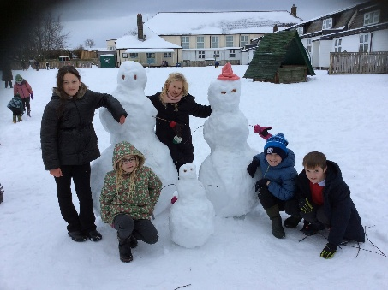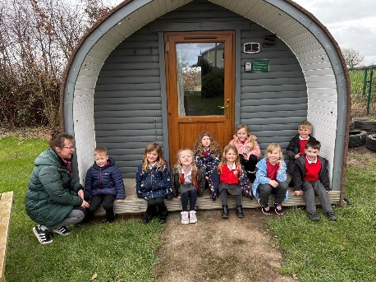
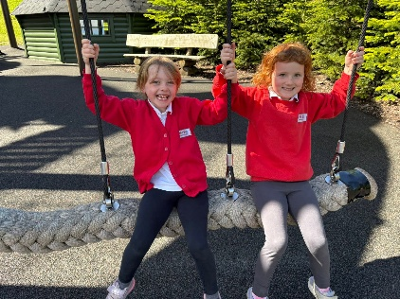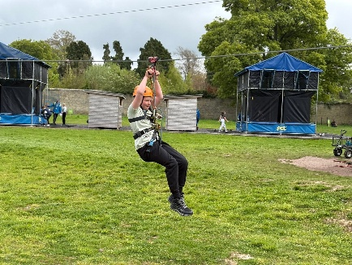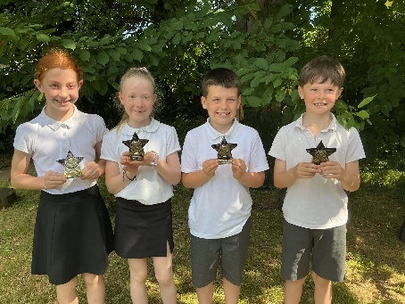

PROSPECTUS

2026 -2027

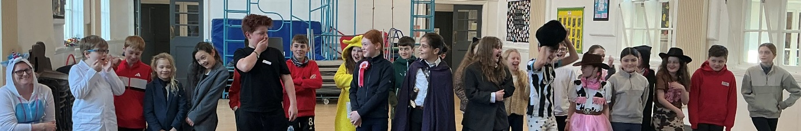

Our Vision

Make
Make a mess,
make mistakes,
make friends,
make an impression,
make progress.

We teach children to make with their hands,
their hearts and their minds.

Believe
Believe in yourself, believe anything is possible,
believe in others.

Belief is central to development, positive attitudes and self-esteem.
Our belief is simple: childhood is special, and children learn most when they are happy.

Learn
Learn from others, learn about the world.
Learn what is appropriate, and what is not.

Children absorb information at a very fast pace. It is our role to keep the momentum going, find the challenges and create their success. Interaction with people of all ages and backgrounds is vital. We introduce the children to inspiring people with incredible talents, stories and knowledge of the arts, history, geography, global issues, sport and technology, to feed their hungry minds.

Achieve
When children are interested in and have ownership of what
they are learning they will achieve more.

Through targets, project work and homework we encourage children to take responsibility for their own progress, achieving more, and more.

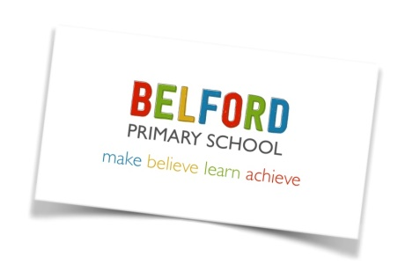

Dear Parents and Carers,

I was delighted to be appointed as headteacher of Belford Primary School in September 2019, having taught in a variety of schools in the North of England over the past 30 years.

Belford Primary School is a small school with a big heart. As a staff team, we share a common belief that children learn best when they feel safe, valued and have fun.

We provide an environment that fosters a love of learning, develops self-confidence and promotes high self-esteem. Attitudes, values and feelings have as much place in a classroom as factual knowledge and skill. We nurture positive relationships and promote care, concern and empathy for others.

Our curriculum is designed to extend the children’s knowledge of the wider world and develop their appreciation of global values, enabling them to ultimately grow into well-rounded adults.

We speak a positive language here, and we care for each other. We take time, we do not rush, we nurture. We create great opportunities for children and teach them to be spontaneous and adventurous.

We have created a safe, caring and stimulating learning environment where children can grow and develop. Our children have a lot of space, a lot of freedom and a lot of fun, but always at the heart of everything is learning. We aim to provide a sound foundation in the core skills of reading, writing, maths and computing, but also develop the skills and passion for lifelong learning.

We value our pupils as individuals and take account of their individual needs and interests and encourage them to contribute to the school community.
We also realise how important it is for parents to be fully aware of what we do and how we teach. We welcome parents and the wider community as partners, and their involvement contributes to our success and the success of the children.

My door is always open to you; why not come in and see what we do?

Mrs Lorna Rainey
Headteacher

EARLY YEARS FOUNDATION STAGE
The Early Years Foundation Stage (EYFS) sets standards for the learning, development and care of children from birth to 5 years. At Belford Primary School, we welcome children into our EYFS setting from the age of 2 onwards.
The seven areas of learning covered in EYFS are:
1. Personal, Social and Emotional Development
2. Physical Development
3. Communication and Language.
4. Literacy
5. Mathematics
6. Understanding the World
7. Expressive Arts and Design.

INTRODUCTION TO RECEPTION
In Reception, we keep detailed records of children’s achievement and progress. We use frequent, systematic observations to ensure children are happy, secure and progressing at the expected rate.

Children start in Reception in the September of the school year in which they reach the age of five. We want children to feel confident, enthusiastic and look forward to the new and exciting challenge of starting school.

Outdoor learning is an integral part of our school ethos. We believe that when children are immersed in nature, they begin to develop respectful relationships with one another and learn to value the natural world. Our children spend much of their time in our outdoor classroom and in our Forest School. We strive to provide real experiences and multi-sensory opportunities which extend children’s thinking and creativity.

Our Reception and Nursery children join the whole school for weekly assemblies and for lunch each day. We encourage healthy routines and promote positive eating habits. The children sit down at a table to eat with their friends and use real cutlery, plates and cups.

THE CURRICULUM
Childhood is special. At Belford Primary School we recognise that every child is unique. Children take in and retain information in different ways.
Our curriculum prioritises basic skills in literacy and maths, practical hands-on work,
investigation and enquiry. We want to excite and challenge our children, then allow them to take risks. Children must learn to adapt and embrace change, to prepare them for a wonderful, but unpredictable world.
Each week children in EYFS, Key Stage 1 and Key Stage 2 receive sports coaching. Children in KS1 and KS2 have a half-term of swimming lessons (each year) at the sports centre in Berwick.

Where appropriate, the curriculum extends beyond the classroom by making use of the
extensive school grounds, the local area within Belford and the wealth of resources which exist within easy reach of the school.
Our school garden plays a central part in the school curriculum. Throughout the year, the children contribute to the growing and tending of the plants. When harvested we make soup, cakes and crumbles in our classroom kitchen. This gives children the opportunity to try seasonal foods.

We truly believe cooking can benefit the children in many ways and support their learning in the classroom. Together we can learn about the origins of food, develop mathematical concepts, fine-tune children’s motor skills and coordination, build self-esteem, promote literacy and language development and generally have fun.

THE CORE SUBJECTS
ENGLISH
Each day, every child in our school takes part in an English lesson that allows them to learn new skills in an exciting and meaningful way. In EYFS and KS1, we use stimulating and purposeful texts linked to a structured intervention known as Read Write Inc. to encourage children to develop skills in reading, spelling and writing. Handwriting is taught daily, and children are encouraged to join letters together as soon as they have mastered correct individual letter formation.
The teaching of reading is given a high priority at Belford Primary School. We use a variety of methods to teach children to read. We teach phonics so that children can tackle new words by blending sounds. We provide attractive and interesting books that the children will enjoy reading at home. The key reading schemes used in school are Read, Write, Inc, Oxford Reading Tree and Project X. Children take these books home each night but should bring them to school each day so the class teacher can also hear them read. All children in school are also encouraged to borrow books from our attractive school library and class libraries. In Key Stage 2, children share good quality whole class novels and enjoy discussing story characters, plots and adventurous vocabulary.

MATHEMATICS
We believe each child should develop confidence, competence and enjoyment in
mathematics. Children take part in daily lessons. Practical investigations play a large part in allowing children to apply the concepts they have been taught. Children are taught to understand the relationship between numbers and to develop a range
of strategies to work out calculations. Mental arithmetic is used to ensure that basic
knowledge of number is learnt and can be applied at speed. Number bonds and timetables are considered essential basic skills and are taught across the school. As part of the mathematics curriculum we also teach shape, space and measure and data handling.

COMPUTING / INFORMATION TECHNOLOGY
To develop IT skills, all children have regular access to iPads, laptops and other equipment such as cameras and robots. Interactive whiteboards are in every classroom and are used for teaching across all areas of the curriculum. In addition, we use portable technology as part of everyday lessons to support research, small group work and independent learning. As part of the computing curriculum, children are taught how to stay safe when using a computer.

FOUNDATION SUBJECTS

SCIENCE
We believe that children learn science best by asking questions, exploring ideas and investigating the world around them. An enquiry-based approach to science encourages pupils to think and work like scientists, developing curiosity, creativity and a love of discovery.
Through practical investigations and hands-on experiences, children learn to ask questions, make predictions, carry out fair tests, observe carefully, collect and interpret evidence, and explain their findings. This helps them develop a deeper understanding of scientific concepts because they discover ideas for themselves rather than simply memorising facts.
Enquiry-based science also develops valuable lifelong skills, including critical thinking, problem-solving, teamwork, resilience and communication. Children learn that science is about exploring, testing ideas and learning from mistakes, helping them become confident learners who are prepared to understand and engage with the rapidly changing world around them.
By making science active, meaningful and relevant, we inspire children to become curious about the natural world and encourage a lifelong interest in science and discovery.

HUMANITIES
At our school, we teach History and Geography through an enquiry-based approach. Rather than simply learning facts, children become historians and geographers by asking questions, investigating evidence, exploring different viewpoints and drawing their own conclusions.
Each enquiry begins with an engaging question that encourages curiosity and critical thinking. Children develop a deeper understanding of the past and the world around them by analysing sources, making comparisons, identifying patterns and explaining their ideas using evidence. This approach helps pupils build secure knowledge while also developing important skills such as communication, problem-solving and independent thinking.
By encouraging children to investigate, discuss and reflect, we aim to inspire a lifelong interest in History and Geography and help them understand how the past and present shape the world they live in today.
Visits to local places of historical and geographical interest give the children first-hand experiences.

PHYSICAL EDUCATION
In PE, children are taught to be active and improve their fitness. The emphasis is on improving and developing abilities. Aspects of gymnastics, games, dance, athletics and outdoor adventurous activities are taught. Children have at least two hours PE every week. All children in KS1 and KS2 have access to swimming lessons at specific points in the academic year. We run a variety of after-school sporting clubs that children can attend. All children have an opportunity in KS2 to take part in a residential visit. At the end of the summer term, parents and children take part in sports day on the school field.

MUSIC
At our school, we believe that high-quality music education enriches children's lives and plays a vital role in their personal, social and academic development. Music helps children develop confidence, creativity, self-expression and resilience, while also improving listening skills, concentration, teamwork and memory. Through singing, performing, composing and listening to a wide range of music, pupils gain an appreciation of different cultures and develop a lifelong love of music.
We are also proud to welcome visitors into school who share their musical talents and experiences with our children. Meeting musicians, performers and members of the local community helps bring learning to life, inspiring pupils and broadening their understanding of the many ways music can be enjoyed and celebrated. These experiences encourage children to explore new instruments, styles and opportunities, while demonstrating that music is for everyone, regardless of age or ability.
By combining high-quality classroom teaching with enriching musical experiences, we aim to nurture confident, creative and enthusiastic young musicians who appreciate the power of music to bring people together and enrich everyday life.
We have a specialist music teacher, Mrs Cochrane, who delivers high-quality music sessions to all classes every Monday afternoon. The children in KS2 learn how to play the ukulele.

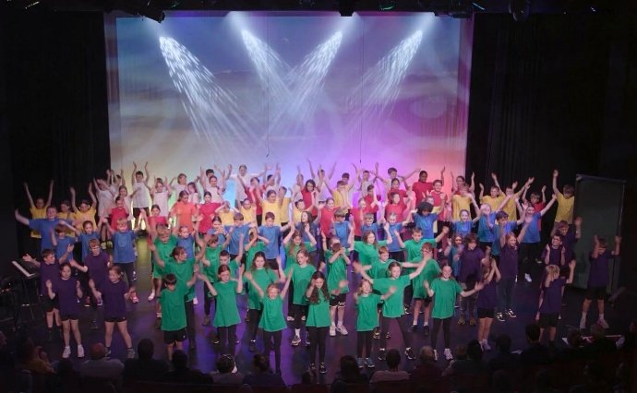

Year 5 and 6 performing ‘Beacon’ at Alnwick Playhouse June 2026
An Aln Alliance project

ART AND DT
During their time at Belford Primary School children will have the opportunity to experience a wide range of techniques and media through painting, printing, modelling, drawing, textiles and collage work. Visiting artists and sculptors work alongside the children on whole school projects. Children are given opportunities to visit art galleries in the local area and wider afield.
We are proud to play an active role in the Belford Arts Festival, welcoming talented artists into school to inspire our pupils and share their creative expertise. Our children also have the opportunity to exhibit their own artwork as part of the festival, giving them a real sense of pride and achievement while celebrating their creativity with the wider community.
Through high-quality teaching and these enriching experiences, we aim to foster a lifelong appreciation of art, culture and creativity.

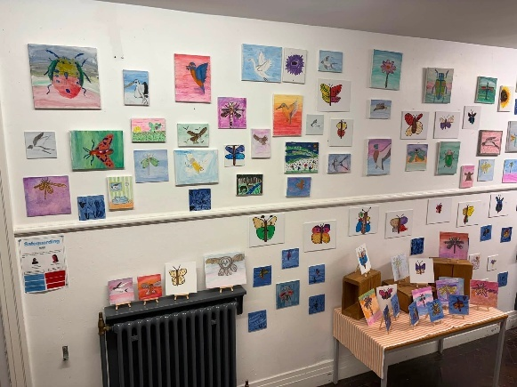

At our school, Design and Technology inspires children to become creative and resilient problem-solvers. Through designing, making and evaluating products, pupils develop practical skills, creativity and critical thinking while learning how design improves everyday life.

RELIGIOUS EDUCATION
We observe Northumberland’s syllabus for the teaching of Religious Education. We take great care to promote the spiritual, moral, cultural and social development of children and prepare them for the opportunities, responsibilities and experiences of life.
We welcome visitors into school to share their beliefs and take the children on visits to places of worship in the local area and wider afield.



FRENCH
At our school, we believe that learning a modern foreign language opens the door to new cultures, experiences and opportunities. Through the teaching of French in KS2, children develop their speaking, listening, reading and writing skills while building confidence in communicating in another language.
Our French curriculum is engaging, interactive and practical, helping pupils to develop accurate pronunciation, extend their vocabulary and understand simple grammar. As they learn about the language, children also explore French culture and traditions, fostering curiosity, respect and an appreciation of the wider world.

ASSEMBLY
Children take part in whole school assemblies each week. Assembly time builds on the work being done in the classroom in Personal, Social, Health and Economic Education classes.
We encourage children to see themselves as part of the family of school and as part of a larger community, where they have rights and responsibilities.
Parents may withdraw their children from assembly time, and to do this they must inform the school formally in writing of their wishes.

PSHE
Personal, Social and Health Education (PSHE) is an essential part of helping children grow into happy, healthy and responsible young people. Through carefully planned lessons, pupils develop the knowledge, skills and confidence to make positive choices, build healthy relationships, understand their emotions and keep themselves safe both in school and beyond.
Our PSHE curriculum encourages children to develop respect for themselves and others, celebrate diversity, manage challenges with resilience and understand the importance of physical and mental wellbeing. These lessons provide a safe and supportive environment where pupils can ask questions, share ideas and learn the skills they need to thrive in an ever-changing world.
We also promote the Five Ways to Wellbeing, helping children develop positive habits that support their mental health and emotional wellbeing every day:
- Connect – Build positive relationships with family, friends and the wider community.
- Be Active – Enjoy regular physical activity to support both body and mind.
- Take Notice – Appreciate the world around us through mindfulness, reflection and curiosity.
- Keep Learning – Embrace new experiences and develop skills that build confidence and resilience.
- Give – Show kindness, help others and contribute positively to the school and local community.
By embedding these principles throughout school life, we aim to nurture confident, compassionate and resilient children who are well prepared for the opportunities and challenges of the future.
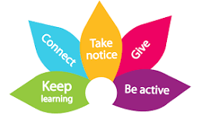
THE SCHOOL DAY
Nursery
8.50-11.50 am or 12.50 pm (if staying for lunch).
Afternoon session: 12.50-2.50 pm

Reception
Morning Session 8.45 am - 12.00 noon
Lunch: 12.00 – 1.00 pm
Afternoon Session 1.00 pm- 3.15 pm

Key Stage 1
Morning Session 8.45 am - 12 noon
Morning Break 10.15-10.30 am
Lunch 12.00- 1.00 pm
Afternoon Session 1.00 - 3.15 pm

Key Stage 2
Morning Session 8.45 am - 12 noon
Morning Break 10.15-10.30 am
Lunch 12.00- 1.00 pm
Afternoon Session 1.00 - 3.15 pm

HOMEWORK
Each child has a reading book and reading diary. Parents are encouraged to read with
their child/ children every night and write comments in the diary. From year one onwards, children are given homework each week relating to the work they’re doing in the classroom. Each half term children will receive a spelling book where they can practise their spelling each week.

EQUALITIES
We are an inclusive school, where every pupil has an entitlement to all areas of the curriculum and educational experiences, which will enable them to achieve. No one is discriminated against because of race, gender or disability. All staff and governors are aware of the educational access rights of disabled children. We make reasonable adjustments to promote the fullest possible participation by all children to access all school activities and facilities.

All children are positively encouraged to respect each other’s differences and treat others as they expect to be treated themselves.

LOOKED AFTER CHILDREN
Children and young people become “Looked After” either if they have been taken into care by the local authority, or have been accommodated by the local authority. Our school is committed to providing quality education for all its pupils, based on equality of access, opportunity and outcomes.

SPECIAL EDUCATIONAL NEEDS AND DISABILITY (SEND)
A child or young person has Special Educational Needs and Disabilities (SEND) if they have a learning difficulty or disability that calls for special educational provision to be made for them. At Belford Primary School, we are committed to providing an inclusive environment where every child is valued and supported to achieve their full potential. We ensure that pupils with SEND are able to participate fully in all aspects of school life, wherever reasonably possible.
Our SEND provision is guided by the Children and Families Act 2014, the SEND Code of Practice: 0–25 years and the Equality Act 2010. We believe that early identification is key to ensuring children receive the right support at the right time. Through high-quality teaching, ongoing assessment and close partnership with parents and carers, we identify and respond to pupils' needs as early as possible. We encourage parents to share any concerns they may have about their child's learning or development so that we can work together to provide appropriate support.
Where a child requires additional support, we follow the graduated approach of Assess, Plan, Do, Review. Individual outcomes and support strategies are agreed in partnership with parents, carers and, wherever appropriate, the child. Progress is reviewed regularly to ensure that provision remains effective and meets the child's changing needs.
Where a pupil has an Education, Health and Care Plan (EHCP), we ensure that the provision specified within the plan is implemented and reviewed in collaboration with families and other professionals. Our SENDCo, Mrs Lorna Rainey, works closely with class teachers, support staff, parents and external agencies to coordinate support and ensure that pupils receive high-quality, personalised provision. This may include adaptations within the classroom, targeted interventions, small group work or individual support, enabling every child to access the curriculum and make the best possible progress.

RELATIONSHIPS, SEX AND HEALTH EDUCATION
At Belford Primary School, Relationships, Sex and Health Education (RSHE) is an important part of our Personal, Social, Health and Economic (PSHE) curriculum. Through age-appropriate learning, children develop the knowledge and skills they need to build healthy, respectful relationships, understand how to keep themselves safe and healthy, and prepare for the physical and emotional changes that occur as they grow.
Relationships Education is statutory for all primary-aged pupils and is taught throughout the school. As children approach puberty, pupils in Years 3, 4, 5 and 6 receive additional learning about body changes, puberty and personal hygiene in a sensitive and age-appropriate way. Parents are informed about this aspect of the curriculum and are invited to view the teaching materials and discuss the programme with staff.
Parents have the right to request that their child is withdrawn from the non-statutory sex education elements of the curriculum. Requests should be discussed with the Headteacher so that we can work together in the best interests of the child. Children cannot be withdrawn from the statutory Relationships Education or Health Education curriculum, or from the science curriculum, which includes teaching about human development and reproduction as set out in the National Curriculum.

PARTNERSHIPS
We recognise that parents know more about their child than we will ever do. We welcome the opportunity to share that knowledge and learn from you. It is our policy to involve parents in the life of the school and to promote positive relationships with the aim of together providing the highest quality education for our children. There are a variety of opportunities to encourage you to support your children’s education at home.
• Reading diaries
• Stay and Play sessions
• Supporting “The Friends of Belford School’, our PTA.
• Assemblies and performances
• Sporting events
• Parent governors

CHILD PROTECTION
Belford Primary School believes that pupils have a fundamental right to be protected from harm. We work in partnership with a variety of agencies to provide the best possible care and support to children. We have a designated Child Protection Officer, a Governor with responsibility for Child Protection, and staff receive regular training to ensure they are familiar with and skilled in implementing child protection procedures. We have a duty of care to report to the appropriate authorities any concerns regarding the well-being or welfare of children in school.

COMPLAINTS PROCEDURE
There may be times when you are unhappy or unsure about an aspect of the school. Please come and speak to a member of the staff as early as possible. In most cases, worries or complaints can be sorted out quickly and easily in discussion with the class teacher or headteacher. Following consultation and if you are still dissatisfied you may wish to make a formal complaint via the Chair of Governors. Copies of the Complaints Policy are available from the school office and are on the school website.

REPORTING TO PARENTS
We want to keep parents informed about their child’s progress and development in school. Alongside the many informal opportunities each day and the times when you might make an appointment to discuss something with teachers, we organise the following to help keep you in touch with what your child is learning and the progress they are making:

- A written end-of-year report.
- Parent consultation meetings are held in the Autumn and Spring terms. This allows parents to speak to their child’s class teacher and look at the children’s workbooks.
- Curriculum plans are sent out to parents at the beginning of every term and can
also be found on the school website.
- Workshops where parents can stay and learn with their children.
- Class and whole school assemblies where the children share their learning.

GENERAL ORGANISIATION

ABSENCE FROM SCHOOL
Good attendance is essential for all children, and therefore attendance data is carefully monitored. If your child is ill, please call the school office before 9.00 am on the first day of illness. If you know in advance that your child is going to be absent due to a medical appointment, please let the school office have a note in order that absences may be correctly coded.
If your child becomes ill during the school day, we will contact you. Please ensure the school has up-to-date contact details.

LATE ARRIVAL AT SCHOOL
Children who arrive at school after 8.45 am should be brought to the school office where your child can be marked present – but will receive a late mark. A member of staff will take the child to class. If you have to arrange emergency medical appointments, please telephone school to let us know you will be late and when you expect to arrive.

MEDICINE
We do not store or administer medicine to children unless they are prescribed four times a day by a doctor. Most can be administered before and after school and at bedtime. However, in the case of children who suffer from hay fever, epilepsy, asthma or other conditions which require medication to be stored and administered on school premises, we can do so. Please inform us by completing a medicine form available from the school office.

ADMISSIONS
Children are eligible to start Reception in September in the year they will have their fifth birthday. Parents can apply online for places at
https://www.northumberland.gov.uk/education-skills/schools/school-admissions-places-appeals

BEHAVIOUR
We aim to maintain a happy, safe and secure school where adults and children feel safe,
involved and valued. We base this on a positive approach to behaviour management. We
encourage and recognise good behaviour. We believe in listening to children and making expectations clear. We aim to be consistent in our approach. All children follow our six golden rules.
Our Golden Rules Are:
We are gentle
We are kind and helpful.
We listen.
We are honest.
We work hard.
We look after property
We show respect to staff and each other.

All parents, children and staff are asked to sign a Home-School contract when children start school. On the rare occasions that persistent difficulties arise, the class teacher will contact parents to discuss the issue.

CHARGING POLICY
At Belford Primary School we have two sources of income – one from Northumberland County Council and the other is money raised ourselves. The Friends of Belford Primary School are very active in raising funds for specific projects and organise many fundraising events. Funds are used to enhance the provision for our children. However, there are many activities which enrich the curriculum such as visits to museums and places of interest which incur an entrance fee or transport costs. In such cases, voluntary contributions from parents are essential and greatly appreciated. No child will be excluded from participating in an activity during the school day because of a lack of parental contribution however, the activity may not take place if there is a continued shortfall of contributions. We make a charge for swimming, breakfast club and after school clubs. Monies raised from after school clubs are spent directly on experiences or equipment for the children e.g. puppet shows, musical instruments and climbing equipment.

DINNER MONEY
Children in Reception and KS1 are eligible for a free school meal each day. There is a cost of £2.20 per day for school lunches; once the children move into KS2 dinner money must be paid in advance on the first day of the school week or the beginning of a school term. We have an online payment system in place. Some children are eligible for free school lunches in KS2. The following website should be used to check eligibility: https://www.gov.uk/apply-free-school-meals

HOME TIME ARRANGEMENTS
All children will be dismissed by the class teacher at the end of the day to an authorised adult. If you wish for your child to walk home alone, it is essential that you complete the relevant forms in the school office. If you wish your child to be collected by another adult, please ensure their details are on your child’s home time arrangements form.

HEALTH AND SAFETY
The safety of children in our care is always our first concern. We ask you to read the
following information and support the school by noting and following the policies we set.

1.Vehicles are not to enter or leave the school site between 8.30 am – 9.20 am and then
3.00pm – 3.30pm. Vehicles should not park or drop off at the school gates or in the
bus drop off area.
2. Smoking or vaping is not permitted in any area of the school grounds or perimeter.
3. Dogs, other than guide dogs for the blind, are not allowed on the premises
4. We are a healthy school. We ask that children do not bring chocolate bars or fizzy
drinks into school as part of their packed lunch. No nuts to be brought in either please.
5. Positive behaviour is expected from all parents and carers on site. They are expected to behave appropriately and set a good example to the children.
6. We do not allow the wearing of any jewellery other than watches, small stud
earrings or an item that has religious significance. All earrings must be removed
before swimming or PE.
7. Sickness and diarrhoea. Children mustn't return to school too soon after illness. This helps to prevent the spread of infection to others. We recommend that children are kept away from school for 48 hours after sickness and/or diarrhoea.

MOBILE PHONES
Parents are asked not to use mobile phones on the school site.
Children are not permitted to bring smartphones to school. If they bring a simple phone to school, it must be handed to a member of staff for secure storage throughout the day. Phones will be handed back to children at 3.15 pm.

SOCIAL MEDIA
Belford Primary School takes its responsibility to keep staff and children safe from any form of violence or harassment, physical, written or verbal. Positive behaviour is expected from all parents and carers. They are expected to behave appropriately in their use of social media and set a good example. Sanctions can be implemented by the school against any parent or carer who has published comments relating to any child, another parent, member of staff or the school that would bring them into disrepute. Complaints should be brought to the attention of the school appropriately and will be followed up in line with our complaints policy.

UNIFORM
Through our uniform, we emphasise being part of a whole school team. It comprises the following:
• Grey skirt, trousers or shorts
• White polo shirt
• Red sweatshirt or cardigan
• Red/white gingham dress (summer)
• Black shoes (no high heels or trainers)
• PE Kit black shorts /white t-shirt
Sweatshirts and T-shirts with the school logo can be purchased from the school office, but are not essential.

PE kits should be kept in named drawstring bags and left on the child’s coat peg. Jewellery must not be worn in school with the exception of stud earrings. Children must be able to remove their own studs before PE and swimming lessons. For reasons of health and safety, these activities cannot be undertaken with studs in place.
Please ensure all clothing is labelled with your child’s name.
We recommend that your child wears a coat in ‘most weathers’. As our climate is quite
changeable, they often need a coat at break times when they are outside.

AFTER SCHOOL FUN
Every term we organise after school clubs to extend the children’s curriculum. Clubs change each half term, and letters are sent home to inform you of the changes. In the past, children have enjoyed: Gardening Club, Dance, Sewing, Football, Tennis, Cricket, Lego, Rugby and Drama. We welcome a variety of visitors into the school to support our curriculum.
Children also enjoy fundraising events such as movie nights, sleepovers and bingo.

NATIONAL TEST RESULTS
The information below demonstrates how Belford Primary School compares to other schools nationally. At the end of Reception we report how many children achieve a Good Level of Development (GLD). At the end of Year 1, we report the percentage of children passing the Phonics Screening Check. At the end of Year 6, children take National tests (SATs) in Reading, Spelling, Punctuation and Grammar (SPaG) and Mathematics. The level that most children are expected to achieve is the ‘expected’ level for their Year group.

Reception: The percentage of children achieving a Good Level of Development.

GLD  Reception |  | 2025 | 2026
GLD  Reception | Belford Primary School | 75% | 77%
GLD  Reception | National | 68.3% | Not yet published

Year 1:
The percentage of children achieving the expected level in the phonics screening check

Year 1  Phonics Screening |  | 2025 | 2026
Year 1  Phonics Screening | Belford Primary School | 80% | 88%
Year 1  Phonics Screening | National | 80% | Not yet published

Year 6: End of Key Stage 2 SATs 2026

Year 6  End of year data  KS2 SATS  12 children in cohort | Children achieving  expected standard |  | Children achieving  Greater Depth
Year 6  End of year data  KS2 SATS  12 children in cohort | Belford  Primary  School  2026 | Nationally 2025 | Belford  Primary  School  2026 | Nationally 2025
Reading | 75% | 75% | 42% | 28%
Writing | 75% | 72% | 8% | 13%
Maths | 83% | 74%% | 67% | 22.5%
SPAG | 92% | 73% | 33% | 32%

PARENTS OF CHILDREN AT BELFORD PRIMARY SCHOOL SAY…

Information and quotes from our Parental/Carer Questionnaire:
100% of parents would recommend Belford Primary School to others.
100% of children enjoy and feel safe at Belford Primary School
“The school provides a good learning environment and teaching is to a high standard with high expectations”.

“Excellent communication between home and school”.

“Staff Listen to parents concerns and deal with them”.

“Each child is treated individually; nothing is just ‘brushed off’. I feel they are cared about”.

“Personal relationships with the children are strong. I drop my son off knowing he has someone he feels attached to and safe with”.

“We like the buddy system with the older children supporting the younger children”.

“My child has a very good level of support in school, during lessons and at break and lunchtime”.

