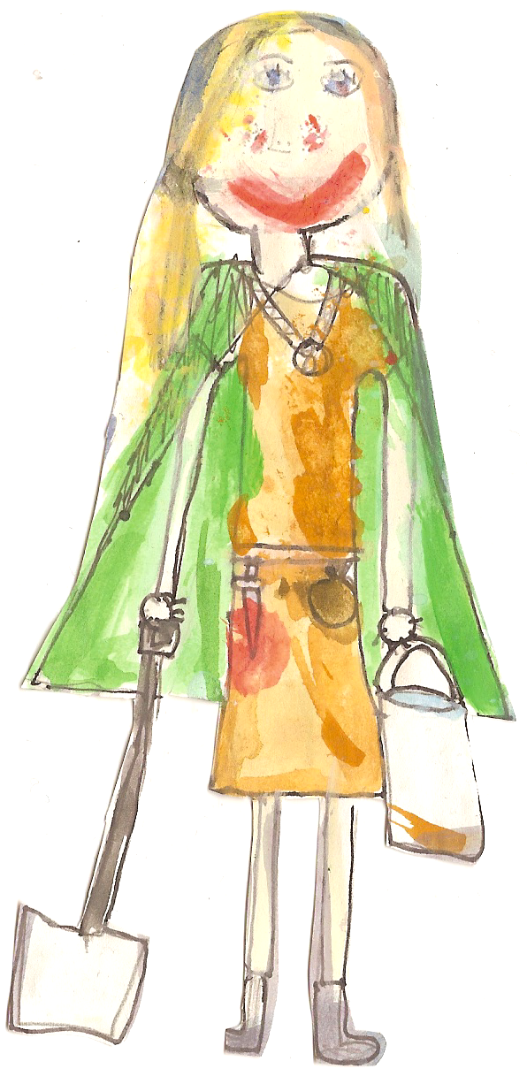

Dear Parents

During the year we take photographs of the children during various activities. We would like to use some of these photographs in our school publications, our school Facebook page and Prospectus

and occasionally send them to the press.

Would you please complete the slip below to let us know if we can use your child’s photograph.

Yours sincerely

L RAINEY

Mrs Rainey

Headteacher

Child’s Name…………………………..…. Class………………

I give*/do not give* permission for my child’s photo to be used in school publications / school website / Facebook page

I give*/do not give* permission for my child’s photo to be sent to the press

(* delete as necessary)

Signed …………………………………(Parent / Guardian)

Dated ……………………………….

Photographs

for

Publishing

**West Street**

**Northumberland**

**NE70 7QD**

**01668 213 372**

[**admin@belfordprimary.northumberland.sch.uk**](mailto:admin@belfordprimary.northumberland.sch.uk)

**Headteacher – Mrs L Rainey**