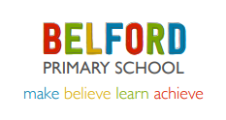 |  | Summer Term 2026  Issue 5 20.05.26
Ford Castle Residential  Our Year 5 children had a fantastic time on their recent residential to Ford Castle. They took part in a wide range of adventurous outdoor activities and all were a real credit to their families and our school.  The zip wire and team challenges were very popular with the children, as was the tasty food on offer! |  | Gymnastics Sessions  After half term, children in Reception, Class 2 and Class 3 will be receiving specialist gymnastic coaching every Tuesday morning (with the exception of week 1, when it will be on the Friday). Please can the children bring their PE kit into school on Tuesdays and Thursdays.
Pyjamarama Day  On Thursday 11th June, the children will be taking part in a special day celebrating books and reading.  They may come to school on this day wearing their pyjamas and if they are able, bring with them a small donation, which we will give to ‘The Book Trust’.’ This charity does great work promoting a love of reading amongst children in the UK.  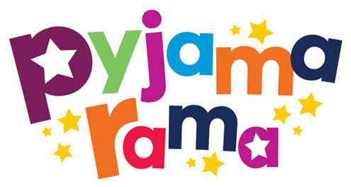 | College Valley | Dates for the Diary  6th June  Countryside Day (Wooler)  Class 2 and 3  1.15pm  KS2 Sports Day  1.15pm  Class 2 Sports Day  Wednesday 28th June  Life Path Day for Class 3  Wednesday 3rd July  Year 6 to visit DCHS  ^{th} July  Year 6 Beach School  Wednesday 10th July  Year 6 visit to DCHS  Sport focus  Thursday 11th July 2.00pm  Year 6 Performance  July  Break up for summer.
Rugby  We have been very impressed with the children’s rugby skills this half term. They have made great progress. Our thanks to Dougie (their coach) for his hard work and commitment. Dougie is retiring this year and we wish him all the best and a well-earned rest! | College Valley
 | Aln Alliance Arts Project
Belford Arts Festival  We are delighted to be involved with the Belford Arts Festival again this year.  The festival will take place on Saturday 11th and Sunday 12th July.  Every child will have their own materpiece on display in school and there will be a wide variety of artists exhibiting their work and performing. | Aln Alliance Arts Project

